Functions and Graphs | Unit 3 | Quadratic functions and Absolute values


WHAT THIS UNIT IS ABOUT

In this unit you will be learning about quadratic functions and how to sketch curves to represent them. The graphs of quadratic functions are called parabolas.

You will also learn about the properties of quadratic functions and how these properties can be identified from the algebraic expressions when they are written in different standard forms.

You will then learn about the Absolute value function and how to draw them using similar skills.

Graphs of functions are common in physics, where data collected in an experiment can be plotted and a graph can be drawn. Many of the relationships and functions between variables in physics were discovered from experimental data.
Michael Jordan about to shoot a basket. The way a ball flies forms a parabola because of the quadratic relationship caused by the force of gravity.

In this unit you will

- Use tables of values to draw parabola graphs of quadratic functions and demonstrate an understanding of the properties of quadratic functions, the y-intercept, the roots and the turning point.

- Plot the graph of a quadratic function or parabola from the properties of the function in factorised form.

- Plot and sketch the graph of a quadratic function by completing the square and identifying the y- intercept, the turning point, the axis of symmetry and the roots.

- Identify the properties of Absolute value functions and use them to plot a graph.

Activity 1
Introduction to Quadratic function graphs
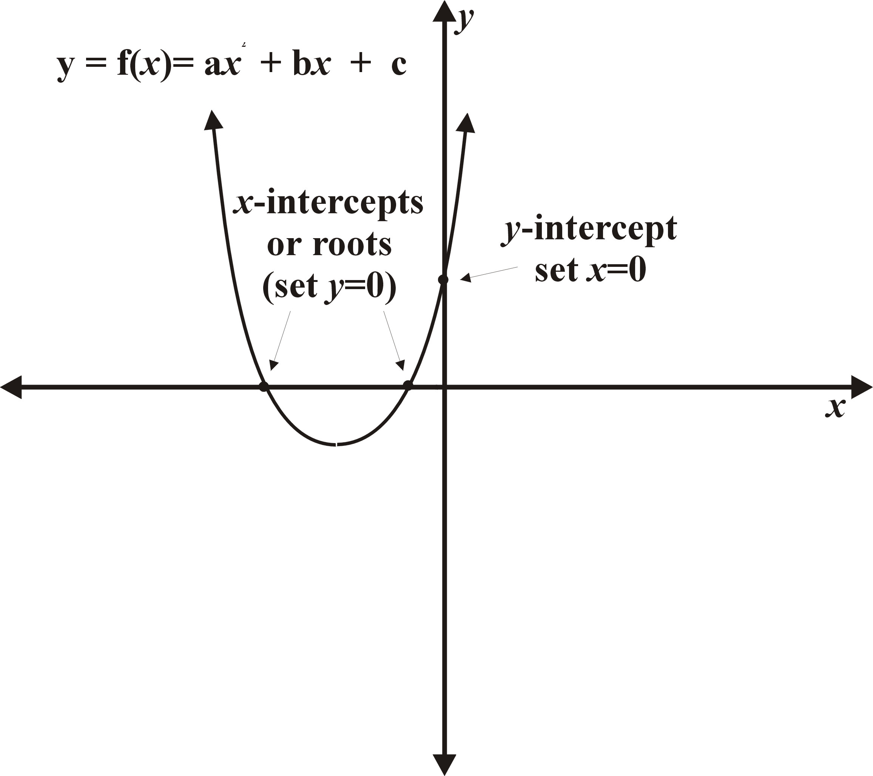
Any function can be drawn using a table of values as sets of ordered pairs. The properties of a quadratic function can be seen from a graph plotted using the generated points.

1.1 Exploring the Quadratic function

Complete a table of values like the one below for the function y = f(x) = x² , then draw a graph of the function by plotting the points on a set of axes like the ones shown.

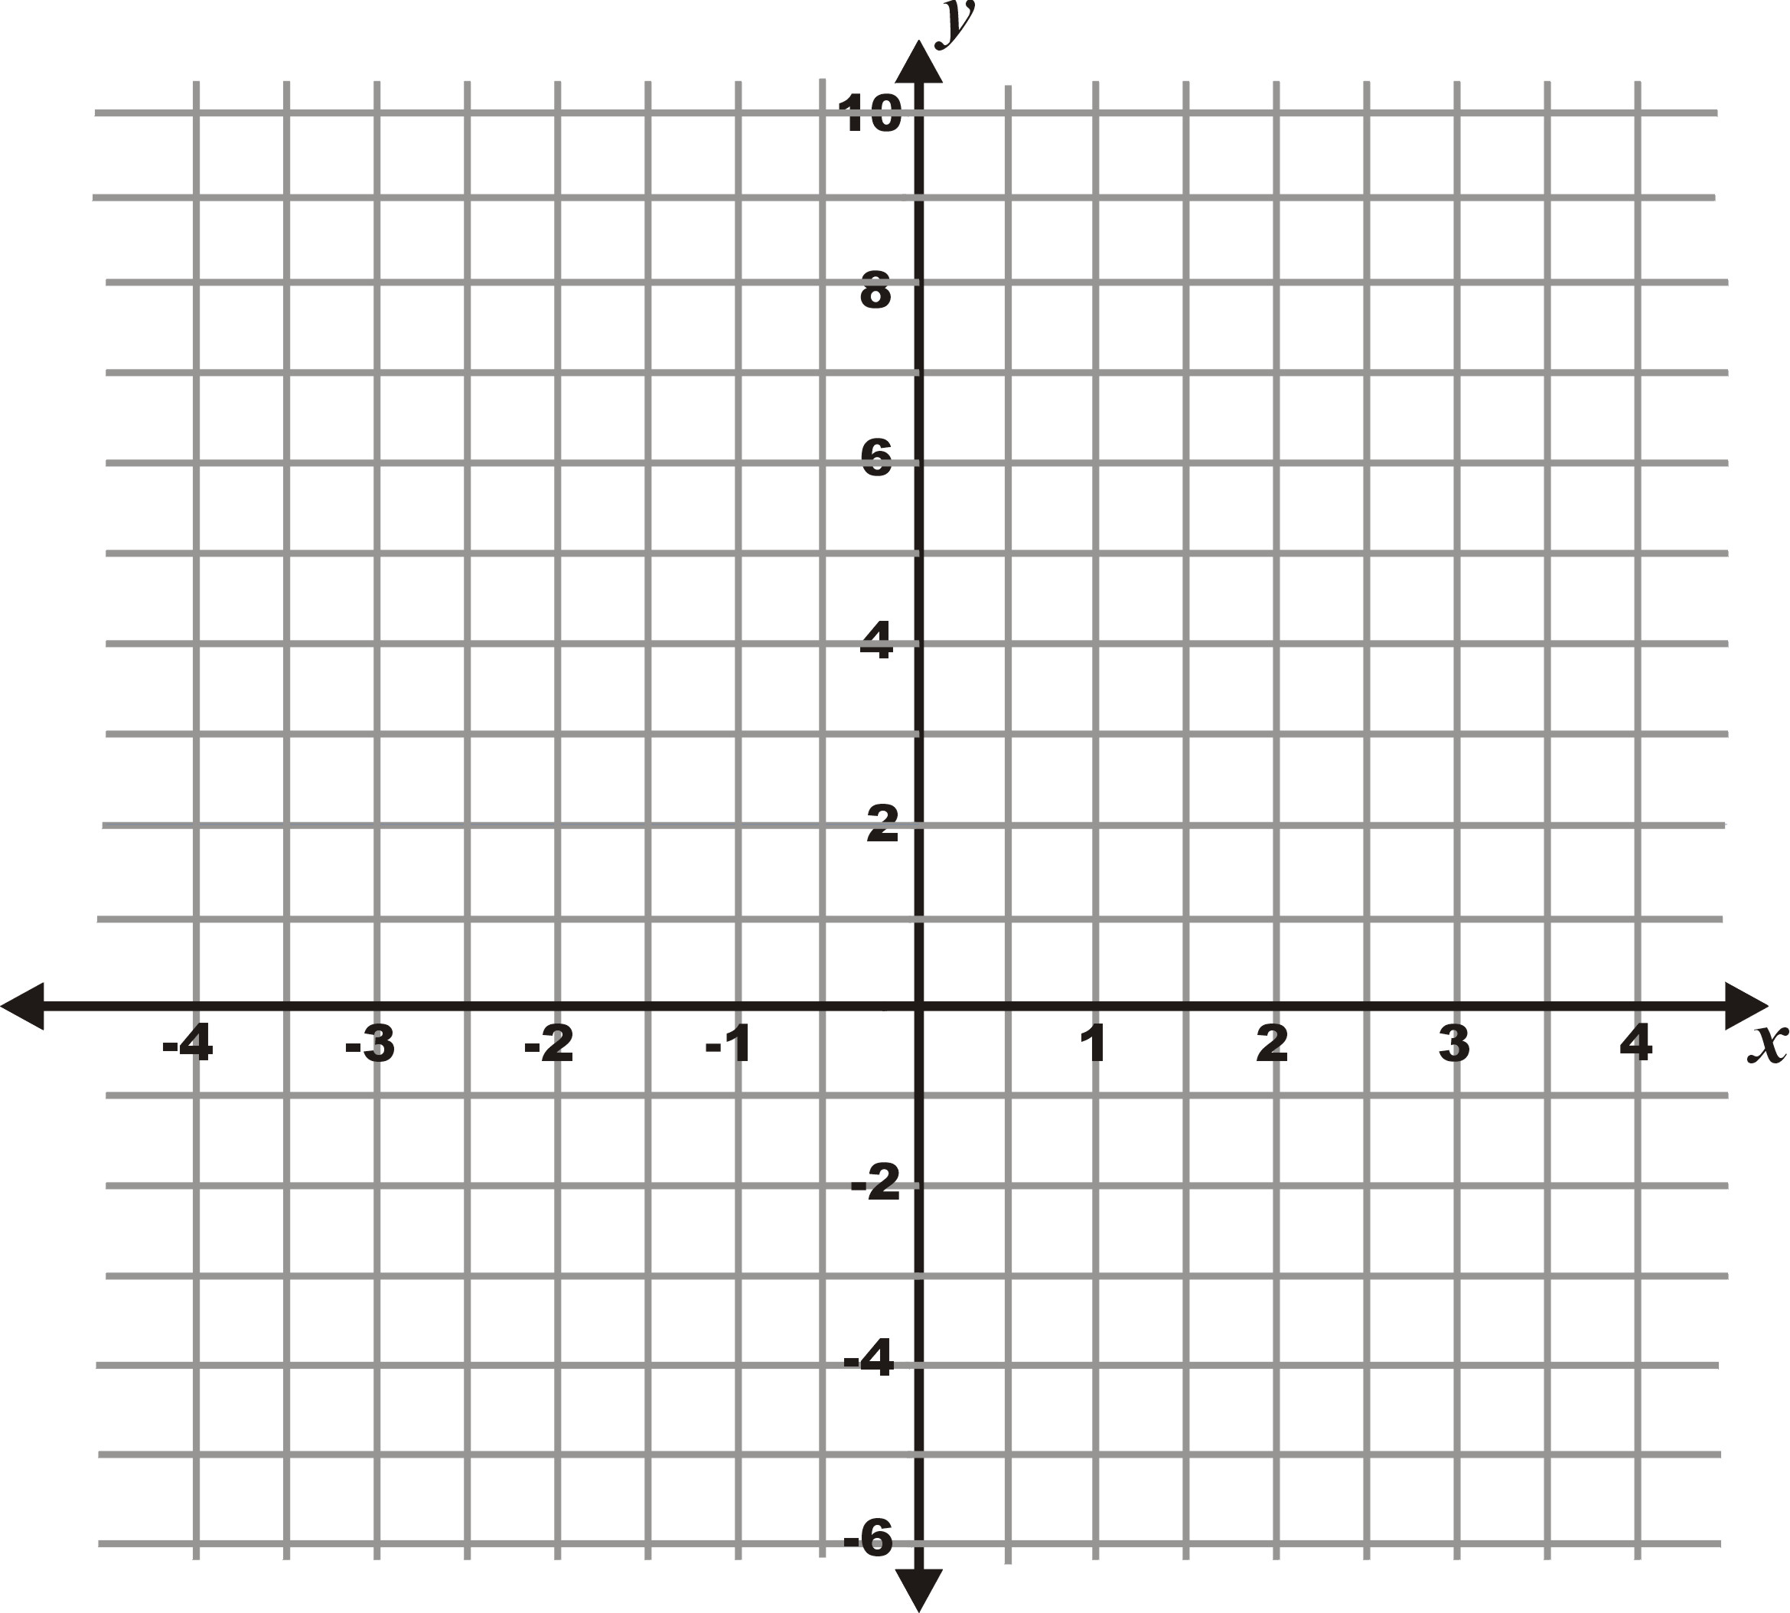
What is a Quadratic function
Any expression that has a term in x² as the highest power is called a quadratic function. e.g.
f(x) = x² + 3x +6
f(x) = 5x²
f(x) = (x+1)²

Functions, values and Ordered pairs.
To determine the value of y or f(x) recall that of f(x) means the value of the function f at the point x.

The value of f(x) = x² at x = 4 is given by
f(4) = 4² = 16
Therefore the ordered pair is given (4; 16)

x-value | y=f(x)=x² | Ordered pair
-3 | 9 | (-3 ; 9)
-2
-1
0
1
2
3

1.2 Properties of quadratic functions

Answer the following questions about the graph of the quadratic function you have drawn in activity 1.1 above.
- Does the graph have a turning point? How do you know this?
- Is the turning point a maximum or a minimum?
- Does the graph have asymptotes?
- Is the graph defined for all values of x?
- Is the graph symmetrical in any way?

  - Flipping, Shifting and Shrinking quadratic curves
Transformation of the Basic Quadratic Function, x²

Changing the signs, adding constant terms and multiplying by different co-efficient are all ways of transforming functions. These changes can be seen on a graph in the following ways.
- Flipping the curve upside down
- A horizontal shift along the x-axis.
- A vertical shift up the y-axis.
- A vertical stretch
- A horizontal stretch

Plot the quadratic curves below on the same set of axes as the one above using a table of values. Then answer the questions that follow.
- $$y=f(x)=−x^{2}$$
- $$y=f(x)=x^{2}+1$$
- $$y=f(x)=x^{2}−1$$
- $$y=f(x)=2x^{2}$$

- What happens to the curve of a quadratic function when the term in x² has a negative sign?
- What is the effect of adding a positive constant term to a quadratic expression?
- What is the effect of a negative constant term in a quadratic expression?
- What is the effect of multiplying the term in x² by a number greater than 1? (2 in this example)?

Activity 2
Graphing Quadratic functions by Factorisation

The general factorised form of the quadratic equation is

Note
The Factorised Form require that the co -efficient of x be one (1), this is obtained by taking out a as common factor in the given function equation on the right hand side.

f(x) = a(x - c)(x - d)

This activity is about using the coefficients, a, c and d to plot the significant points of the function on a set of axes. The method is simpler than using a tale of values if the function can be expressed in factorised form.

  - Plotting Quadratics from the factorised form.
Answer the questions below using the factorised form of the quadratic function and the coefficients a, c and d. Then use the information to plot the curve.

The coefficients and factors of the factorised form
a(x – c)(x – d)
a = +1
c = +4
d = –2

f(x) = x² - 2x – 8 or in factorised form
f(x) = (x – 4)(x + 2) and in standard form
f(x) = 1(x – (+4))(x – (– 2))

A The effect of a

The effect of a
The co-efficient of a comes from the term ax². If a is positive this term is always positive and it will dominate as x gets larger.
Therefore
If a>0, the curve has a minimum turning point and increases in a positive direction for both large negative and positive x-values.
Conversely,
If a<0, the curve has a maximum turning point and decreases rapidly in a negative direction for both large negative and positive x-values.

- Does the co-efficient a have a positive or a negative value?
- What does this tell you about the value of the function for very large negative x-values like f(–100) and very large positive x-values, say f(100)?
- What can you therefore say about the turning point? Will it be a minimum value or a maximum value?

B The x-intercepts or roots

The x-intercepts
c and d are the are values that make the function equal to zero:
f(c)=0, f(d) = 0

They will both therefore lie on the x-axis, since

y=f(x) =0
They are therefore called the x-intercepts.

- What is the value of c and d?
- Why are these called the roots of the function?
- What is the value of f(x) for x=c or x=d?
- Write down two points using ordered pair notation, that are given by the values c and d.
- What are these two points called?
The y-intercept.
- The y - intercept is calculated by setting x = 0
- This point must lie on the y-axis.

C The y-intercept.
- What is the value of f(x) when x=0?
- Where would this point be on a graph?
- What is it called?
The turning point.
- The quadratic function is always symmetrical about the line passing through the midpoint of the roots.
- The x-value of this point can be found by finding the average of the two values, i.e.
$$x_{\text{tp}}=\frac{c+d}{2}$$
- The y-value of the turning point can be fond by substitution:
f(x_{tp}) = f($\frac{c+d}{2}$)

D The turning point.
- What is the x - co-ordinate of a point that is exactly between the two roots (x-intercepts)?
- Why do think this value is relevant?
- What is the value of the function at this x-value?
- What do you call this point?
- Write down the co-ordinates as an ordered pair.
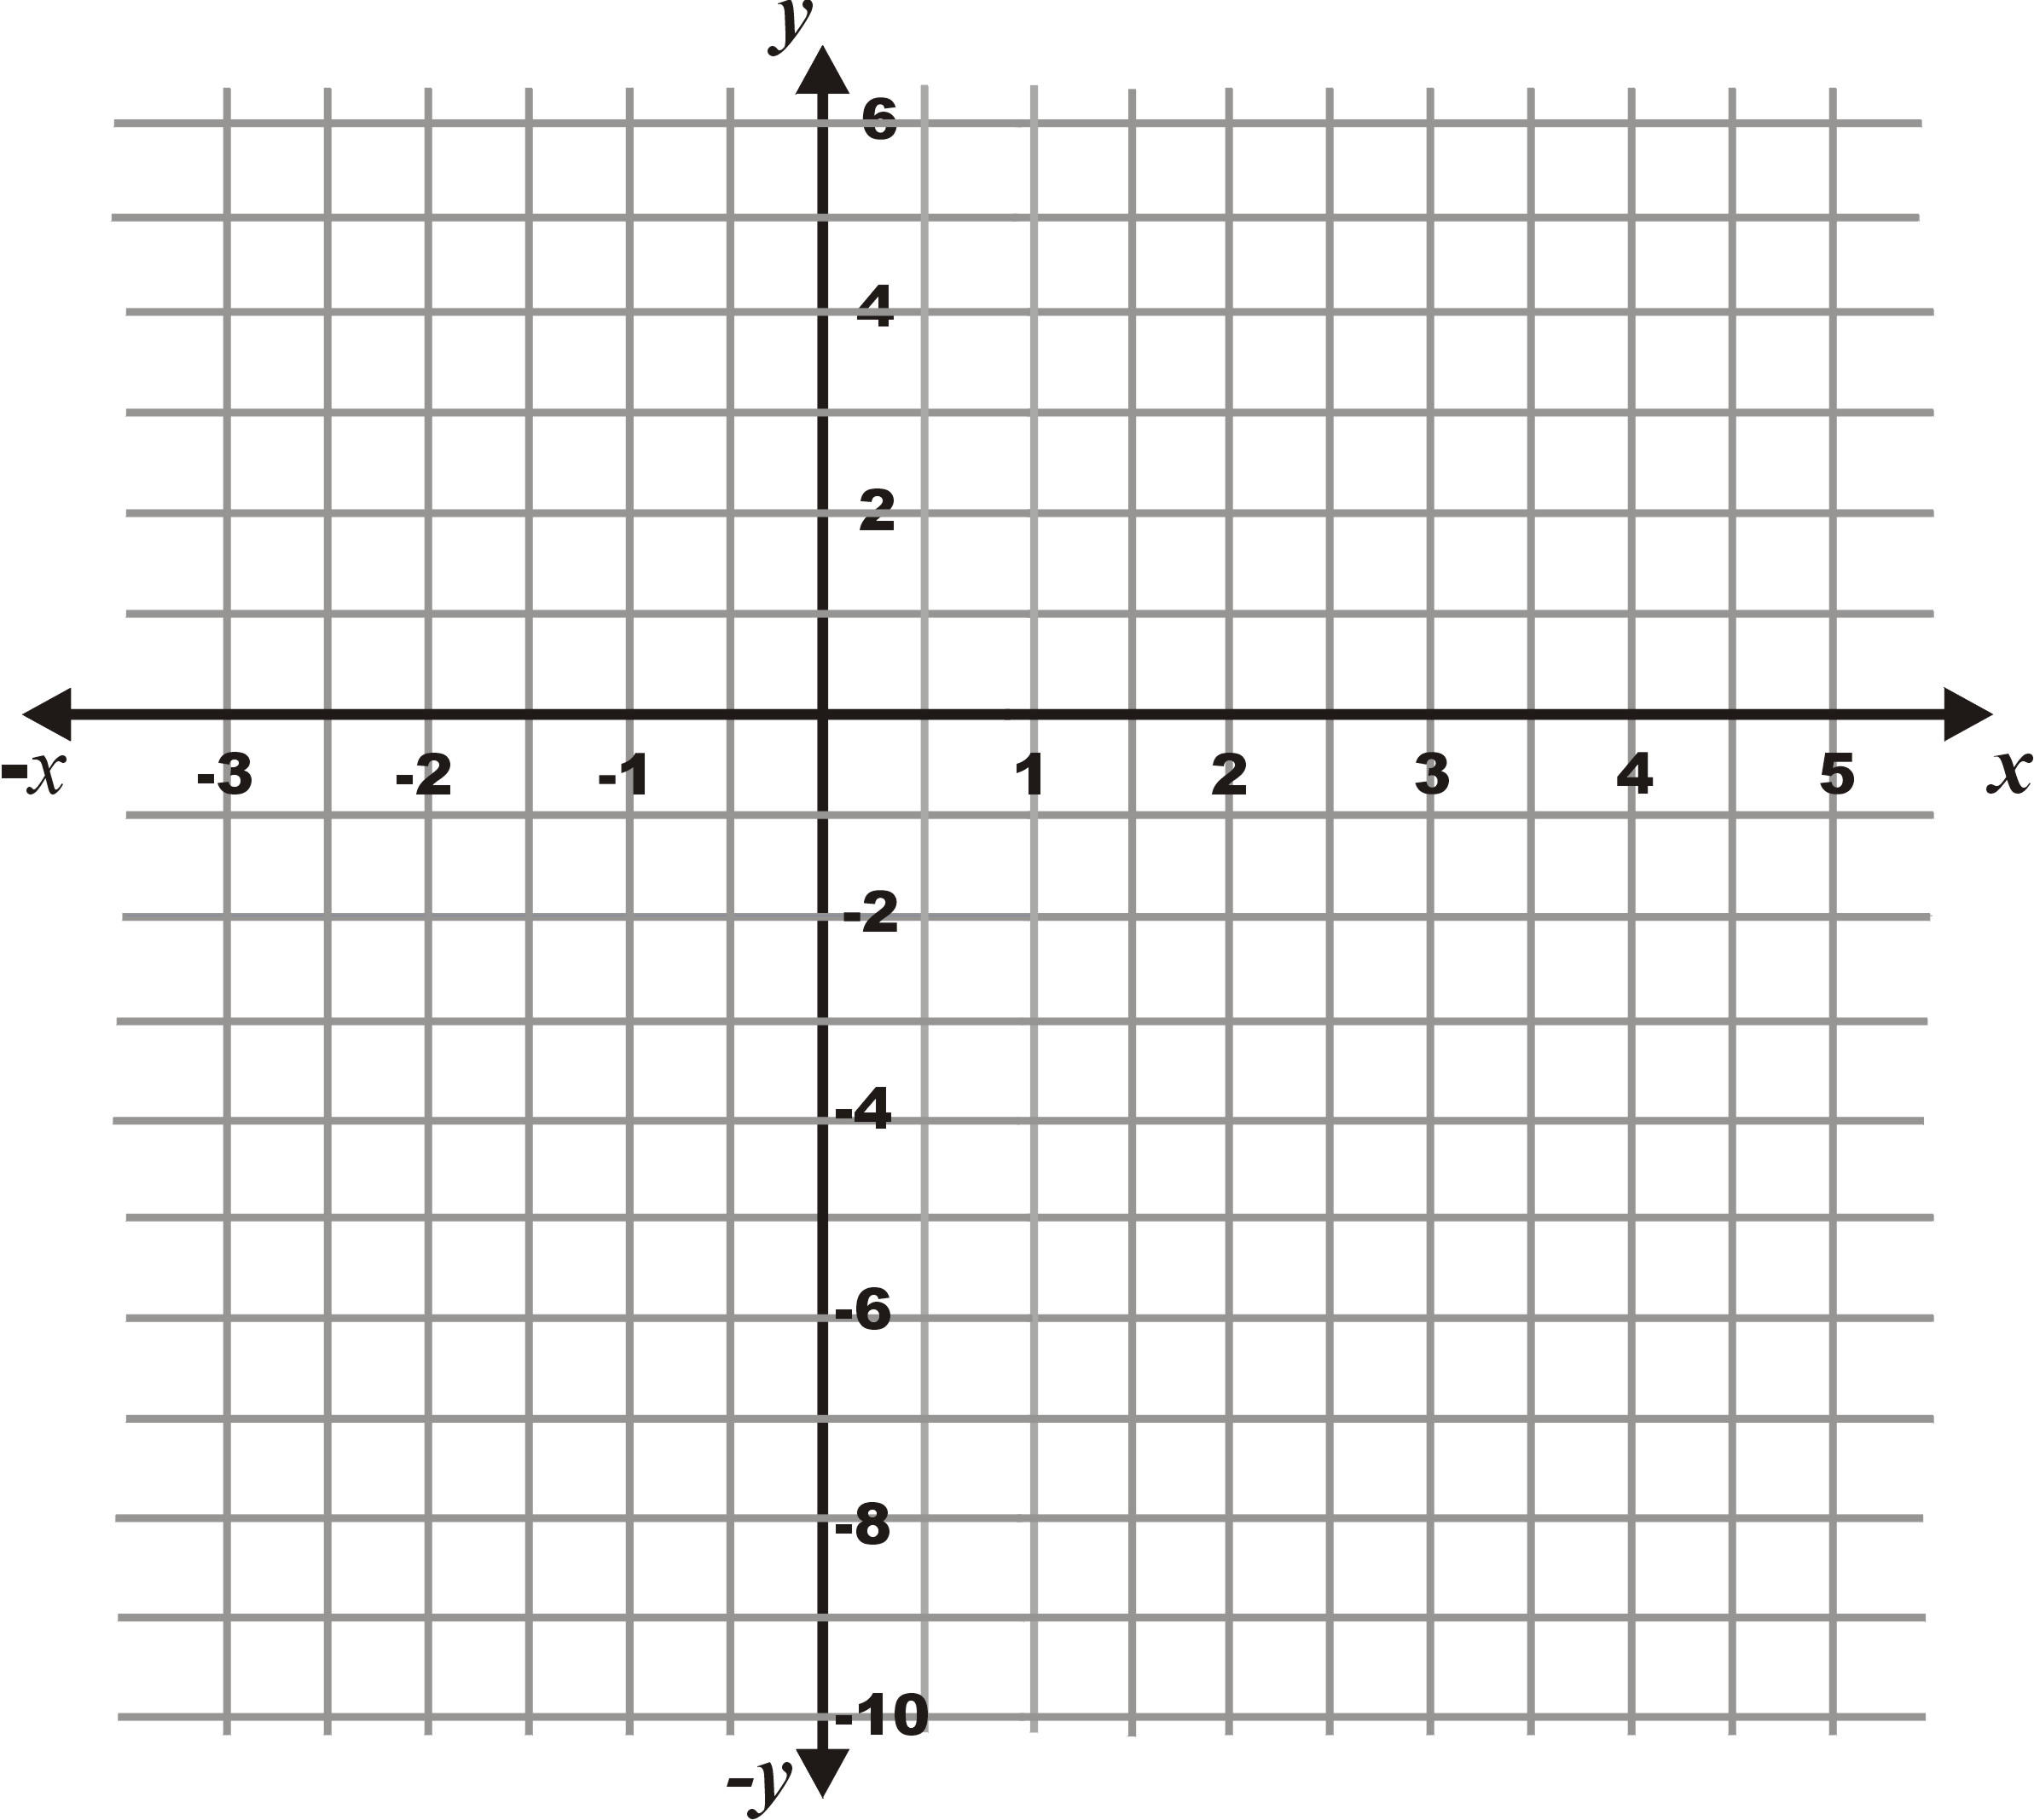
- Now use the information you have gathered to plot the curve.
f(x) = x² - 2x – 8
= 1(x – 4)(x + 2)

- What can you say about the slope of the curve at the turning point?
- Write down the co-ordinates of the point that is symmetrical to the y-intercept, i.e. has the same x-co-ordinate as the y- intercept but lies on the other side of the curve.

  - Plotting Quadratic curves using the factorised form.

A Factorise the quadratic functions below, then plot the curves using the properties that can be identified from the co-efficients of the factorised form.

- f(x) = -2x² + 2x + 4

- f(x) = x² +2x – 3

2.3 The flight of the basket ball.

A basketball player is 2m tall and throws a ball at a basket with an initial velocity of 8m.s⁻¹ at an angle of 60⁰. The table of values below shows the path that the basketball follows.

Plot the curve on a set of x-y axes, then answer the questions that follow.
- Why do you think this might be a quadratic function?
x position of ball (distance) | y-position of ball (height)
0 | 2.0
0.5 | 2.6
1 | 3.0
1.5 | 3.1
2 | 3.0
2.5 | 2.6
3 | 2.0
3.5 | 1.1
4 | 0

- If the ball goes through the hoop, what is the height of the hoop and how far away if the player standing?
- What is the y-intercept?
- How far is the basketball pole from the thrower?
- How far away from the pole would the ball land if it didn’t get deflected?
- Use the information above to write down one root of the function.
- If you assume the function is quadratic, write down the negative root of the function.
- What would the sign of a be if you were to write the function in the form a(x-c)(x-d)
- What value of a would you need to use to give a y-intercept of 2? a(-c)(-d)=2?
- Write down the function in factorised form that descries the path of the ball.
- Write down the expression in expanded form.

Activity 3

Factorising quadratics by Completing The Square

The method of completing the square is sometimes used when the roots of a quadratic equation cannot be obtained by simple factorisation. It is also used to solve quadratic equations. This method is based on the fact that any quadratic equation may be written in the from:

(x - p)² + q , where p & q are real numbers. ,

This activity will help you to use the completing the square method to factorise a quadratic function so that you can then plot the curve.

The co-efficients and constants
f(x) = x² + 8x + 9
a=1
b=8
c=9
3.1 Factorising by completing the square.

Use the procedure below to factorise the function
f(x) = x² + 8x + 9 by completing the square.

A Completing the square and identifying the turning point.

Completing the square
Group the first two terms of the function together using brackets and write it in the form: f(x) = (x² + bx) + c
Complete the square of the term in brackets by dividing the co-efficient b by 2 and then squaring .
Then subtract the added term outside the bracket:
Write the function in the form
(x - p)² + q

- Write down the function f(x)= x² + 8x + 9, so that the terms in x² and x are grouped together.
- What is the y-intercept of the function? Write it down
- What is the value of the b or the coefficient of x?
- Calculate the value p =$\frac{b}{2}$. This value completes the square. Check that this is so by finding the product:
(x + $\frac{b}{2}$) (x + $\frac{b}{2}$) or (x + $\frac{b}{2}$)²
- In completing the square you have added a constant term to the expression. What is the value of the constant term you have added? What will you need to do to the function to compensate for adding this term?
- Write down the function in the form f(x) = (x - p)² + q, where q is the new constant term found by combining the original constant and the constant added when completing the square.

B Identifying the turning point and the axis of symmetry.
- Identify and write down the y- co-ordinate of the turning point of the function x² + 8x + 9 using the value of q you calculated in part A above.
Identifying the turning point
The value of q gives the y-co-ordinate of the turning point.
y co-ordinate = q
The value of p tell you the x-co-ordinate of the turning point.
x - co-ordinate = p
- Write down the x-co-ordinate of turning point.
- This value describes an axis of symmetry? What do you understand by this?
- Plot the turning point on a set of axes like the one below and draw in the axis of symmetry.
- Plot the y-intercept.
- Plot the point that is symmetrical to the y-intercept on the opposite side of the axis of symmetry.

C Identifying The roots of the equation

Equations and square roots

If $x^{2}=a$then you will need to find a square root to find x. i.e.
$$x=±\sqrt{a}$$
Note there are two solutions because $(−\sqrt{{a)}^{2}}$and $(+\sqrt{{a)}^{2}}$will both equal a.

- Set f(x) = 0 and substitute the values for p and q (from part A above) into the equation below.
f(x) = (x - p)² + q = 0 or (x - p)² = -q
- How many solutions are there to an equation of the form $x^{2}=a$? Why is this?
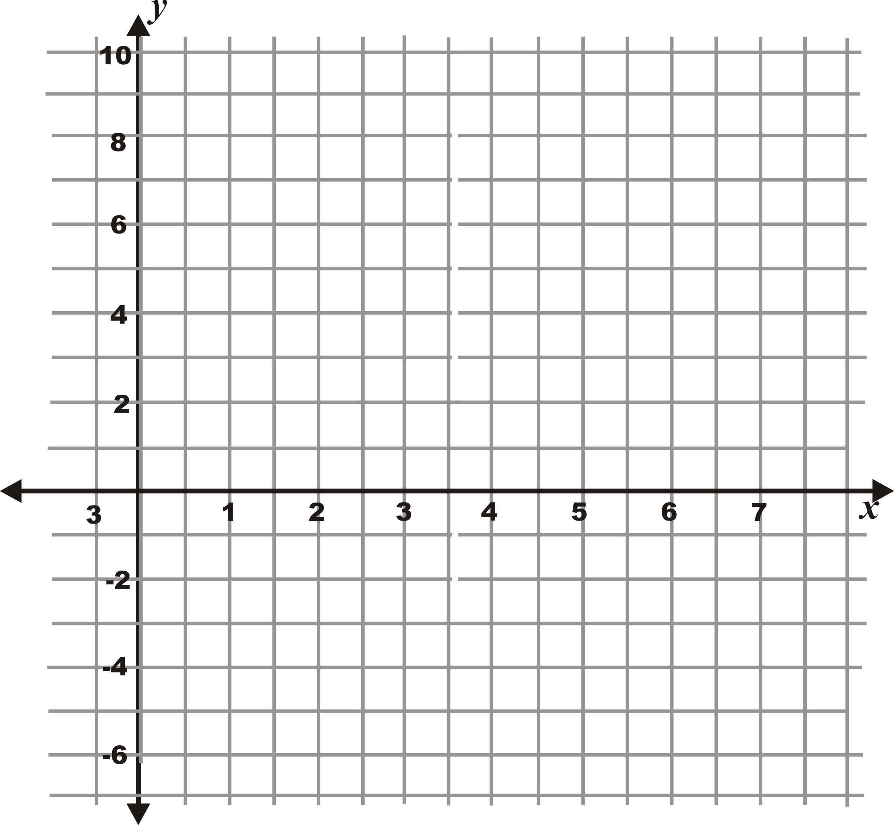
- What do you have to do to remove the square?
- Solve the equation in 1 above and write down the two roots, as ordered pairs, to two decimal places. $x=±\sqrt{a}$
- Plot these two additional points on the axes, then sketch the curve that represents the function.

3.2 Factorising by completing the square.

Factorise the examples below by completing the square. Then draw rough sketches of the functions on a set of x-y axes.

- f(x) = x² - 6x + 5
- f(x) = x² - 6x + 6
- f(x) = 2x² - 12x + 10
- f(x) = 3x² - 5x + 2

3.3 Factorising using the quadratic formula

If you complete the square on the standard form of the equation, f(x) = ax² + bx +c directly then you get a generic formula that can always be used to determine the roots of a quadratic function or to solve a quadratic equation.

The quadratic formulae

1. x = - b ± $\frac{\sqrt{b^{2}−4\text{ac}}}{2a}$ Gives the roots of the function, i.e. f(x) = 0
2. x = $\frac{−b}{2a}$ = x - co-ordinate of the turning point ( Axis Of Symmetry)
3. y = $\frac{−(b^{2}−4\text{ac})}{4a}$ = y - co-ordinate of the turning point

This can be used when the roots of an equation cannot be obtained through simple factorisation.

The formula can also be used to identify the axis of symmetry (x -co-ordinate of the turning point) for a quadratic function and the y - co-ordinate of the turning point.

These equations are very useful and can often be used when you are having difficulty finding the roots of quadratic functions.

Completing the square summary

Any quadratic function f(x) = ax² + bx +c can be written as

f(x) = a(x - p)² + q

The properties of the function can be found from this form as follows:

1. If a>0, the curve has a minimum turning point.
If a<0,the curve has a maximum turning point.

- The x - co-ordinate of the turning point is given by p.

- The y - co-ordinate of the turning point is given by q.

4. The x - intercepts are calculated by setting f(x) = 0, and factorising the
resulting quadratic equation.

5. The y - intercept are calculated by setting x = 0.

Activity 4
Plotting and Transforming Graphs

4.1 Plotting quadratic functions.

Sketch the graph of the following quadratic functions using any of the above methods.

- f(x) = x² - 2x - 8

- f(x) = 2x² - 12x + 10.

- f(x) = 2x² + 4x - 6.

- f(x) = -x² - x + 2

- f(x) = -x² +2x + 8

- f(x) = 4 x² - 4x + 1

4.2 Transforming quadratic functions.

In this activity you will see how small changes to the basic quadratic function, f(x) = ax² changes the shape of the curve that you plot.

This is called transformation of graphs. It refers to the stretching and shrinking of curve shape and the horizontal and vertical shifting of position relative to the x and y axes.

Draw the graph of the following functions on the same set of axes. Then answer the questions that follow.

f(x) = x²
f(x) = x² + 1
f(x) = 3x²
f(x) = x² - 1

$$f(x)=\frac{1}{4}x^{2}$$

- What happens to the basic function f(x) = x² when it is multiplied by 3?
- What happens when the basic function f(x) = x² is multiplied by $\frac{1}{4}$?
- What will happen to the basic function if it is multiplied by -3 or $\frac{−1}{4}$
- What is the axis of symmetry and turning point of these graphs.

- What is the effect of adding +1 to the basic function f(x)=x² ?

- What is the effect of adding -1 to the basic function f(x)=x² ?

- What is the axis of symmetry and turning point of these graphs?

Now plot the curves of f(x) = (x - 1)² and f(x)) = (x + 1)²

- What is the effect of the -1 on the graph?

- What is the effect of the +1 on the graph?

- What is the axis of symmetry and the turning point of these graphs?

Activity 5
Exploring the Absolute value function
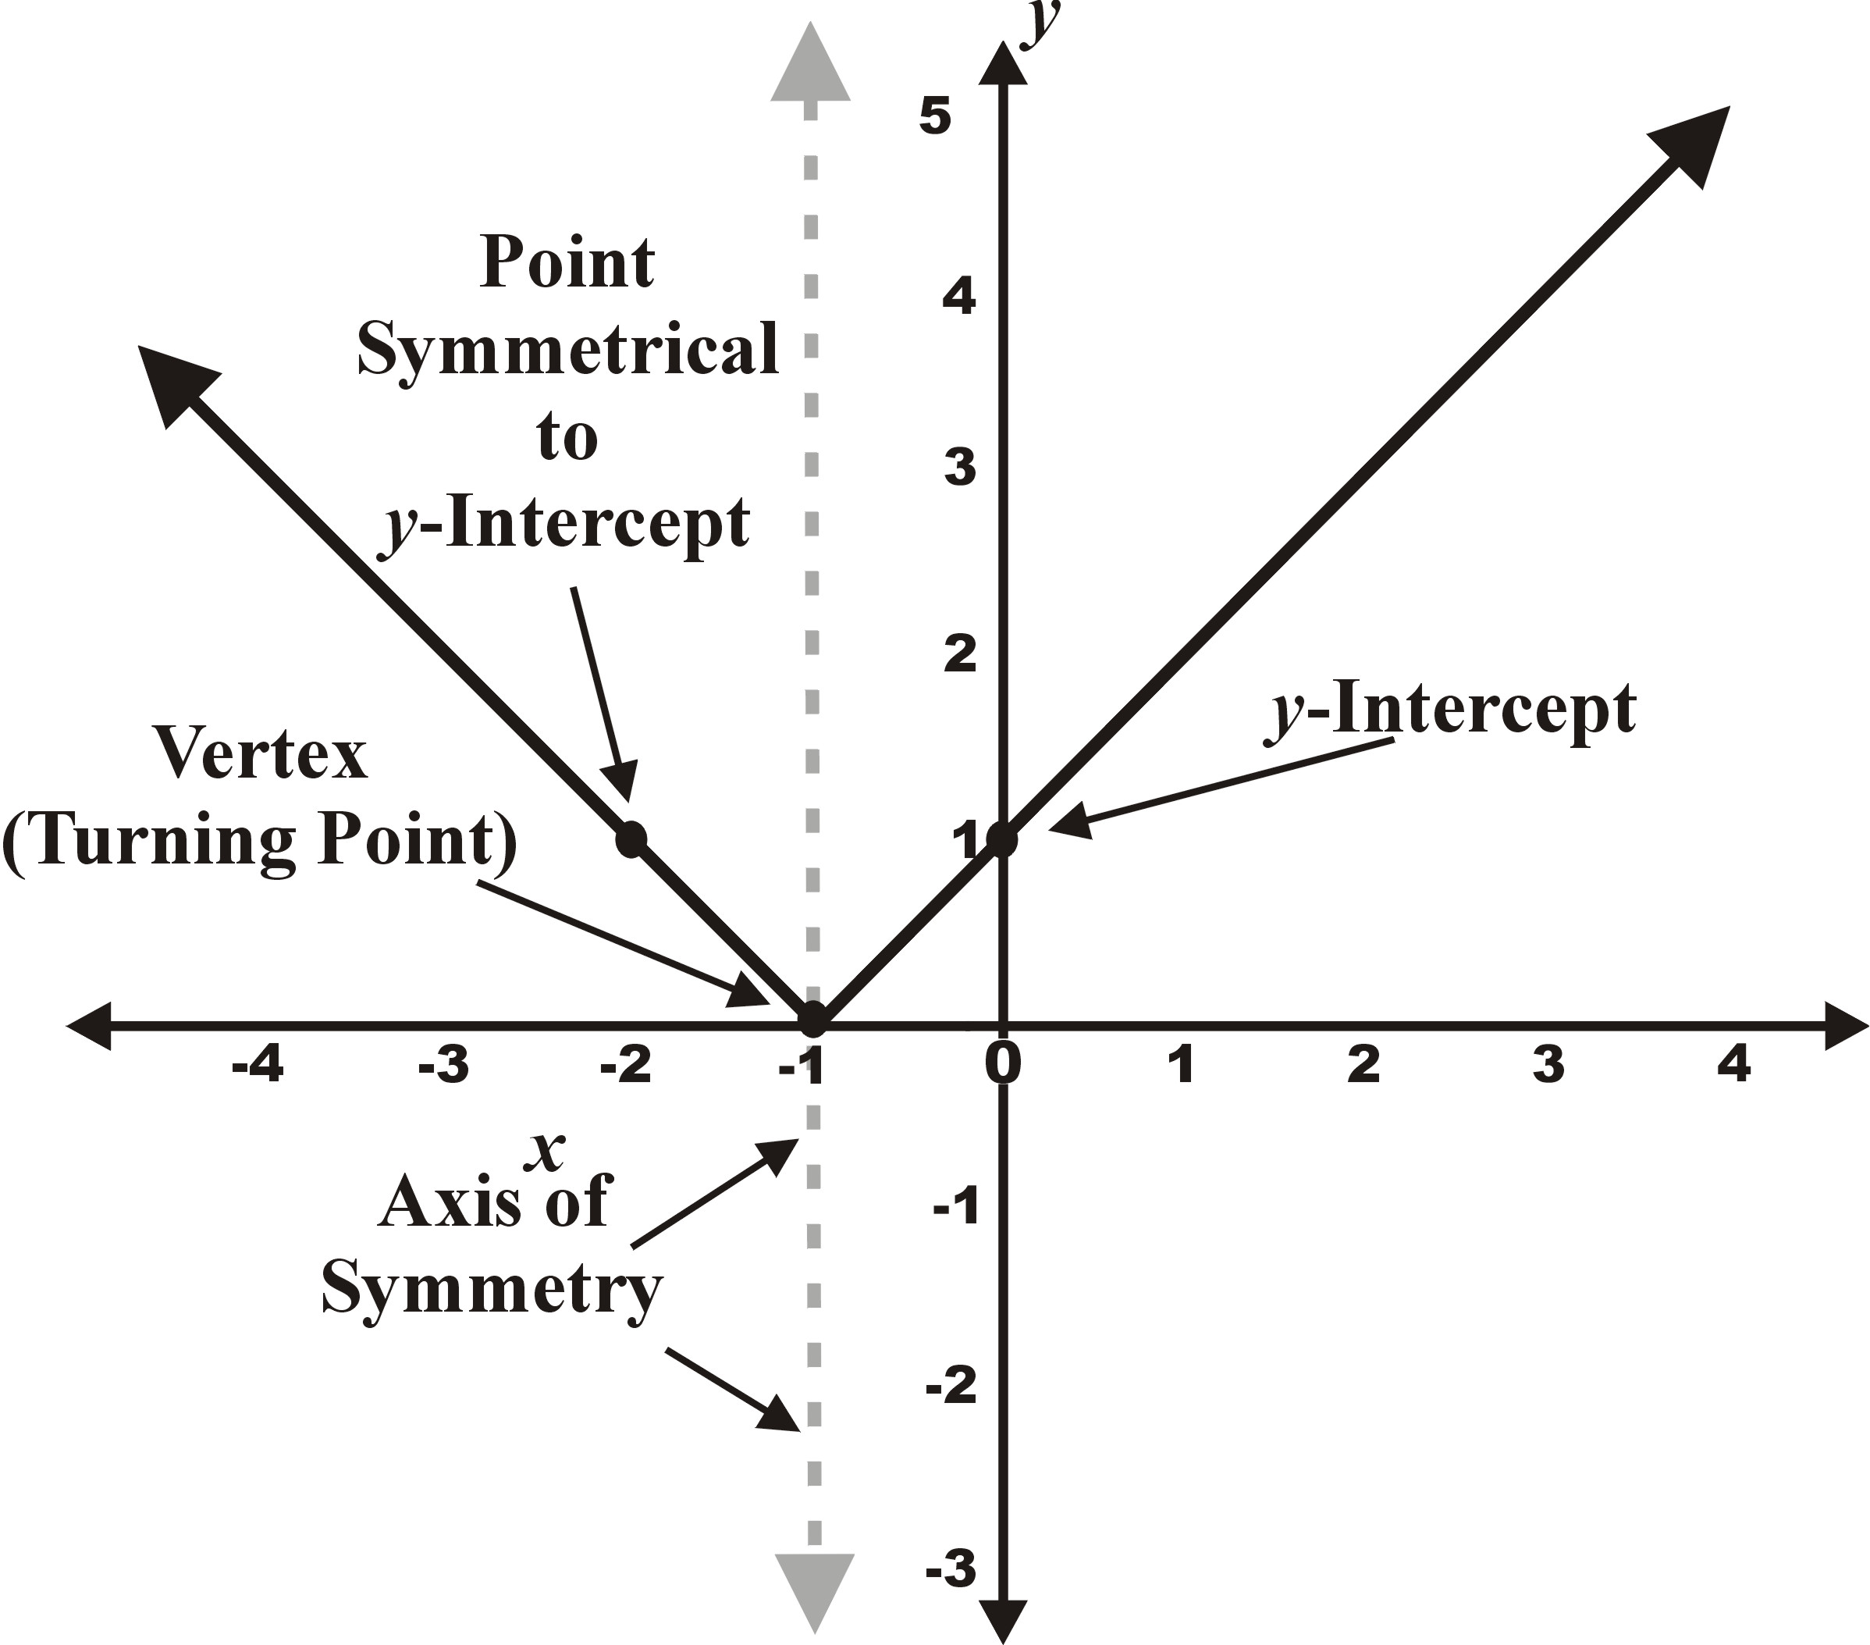
In this activity you will be exploring the properties of the absolute value function and what it looks like when you sketch it.
The absolute value or the modulus of a number is simply the “magnitude” of that number which is equal to the positive value. The absolute value of an algebraic function is also the “magnitude” of that expression. It cannot always be represented by simply changing the sign of the negative range of the expression.
What is an Absolute value
If a number is positive, its absolute value is the number itself. For example, |5| = 5
If a number is negative, then its absolute value is the additive inverse of the number. For example, |-8| = 8

x|x|-22-11001122
5.1 Finding the absolute value of some numbers.
Find the absolute value or the modulus of the following numbers.
| -15|, - |- 9|, |- 6 – 8|, |$\sqrt{2}$ - $\sqrt{3}$|, |5 – b| if b > 5
Solve for x:
|x| = |-5|, |-x| = 4, |2x| = |-7|, |3 – 2x| = 4

5.2 Exploring the graphs of absolute value functions.
x | -3 | -2 | -1 | 0 | 1 | 2 | 3
f(x)
g(x)

A Use the table values shown to sketch the graph of y = f(x) = x and y = g(x) = -x on the same set of axes. Then answer the questions below.

What is the domain for both graphs.

Write down the range for these two graphs?
- Draw the graph with the range restricted to y ≥0
- Describe the shape of the graph obtained.
- What can you say about the value of the range (y) for any real value of the (domain) x?

Can the distance between two points be represented by this graph? Why?
B Now draw up a table of significant values, like the one shown and sketch the graph of the absolute value function, y = f(x) = $\left|x\right|$ on the same set of axes. Then answer the questions below.
x | -? | -3 | -2 | -1 | 0 | 1 | 2 | 3 | +?
f(x)= $\left|x\right|$

- What is the domain of f(x)?

- What is the range of f(x)?

- What is the equation describing the range y

- What is the shape of the graph?

- Does the graph have symmetry? If so, about which point?

- Is there a turning point?

Properties of the Absolute Function
- If x > 0, then f (x) = |x| = x, (therefore the graph of f will be given by y = x).
- If x <0, then f (x) = |x| = -x (therefore the graph of f will be given by y = -x.
- Its domain is the set of all real numbers and the range consists of the set of all non-negative numbers.
- The function has a turning point.
- The function is symmetrical about the turning point.

5.3 Transformation of the basic absolute value function.

The basic absolute value function, f(x) = |x| can be transformed in a number of ways to help to sketch the graphs of more complicated functions. The activities below will help you to investigate the effect of these transformations.

The following transformations will be investigated using the basic function f(x) = |x|; x ∈ Z.

- Vertical shift
- Horizontal shift
- Vertical stretch
- Vertical shrink

A Use the table to plot graphs of the functions below on the same set of axes.

- f(x) = |x|,
- g(x) = |2x|,
- h(x) = | $\frac{1}{2}$x |,
- t(x) = |x| - 1,
- q(x) = |x - 1|

x | |x| | |2x| | | $\frac{1}{2}$x | | |x| - 1 | |x - 1|
-3 | 3 | 6 | $$\frac{3}{2}$$ | 2 | 4
-2
-1
0
1
2
3

B Now compare each of the graphs you have just drawn to the basic absolute function graph, f(x) = |x|.

- Which function has a graph that is a vertical stretch of the graph of f (x) = |x|;
- Which function has a graph that is a vertical shift of the graph of f (x) = |x|?
- Is the vertical shift upward or downward?
- Which function has a graph that is a vertical shrink of the graph of f (x) = |x|?
- Which function has a graph that is a horizontal shift of the graph of f(x) = |x|;?
- Is the horizontal shift left or right?

C The activity 1 and 2 provided you with the opportunity to investigate certain patterns. A pattern opens an opportunity to make mathematical generalisations.

Use your observations above to compare the functions in the table below to the basic function f(x) = |x|, and to make generalisations about the absolute value function

Function example | General form | Type of transformation from the basic function.
g(x) = |2x| | f(x) = |ax| | Vertical - stretch or shrink
t(x) = |x| - 1,
q(x) = |x - 1|

Activity 6

Sketching Absolute Value Functions

In this activity you will using the properties of absolute value functions to help you to plot and sketch curves. You will come across some new words describing properties of these graphs and they will be fun to learn, understand and use. The graph has a V-shape for example so the turning point is called a vertex.
General forms of the equations:
1. y = f(x) = |ax|
2. y = f(x) = |x - a|
3. y = f(x) = |x| - a

6.1 Identifying properties and plotting curves.

Use the properties highlighted in the boxes to answer the questions about the absolute function below. Then plot the function on a set of axes.

y = f(x)= |x - 2|

A Identifying general properties
- What is the domain of x ?
- What can you say about y because the whole expression is an absolute value?,
- What is the range of y?
- What can you say about the minimum value of y?
- What is the y-intercept or the value of the function when x=0
The Vertex, Turning point or Salient Point
y = |x - a| means that:
- y ≥ 0
- y = 0 when x = a
- (a; 0) are the co-ordinates of the vertex of the graph of y = |x - a|
- The point at the vertex i.e. (a; 0) is called the salient point of the graph!
- The graph is symmetrical about
this point.

B Identify the Vertex
- What is the value of a for this example?
- What does this value tell you?
- Write down the co-ordinates of the vertex as an ordered pair.
- Plot this value on a set of axes.
- Draw in a line of symmetry.
- Plot the value that you can find from the y-intercept because of symmetry.
- Sketch the curve of the function.
In general for y = |x - a|, if a>0. The vertex lies a - units along the x - axis to the right and if a < 0, e.g. f(x) = |x + 2|, the vertex lies a units along the x -axis to the left.

6.2 Absolute Value Function Curves

Use the significant properties of the absolute value functions to plot the curves of the functions below.

- y = |3x |

- y = |x + 1|

- y = |x | - 2

- y = |2x-1|

Label all your graphs and show the co-ordinates of the Salient Point or the Vertex. the y-intercept and the axis of symmetry.

6.3 Inequalities involving Absolute Values
Absolute values and Inequalities

1. |x| = a means x =a or -x = a

- |x - a| ≥ 3 means (x - a ) ≥ 3 or (-x +a ) ≥3, i.e.
x ≥ a+3 or x ≤ a-3

Inequalities involving Absolute values can easily be identified from the absolute value graph. Remember that often an inequality involving absolute values will have two separate ranges.

Use the graphs in 6.2 above to identify the domain and the range of values that satisfy both the conditions below.

- y = |3x | , y ≥ 6

- y = |x + 1|, y ≤ 5

- y = |x | - 2, y ≤ 6

- y = |2x-1| , y ≥ 2

