Trigonometry | Unit 1 | Triangles to Measure


WHAT THIS UNIT IS ABOUT

In this unit you will learn how the triangle can be used to calculate the height of tall buildings that are difficult to measure using a tape measure.

This method is the basis for the mathematics topic called Trigonometry. A trigon is a triangle and metry means to measure. Trigonometry is a whole area of mathematics that was started by people wanting to measure long distances.

This activity is based on the principle that you see things in straight lines or that light travels in a straight line. You will be lining your eyes up with some measuring sticks to make a straight line to a point on the ceiling. You will then work out the height of the ceiling by measuring along the ground, which you can reach.

You will then learn how to use the proportion of triangles to calculate the height using the measurements along the ground.

In this unit you will:

- Work effectively as a group to set up and measure the height of a ceiling using the “line of sight” principle and the proportions of right angled triangles.

- Draw and label a diagram of your measurement set-up with the measurements you have collected.
- Use fractions to calculate the height of the ceiling using the principle of proportion.

- Make general conclusions about all right angled triangles with the same angle of elevation.

Activity 1

Measuring the height of buildings
Did you know that the word Trigonometry means measuring using triangles.
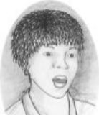
In this activity you will be using some of the properties of triangles to measure the height of buildings without ladders or climbing equipment.

1.1 Collecting the Measurements.

- Organise your group into the following people. Make a label for each member using the letters shown in brackets and stick them on as badges.

You will Need

- A tape measure
- 2 measuring sticks (1m)
- 1 measuring stick (1.5m)
- String (4m to 6m)

- A straight line sightor, (SLS)
- A 1m measuring stick manager. (MSM)
- One 1.5m measuring stick manager. (MSM)
- One length measurer. (LM)
- A scribe to write it all down. (SCRIBE)

- Your educator will tell you which point on the ceiling to measure the height. Move to the wall underneath your measuring point.

- Collect the equipment you will need from your educator. If you are the scribe, make sure you have paper and a pen or pencil.

- The 1m MSM should take one end of the string and hold it against the wall at a height of exactly 1m.

- The SLS should take the other end of the string and a 1m measuring stick and walk away from the wall (at 90⁰) until the string is tight. (between 4 and 6 m away).

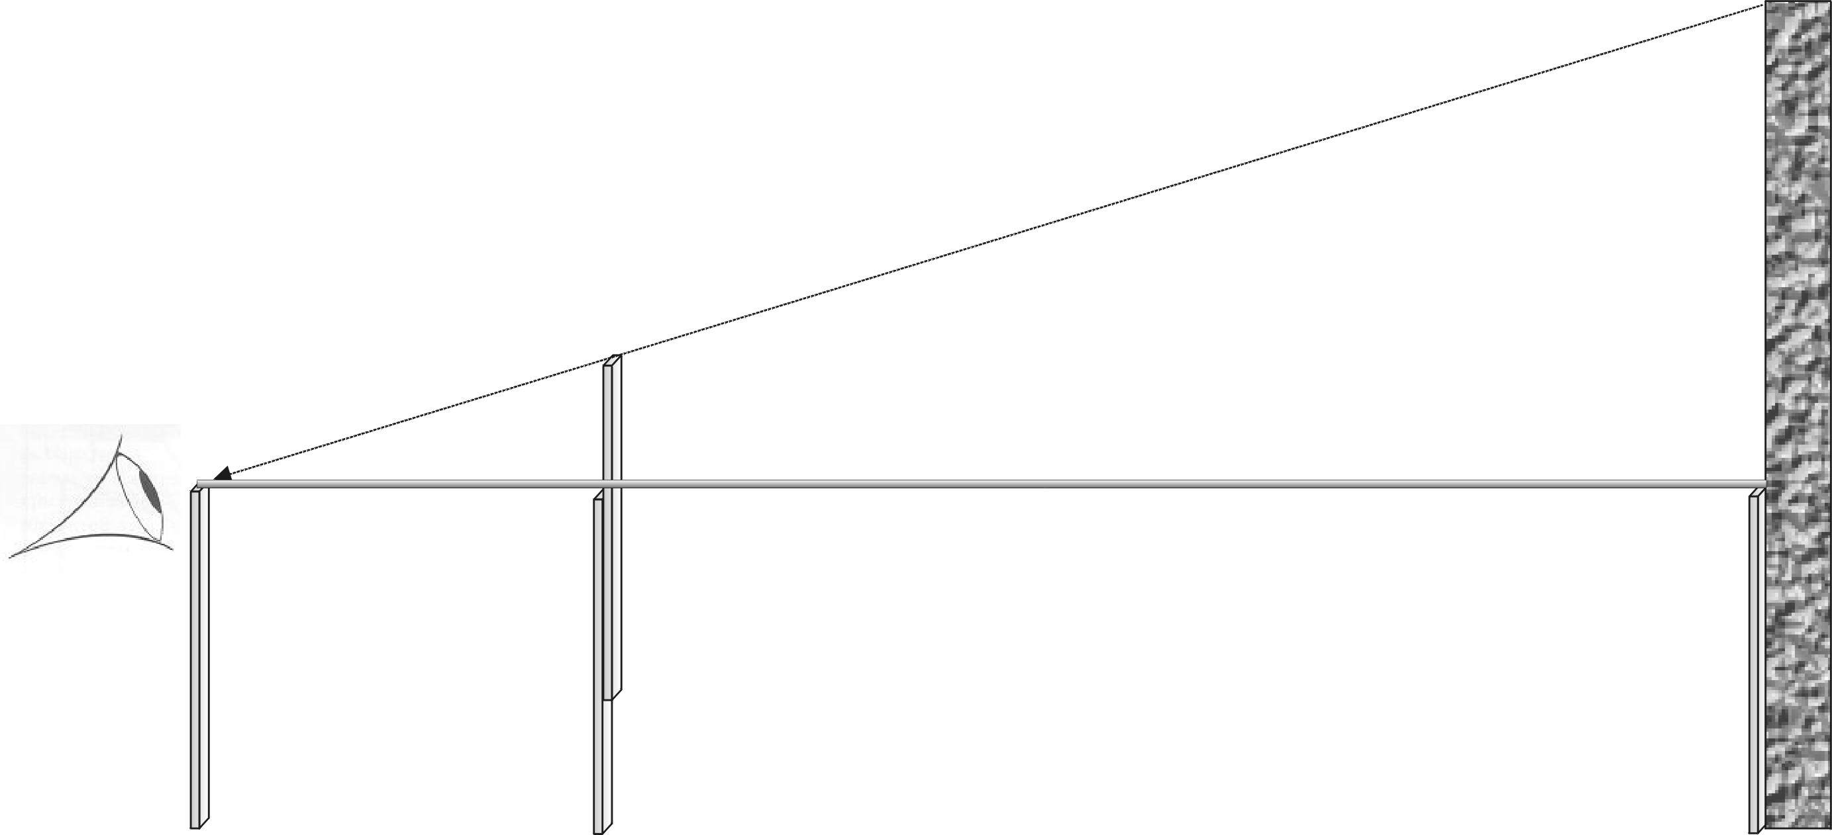
- (SLS) Using the measuring stick, hold the string at exactly 1m above the ground, then crouch down and place your best eye, as close to the end of the stick (and the top of the string) as you can. Make sure that you can see your point on the ceiling.
P

- The 1.5m MSM should move the 1.5m measuring stick along the string until the SLS sees the top of the stick exactly in line with your point on the ceiling.

SLS
1.5m MSM
String
- (1.5m MSM) Make sure that your stick is straight and touching the ground. Check with the SLS that she or he sees the point on the ceiling lining up with the top of both sticks.

- (1m MSM) check that the string is exactly 1m above the ground all the way along its length.

- The LM should give the SCRIBE the end of the tape to hold against the wall.
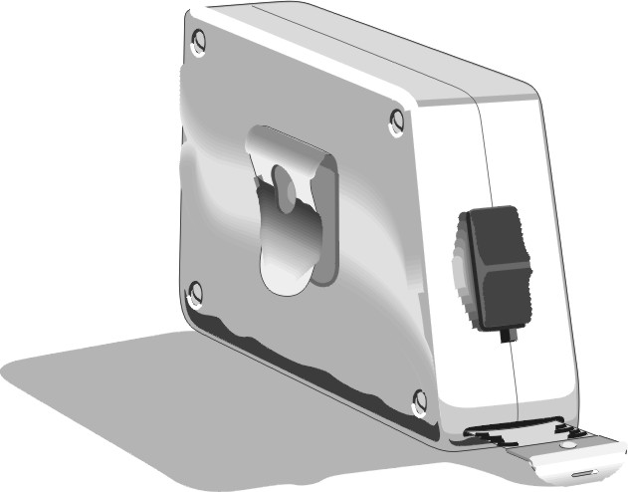
- The LM should measure the distances as follows. The MSM should again check that the measuring sticks are straight.
- From the wall to the base of the 1.5m measuring stick.
- From the wall to the base of the 1m stick being held by the SLS

- The SCRIBE should note these measurements down.

- Return to your groups. Make a diagram of the measuring arrangement and mark the following measurements onto your diagram.
- The distance from the wall to the 1.5m measuring stick.
- The distance from the wall to the base of the stick used by the SLS.
- The heights from the floor to the top of the 1m stick.
- The height from the floor to the top of the 1.5m stick.
- The height from top of the 1.5m stick to the top of the string.

- Check your diagrams and make sure you all agree.

$P_{c}$1.2 The angle of elevation
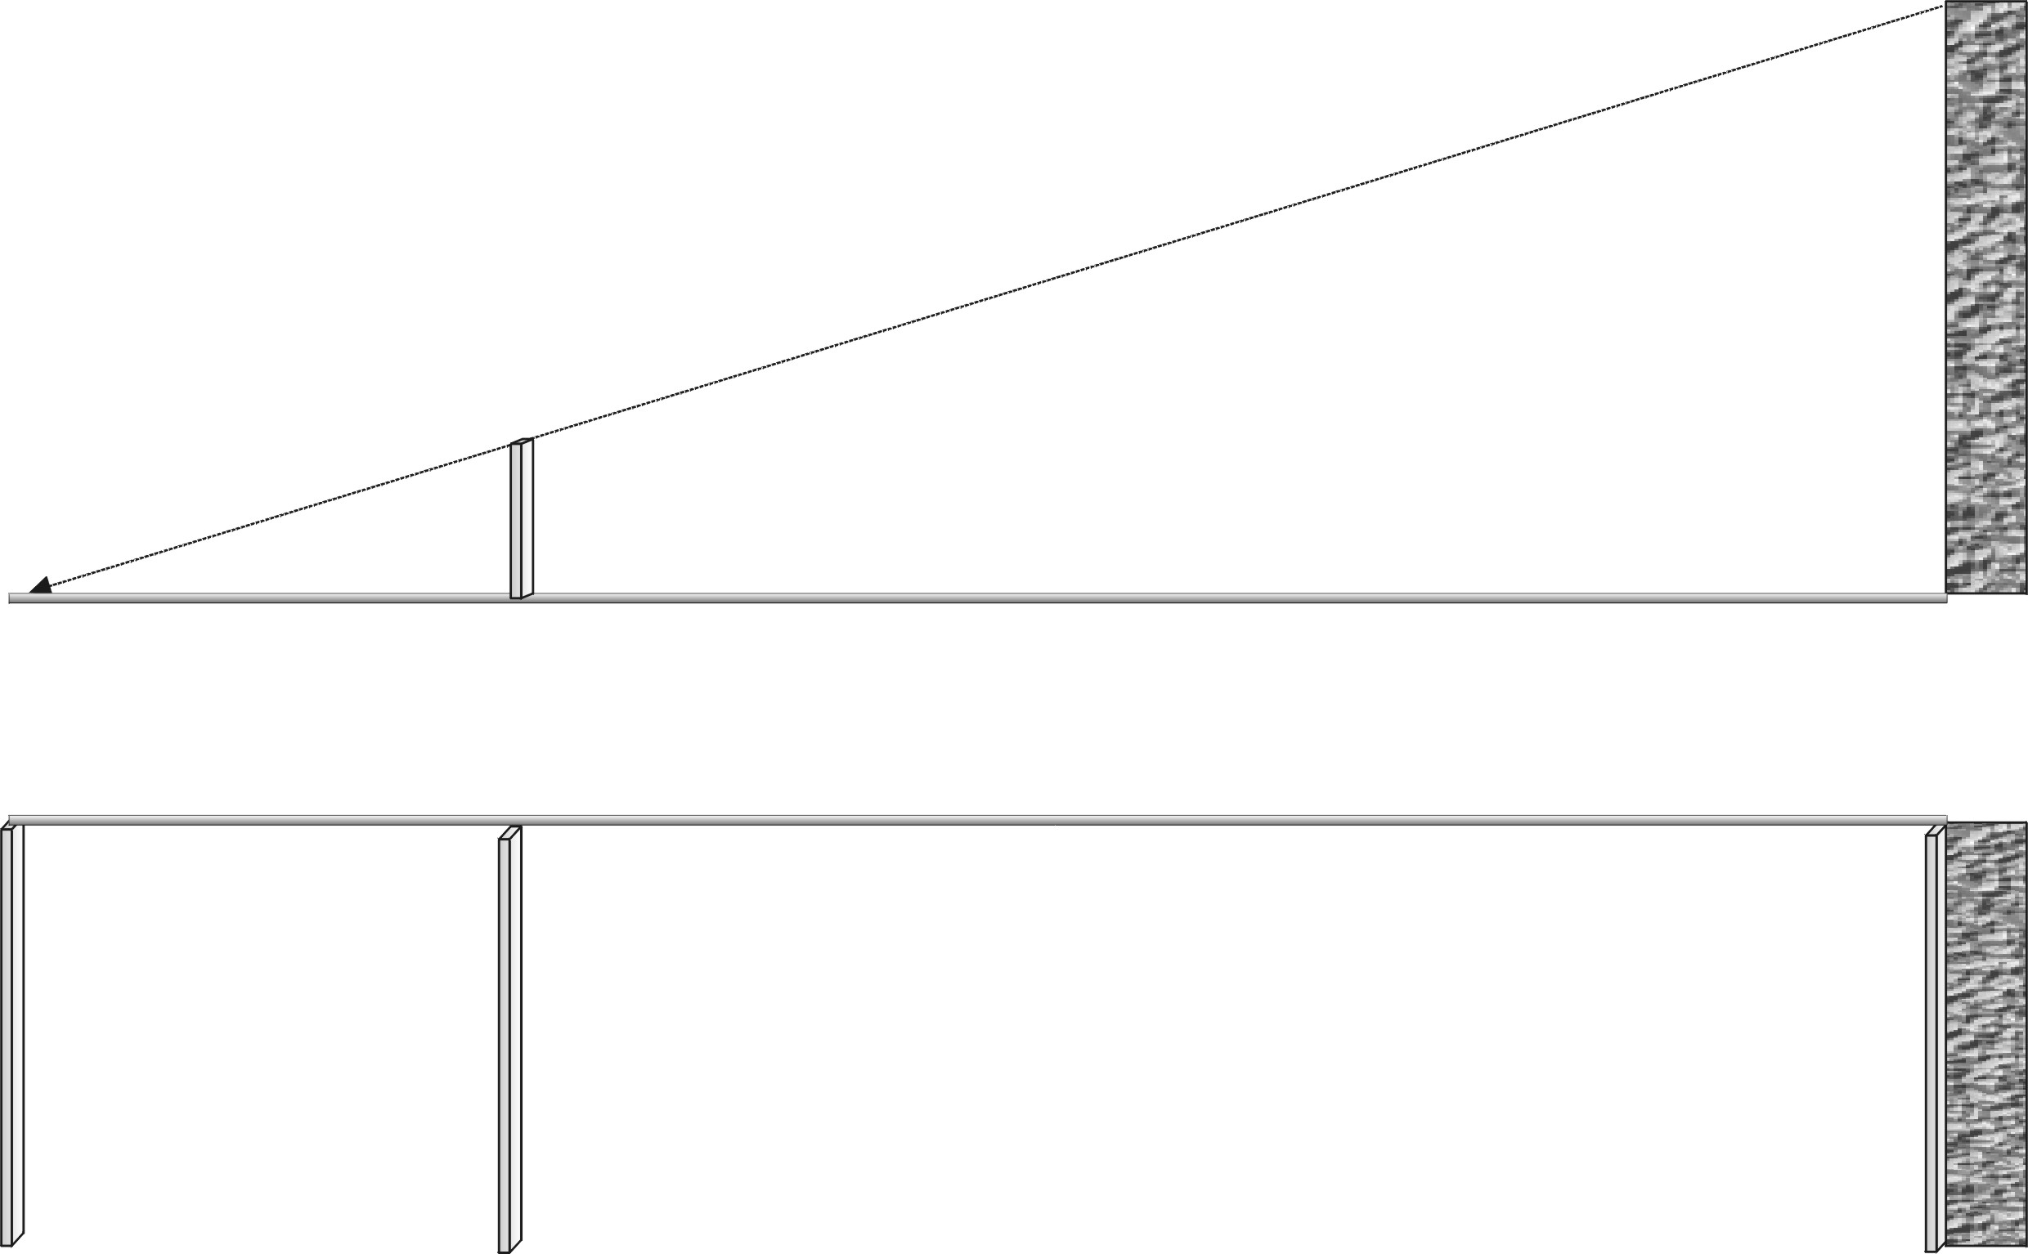
- Split your diagram into a rectangle 1m above the floor and a triangle (on top of the rectangle).
Angle of Elevation
- $S_{e}$$S_{w}$The top of the rectangle is 1m above the floor. The total height from the floor to the point P_{c} on the ceiling will be the distance from point where the string touches the wall ($S_{w}$) to the point on the ceiling ($P_{c}$) plus one 1m.
Elevation comes from the word to Lift up.
The angle of elevation is the angle that shows how much a point has lifted up.
$$\text{Height} \text{of} \text{the} \text{ceiling}=1+P_{c}S_{w}$$
3 The triangle $Δ$S_{e}S_{w}P_{c} is a right angled triangle and the angle $∠S_{e}$formed between the string line and the line of sight to the ceiling is called the angle of elevation.
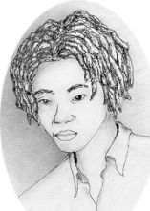

Trigonometry, The Basic Principle

For a given angle of elevation in a right-angled triangle, there is a fixed ratio between the height and the length of the triangle, i.e.

$\frac{P_{c}S_{w}}{S_{w}S_{e}}=a \text{fixed} \text{number}$

All Right angled triangles with the same angle as $∠S_{e}$will give the same fixed number if you divide the height by the length.

Trigonometry always uses right-angled triangles.

1.3 Finding the height of the ceiling.
$P_{c}$
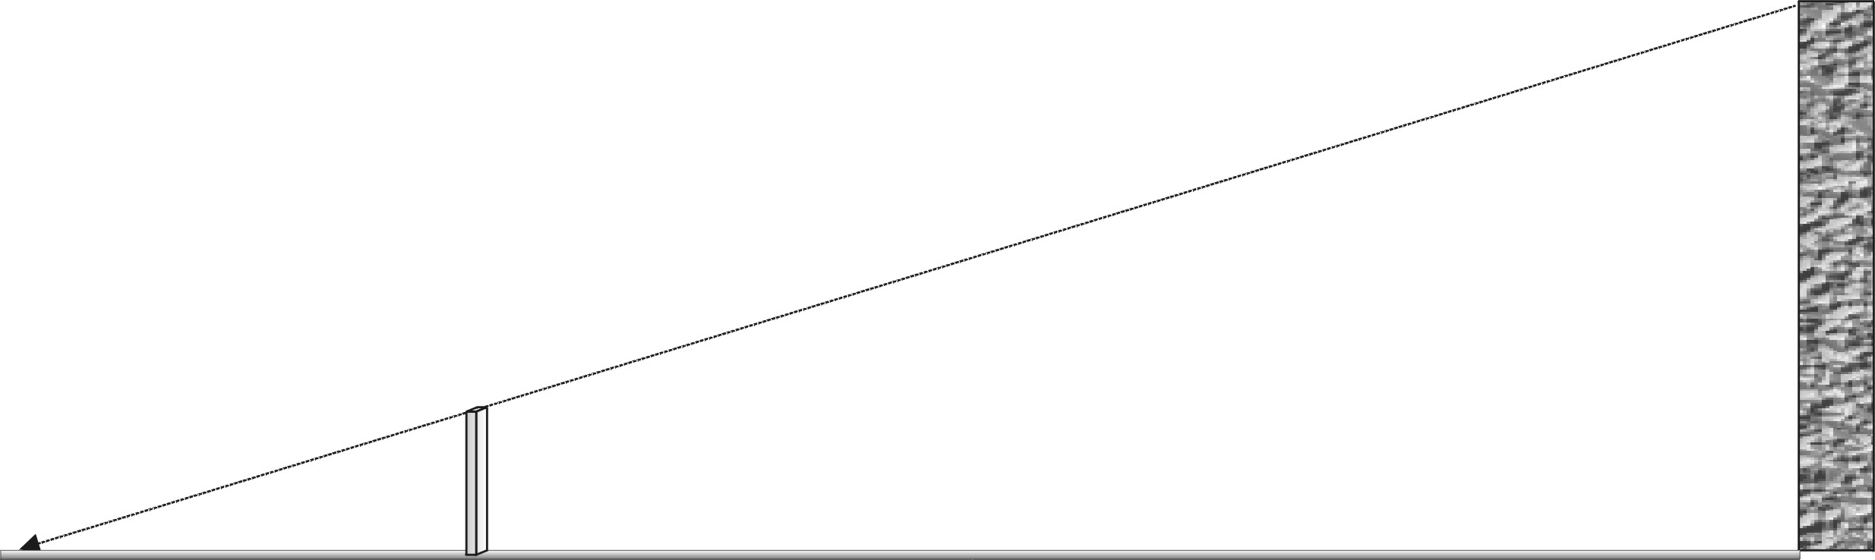
If you look again at your diagram you can see two right-angled triangles. The large one that goes up to the ceiling and the small one that goes to the top of the 1.5m measuring stick (T_{ms})

- $S_{e}$$S_{w}$$B_{\text{ms}}$$T_{\text{ms}}$Use the small triangle to find the fixed ratio between the height and the length of the small triangle, ${ΔS}_{e}B_{\text{ms}}T_{\text{ms}}$, i.e. find
$$\frac{T_{\text{ms}}B_{\text{ms}}}{B_{\text{ms}}S_{e}}=?$$
- The ration of height to length of the large triangle, $Δ$S_{e}S_{w}P_{c} is the same as this value, i.e.
$\text{The number above}=\frac{P_{c}S_{w}}{S_{w}S_{e}}$
- You should now be able to find the height to P_{c} on the ceiling. Remember that you will also need to add on the height from the floor to the string. Note your answer down. Make sure you all agree and that the number makes sense.

The Height to the ceiling is _____________________?

1.4 Compare your results

- Elect a spokesperson for your group. Give the class the following information.
- The Height of the ceiling
- The length of string you were using.
- The fixed ratio between the height and the length for your angle of elevation.
Note down the results from each group.

1.5 What can you say about measuring with triangles.

Discus the questions below in your groups and then write down your own answers.

- Were all the groups using the same length of string?
- What can you say about the angle of elevation of two groups who were using the same length of string to measure the same height?
- Did the groups using the same angle of elevation find the same fixed ratio between the height and the length?
- Which group was using the longest piece of string? How long was it?
- For this group, do you think the angle of elevation was larger or smaller than the other groups?
- What about the ratio between height and length for this groups? Was it larger or smaller than the other groups? Why?
- If a group found that their ratio was 1 (i.e. the height = the length), what do think the angle of elevation would be?

To Remember

Trigonometry is about the relationship between the angles of a right- angled triangle and the different Ratio’s between the lengths of the sides.

The ratio between the Height and the Length that you used in this example has been given the name Tan (of angle)

$\text{Tan}(S_{e})=\frac{\text{Height}}{\text{Length}}=\frac{P_{c}S_{w}}{S_{w}S_{e}}=\frac{T_{\text{ms}}B_{\text{ms}}}{B_{\text{ms}}S_{e}}$

Task List Assessment

Measuring with Triangles
Task | Score | Weight | Points
Work in a team to gather accurate information. Demonstrate that you can co-operate with other people and contribute positively to completing a team task.  Activity 1.1 Collecting the Measurements. | 1 2 3 4 | 1
Drawn a diagram that clearly represents the measurement setup of your group and has accurate measurements in the appropriate places.  Activity 1.1, Step 13, Diagram of the Measuring arrangement. | 1 2 3 4 | 1
Calculated the height of the ceiling and demonstrated the ability to cross multiply fractions to calculate an unknown quantity.  Activity 13, Finding the height to the ceiling. | 1 2 3 4 | 1
Answered questions that demonstrate an understanding of the relationship between the angle of elevation and the ratio between height and length of right angled triangles.  Activity 1.5 What can you say about measuring with triangles. | 1 2 3 4 | 2
Total Score | Max = 4x5=20

How to score 4 points = Task completed excellently
3 points = Task completed well, mostly correct, mostly understood and well presented.
2 points = Task completed & partially understood, some aspects correctly explained.
1 point = Task completed.

Multiply score by weighting to get final score for that Outcome
Add up each outcomes score to get your Lesson Score

