Data handling & Statistic | Unit 2 | Understanding  Probability

WHAT THIS UNIT IS ABOUT

In this unit you will be learning about probability.

Probability is a branch of mathematics that deals with the possibility that an event or experiment will have a particular outcome. An understanding of this theory is essential to weather reports, medical findings, politics and many other areas.

The 17th century French mathematicians Blaise Pascal and Pierre de Fermat first explored probability. They began in an attempt to predict the outcomes in games of chance, such as the chance that the total will be six when a pair of dice is thrown.

In this unit you will

- Collect data by counting outcomes in a coin tossing game and relate the results to the idea of chance. (SO6: AC2 and AC8) | - Investigate the combined probability of rolling different totals when using more than one dice and calculate the mathematical probability of these combinations. (SO6; AC2, AC6, AC9)
- Demonstrate understanding of the language mostly associated with the probability and use it to predict the relative probability of things that might happen. (SO6: AC9) | - Plot a bar graph to represent the Monkey Ladders game and relate the results to the monkeys that usually won the races. (SO6; AC5)
- Investigate the game Beetle and how probability relates to throwing different numbers on a dice and calculate the mathematical probability of rolling numbers specific. (SO6; AC2, AC8 & AC9) | - Demonstrate understanding of how the overall probability reduces when specific outcomes are required from several consecutive or combined tests (AND conditions) (SO6; AC9)
- Demonstrate understanding of how the overall probability increases when you repeat a test more than once or you are looking more than one possible outcome. (OR conditions) (SO6; AC9) | - Explore different values and attitudes relating to the National Lottery and contrast the mathematical probability of winning with people’s expectations.

Activity 1
Tossing a coin, an investigation

Chance is the probability of different but equally likely things happening.
These happenings are called events.
In this activity we are going to investigate the mathematics of tossing a coin. You are going to look at the chances of getting a head (H) or a tail (T) if a coin is tossed. You are then going to use mathematics to represent the outcome so that you can make predictions about what might happen when you play this game.

When you are using a coin to come to a decision, both sides have an equal chance of winning. Tossing a tail or a head are equally likely every time. That is why both sides are willing to accept the decision.

  - Team Heads, Team tails, Who is the winner?

To win this game you must toss more heads or tails than your partner when you both toss a coin the same number of times.

Use the procedure below to play. Make sure you record the “events”, that is what happened each time the coin was tossed.

How to play

- Split your class into two teams called Team Heads and Team tails. If you give everyone a number one or two around the class, then the one’s can be heads and the two’s can be tails.
- Each member of team heads should now pair up with one member of team tails. Each pair will need a coin to toss.
- Copy Table 1 on to your book so that everybody has a copy. You should make sure that your records correspond with your partners at the end of the game.
- Take turns to toss one coin, each person tosses ten times and do not forget to record your outcomes.
- If the coins fall off the table then toss again.
6. Use tallies (/) to represent your outcomes, (H / T) in the relevant block.

Table 1 – Individual Team Scores

 | Team heads |  | Team Tails |  | Combined Totals
Toss Number | Heads | Tails | Heads | Tails | Heads | Tails
1
2
3
4
5
6
7
8
9
10

Totals

  - You and your opponent

- Who is the winner between you and your opponent? Team Heads or Team Tails?
- Calculate the fractions below using each of your results:
- $\frac{H}{\text{Tosses}}$, The number of heads tossed 10 (the total number of tosses
- $\frac{T}{\text{Tosses}}$, The number of tails tossed 10 (the total number of tosses
Probability and Fractions
Probability is expressed as fractions, ratios or percentages of:
The number of times something happened The total number of times you tried

- $$\frac{H}{\text{Tosses}}+\frac{T}{\text{Tosses}}$$
- $$\frac{\text{Total}H}{\text{Total}\text{Tosses}}$$
- $$\frac{\text{Total}T}{\text{Total}\text{Tosses}}$$
- $$\frac{\text{Total}H}{\text{Total}\text{Tosses}}+\frac{\text{Total}T}{\text{Total}\text{Tosses}}$$
- What can you say about the winners “probability” fractions when compared to the loser?

1.3 Overall Winner?
Table 2 – Combined Class Tosses
Pairs Number | Combined Totals or Outcomes
 | Heads | Tails
1
2
3
4
etc

Total

Draw up a table like table 2. Collect the data from each pair and enter it into the table. Then answer the questions below.
- How many times did 5the Team Tails player win?
- How many times did the Team Heads player win?
- Did team Heads or Team Tails win overall? How do you know?
- How many pairs tossed the same number of Heads and Tails?
- Calculate the Heads Probability Ratios for each pair in your class.
- Why do you think you do not need to calculate both ratios?
- Calculate the Total Heads Probability Ratio (Heads Total tosses)? Does this tell you who won or lost? Explain.
- What can you say about the probability of throwing heads compared to the probability of throwing tails?
- If you had done 1000 tosses each, approximately how many times would you have tossed heads? How do you know this?
- What do you think is the probability of tossing Heads if you toss a coin once?
- What do you think is the probability of getting a Tail if you toss the coin once?
- Write your answers in a mathematical form using the notation like the example below:
$$P(\text{heads})=\frac{\text{Likely}\text{number}\text{of}\text{Heads}}{\text{Total}\text{Number}\text{of}\text{throws}}$$
- What do you think is the probability of getting either a Head or a Tail if you toss a coin once?
- If the probability of something happening is 1, what can you say about that happening?
- Explain what you understand by “chance” ? Why is it that you will never be able to predict exactly how many Heads or Tails you will toss in an experiment like the one above?
- What do think the mathematical idea of probability can help you to predict?

Activity 2

Language of Probability

In this activity you will learn about common terms in the study of probability and you will arrange these terms according to what they mean or the weight they carry in the probability washing line. The extreme ends in probability are such that something is going to happen for sure or it is not going to happen at all, but it is always

Work in-groups of five or six for all the activities below.
Maybe | Likely | Even Chance | Less Likely
No Chance | More Likely | Poor Chance | 50-50
Good Chance | Probable | Very Likely | Equally Likely
Possible | Very Unlikely | Impossible | No way
Certain | Outside chance | Might Happen | Unlikely

Words to describe probability

Look at the words in the box shown. They are all different ways of describing the probability of something happening.

Organise them into a table like the one below so that each column describes the same approximate probability of something happening.

Most likely |  |  | Least Likely

  - Making a probability Washing Line

You will Need

String,

sticky tape,

measuring tape

probability tags,

Use the procedure below to make a probability washing line:

- Choose 5 descriptions that can represent different probabilities of something happening on a scale from most likely to least likely. Write these descriptions onto 5 different pieces of paper. These will be your Probability tags.
- Measure and cut your string one metre long.
- Hang the string between two tables or along the wall. You an use sticky tape or prestik to secure the ends.
- Hang your “most likely” probability tag on one end and your “least likely” tag on the other.
- Arrange all the other tags in between the two extremes to make a continuous probability scale.

  - Events and Probability

Read each of the possibilities below. Discuss where you would place each one on your probability washing line? When you agree, tie a piece of string onto the washing line at the appropriate position.
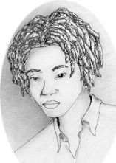
- Winning 5 Million rand on the lottery?
- Toss a coin and get a tail?
- A triangle will have three sides.
- A shark will suddenly appear in your left nostril.
- Government will win the battle against crime in the next fifteen years.
Probability is about predicting what might happen rather than knowing what is going to happen
- You will throw a dice and get a ten
- Everybody will have a house the following year if we vote for the DA in the next elections.
2.4 Expressing Probabilities as numbers
Putting Numbers on Probabilities
A probability of zero (0) represents an event that will never happen or an impossible event. Throwing a 7 when using one dice would be impossible and the event has a probability of zero, 0.
A probability of one (1) represents an event that must happen or a certainty. Scoring at least 2 when you throw two dice at the same time is a certainty and the event has a probability of 1.
Probability values between 0 and 1 represent possibilities. The closer the probability value is to 1, the more likely an event is to happen. The closer the value is to 0, the less likely an event is to happen.

Now look again at the possibilities listed above. Give each one a number between 0 and 1 where 0 means that it is absolutely impossible and 1 means that the event is definite or a certainty.

If something is not impossible but it is very unlikely for example, give it a probability score very close to (but not equal to) zero, e.g.
P(winning lottery) = 0,00000001 or 1 in a trillion.

Activity 3
The Beetle Game and Calculating Probability

In this activity you are going to play a game called beetle using a dice. The idea is to draw different parts of a beetle by throwing different numbers on a dice. You will then look at how to calculate the probability or chance of throwing the numbers you need and relate the probability values to the parts of the beetle you found difficult to throw.

3.1 Beetle, a probability game
Play this game in groups of 5 or six people. The wining group is the one who draws the beetle the fastest using the fewest number of throws of the dice.

You will need

paper
- pencils
- a dice

How to play Beetle
The Rules
- You cannot draw legs or spots before you draw the body.
- You cannot draw eyes or tentacles before you draw the head.
- Each group member throws the dice and hands on to the next ember.
- If you can, the group draws the part of the beetle represented by the number on the dice.(see diagram opposite)
- One group member should record each throw in a table like the one shown below.
- The group continues to pass the dice on and throw until you have draw the full Beetle.
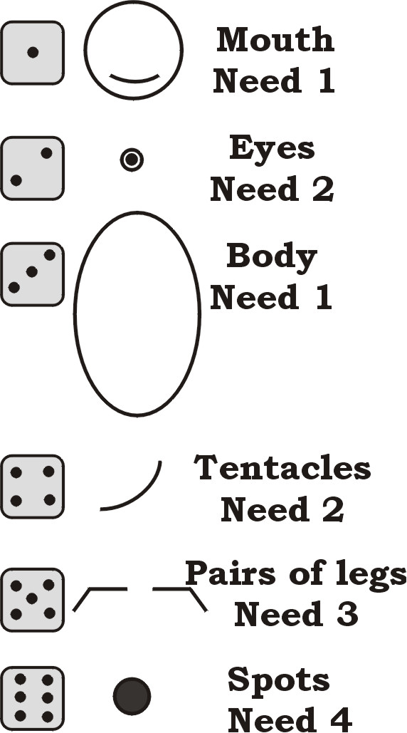
- When you have a full beetle you should shout Beetle to stop the game.

Throw | Player
Throw | 1 | 2 | 3 | 4 | 5 | 6
1
2
3
4
5
6
7
8
9
10
11
12

3.2 Probability and the Beetle game

- How many times do you need to roll a dice / die to complete the beetle?
The Mathematical Definition of Probability
The probability of an event A occurring is defined as:
P(event A) = __Number of ways that event A can occur___
The total number of possible outcomes.

- An outcome is the result of a single trial of an experiment. In the case of rolling one die all of the outcomes can be represented as a set, S ={1,2,3,4,5,6.
- Each of these can only occur once per throw, therefore the number of ways to throw a particular number will be one per throw.
- The total number of possible outcomes is 6, because there are 6 numbers.
- P(Throwing a four)) =$\frac{1}{6}$ in the case of a dice.
- All the faces have an equal chance of coming up. Therefore all the numbers have an equal probability ($\frac{1}{6}$) for one throw of a dice.

- How many different parts did you have to draw?
- What was the minimum number of throws possible to complete the beetle?
- Calculate the probability of throwing a 1 for the head on the first throw.
- What was the hardest part of the beetle to complete? Why do you think this is?
- What was the total number of throws the winner threw?
- Count how many times each umber was thrown during the game. What can you say about the probability of throwing each number?
- Calculate the probability of throwing either a head (1) or a body (3) with the first throw of the dice:
P(head or a body) = Number of ways (choices)

Total number of possibilities
- In theory, how many groups should have been able to draw a head or a body on the first throw?
- How many groups did throw a head or a body on the first throw?

OR Conditions,
Increasing your chances

If you want to throw a specific number you can increase your chances by throwing more than once. Each time you throw you add the probability of a single throw.
P(4 from two throws) =P(4 from one throw) + P(4 from one throw).
P(3 from 4 throws) = 4 P(3 from one throw)
If you want to throw more than one specific number (e.g. 1 OR 3) the same applies. You add the probability of throwing each individual number

Activity 4
Monkey Ladders, Probability and two dice

In this activity you are going to look at the combined totals when you throw two dice, i.e. {2,3,4,5,6,7,8,9,10,11,12}. You are going to use these numbers to race Monkeys up different ladders. Eleven monkeys will participate. Each monkey will move one step up their ladder, every time their combined total is thrown using two dice.

  - Monkey Ladders
The Winning Monkey

The winning monkey is the first monkey to climb 7 rungs of the ladder.

In this race a monkey climbs every time its favourite total number is rolled. Take turns in your group to roll both dice at the same time. Use a coin or a stone to mark the position of each monkey.

Each member of your group should choose which monkey they think will win and which monkey will come last. Record your choices. Then play.

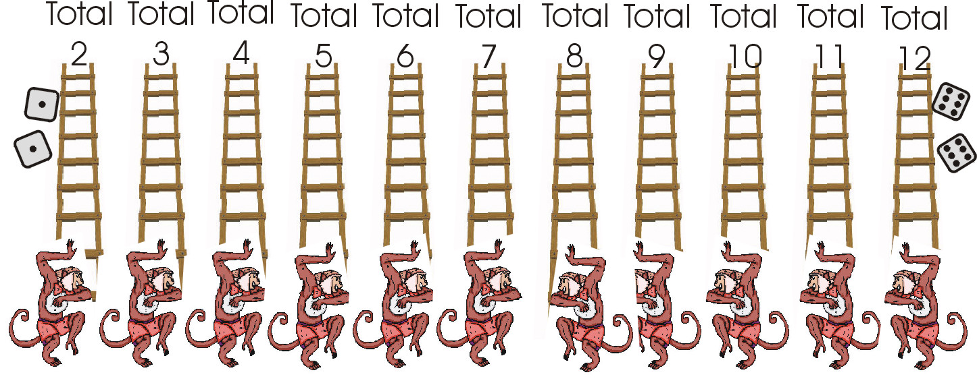
  - Monkey Ladders and Probability

- Which monkey won in your group? Why do you think this monkey won?
- Which monkey came last? Why do think they came last?
- Is the race fair? Why do you say this?
- Choose three monkeys that are likely to win most of the time. Explain your choice
- Choose four monkeys that are likely to come last most of the time. Explain your choice.
- How many different ways are there to roll a double 1?
- How many different ways are there to roll a total of 7?

  - Probability bar graph.

You are now going to calculate the theoretical probabilities of rolling all the totals for all of the monkeys. To do this you need two pieces of information for each possibility:
- The number of different ways to roll the monkeys favourite number
- The total number of different throws possible.
Each probability ca then be calculated using the probability formula below:

P(total number) = Number of different ways to get that number
Total number of different combinations possible
P(6) = ?

Different rolls to give a total of six; (1,5), (2,4), (3,3), (4,2), (5,1)
- There are 5 different ways to roll a 6.
- There are 11 different totals that can be rolled

A Complete the table below by working out how many ways there are of throwing each of the monkeys favourite numbers. Then calculate the total number of different combinations.

Monkeys favourite number | Dice combinations | Number of possibilities
2
3
4
5
6 | (1,5), (2,4), (3,3), (4,2), (5,1) | 5
7
8
9
10
11
12
Total number of different combinations possible.

B Use the formula above to calculate probabilities of rolling the totals in brackets using two dice:
- P(2)
- P(4)
- P(6)
- P(9)
- P(10)
- P(11)

C Use these probabilities to deduce those for:
- P(3)
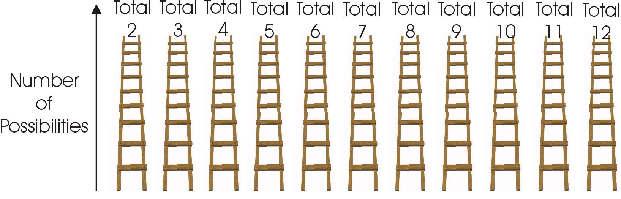
- P(5)
- P(7)
- P(8)
- P(12)

D Plot the number of possibilities for each total on a “monkey ladder bar graph” like the one shown. How does this graph relate to the finishing positions of your groups monkey race?

Activity 5
Lottery Alert

Is the Lottery a good thing? Is it going to make everybody rich? Does it make any people poorer?

In this activity you are going look at how easy or difficult it is to win the Lottery. What are the chances? Somebody said that the chance of winning the jackpot in the National Lottery is 1 in 14 million chances. This means if you try 14 million times you might win only once. In money terms this means that you will pay 14 million x R2.50 = 35 million in tickets to win once.

  - Analysing the Lotto

In the South African National Lottery, six balls are selected at random from forty-nine numbered balls. Players have to guess which balls will be drawn. If they get all six correct, they win the jackpot prize. Answer the questions below about this situation.
- You have chosen 6 numbers, what is the probability of the first ball matching one of your six numbers?
Rolling Probabilities, The P(of one event) AND P(another event)

When you have two possibilities and you want to calculate the overall probability of BOTH happening, You multiply the two probabilities together.
For example, the probability of rolling a six on a dice and then rolling another six is:
P(6) AND P(6) = $\frac{1}{6}×\frac{1}{6}=1\begin{aligned}\frac{\text{36}}{}\end{aligned}$
You can check this by looking at your Monkey Ladders table for throwing 12 (double 6)
- Assuming you have matched the first ball, you now have 5 numbers left to match and there are only 48 balls left. What is the probability of matching the second ball.
- Assume you go on winning, calculate the following probabilities (in order):
- P(matching ball 3).
- P(matching ball 4)
- P(matching ball 5)
- P(matching ball 6)

- Now calculate the rolling probability of matching all of the 6 balls, i.e. :
P(ball 1) AND P(ball 2) AND P(ball 3) AND P(ball 4) AND P(ball 5) AND P(ball 6)

5 Was the person who said that the chances of winning were 1 in 14 million correct? Explain how the probability you calculated above relates to your chances of wining.

  - What you think about the Lotto

Are the statements below true or false? Why do you say this? Discuss these issues in your group and prepare a summary of your opinions to present to the class.

If you play the lotto for long enough you are sure to win?
- You will only win if you follow your Gut feeling.
- Luck doesn’t exist.
- Poor people are eating less bread because of the Lotto
- You need skill to play the Lotto.
- Only the organisers of the Lotto make money. They are making millions in profits so most people must be losing.
- The Lotto makes us believe we can win but probability calculations prove that winning is almost impossible.
$$P(\text{event}A)=\frac{\text{Number}\text{of}\text{ways}\text{that}\text{event}A\text{can}\text{occur}}{\text{The}\text{total}\text{number}\text{of}\text{possible}\text{outcomes}}$$

Probability Summary

- Mathematical probability is a way of describing the chance of one thing happening when there are several equally likely things that might happen.
- Mathematical probability values are always between 0 and 1 and are defined as:
$$P(\text{event}A)=\frac{\text{Number}\text{of}\text{ways}\text{that}\text{event}A\text{can}\text{occur}}{\text{The}\text{total}\text{number}\text{of}\text{possible}\text{outcomes}}$$
- OR Conditions occur when you repeat a test more than once or you are looking more than one possible outcome. In the case of OR conditions, the overall probability increases and you add the individual probabilities of each test to get the overall probability of the combination.
$$P(\text{event}A\text{ OR }\text{event}B)=P(\text{event}A)+P(\text{event}B)$$
- AND conditions occur when specific outcomes are required from several consecutive or combined tests. In the case of AND conditions, the overall probability decreases and you multiply the individual probabilities of each test to get the overall probability of the combination.
$$P(\text{event}A\text{ AND }\text{event}B)=P(\text{event}A)×P(\text{event}B)$$

