Data Handling & Statistics | Unit 1 | Data about People

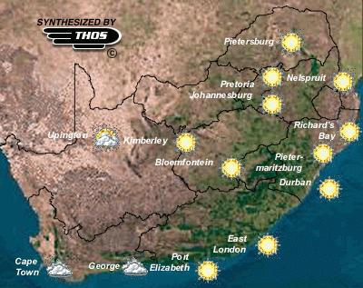

WHAT THIS UNIT IS ABOUT

During Census 2001 people from Statistics South Africa collected, summarized, analized and drew conclusions about everybody in South Africa. They collected data and changed it into useful information. The government in particular will use this information to work out what people need most in the future so that they can plan for development.

Individual facts and numbers are called data, the names and ages of people in a family for examples. When lots of pieces of data are put together then you have information, about a family for example. Data on its own is not useful, but information is. This unit is about changing or processing data so that it becomes useful information.

In this unit you will collect data about people and products. You will learn how to use data that is presented as graphs, charts, and tables. You will learn how summarise and communicate information with graphic display and which type of presentation is most appropriate for the message. You will also learn how to summarise numerical data (numbers) by using averages or mean values.

In this unit you will

- Plan and carry out simple surveys and record data in different ways. (SO6; AC2) | - Interpret information to make generally true statements about people and products. (SO6; AC4)
- Organise data so that it is easy to analyse and understand. (SO6; AC3) | - Interpret information given in different types of graphs. (SO6; AC7)
- Process data into information by calculating the average values. (SO6 AC4) | - Present data in graphs and in pie charts (SO6; AC5)

Activity 1

How tall are you?
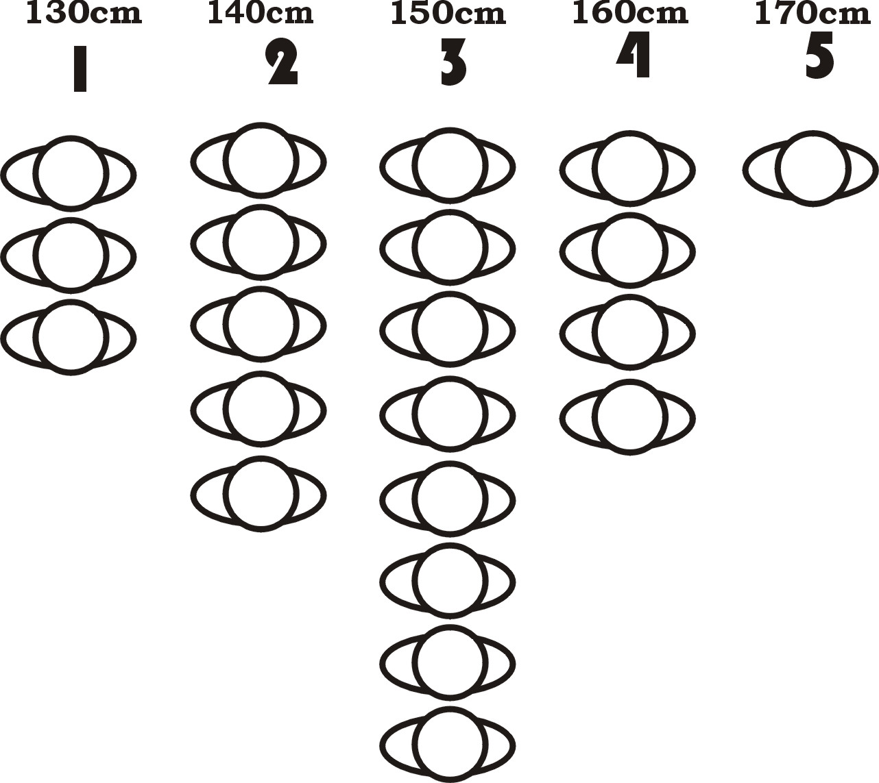
In -this activity you will be measuring your approximate height and comparing it to other learners in your class. You will then be learning how to record and present that information so that you can make general statements about how tall the people in your class are.

1.1 Setting up

You will need
A Tape measure
Masking tape

Use the procedure below to set up 5 height measuring points in the classroom.
- Tape a piece of masking tape onto a section of the wall at a height of 130cm above the ground.
- Tape a second piece of masking tape onto a different piece of the wall (at least 1 metre away) at a height of 140 cm
- Tape a third piece 150 cm above the ground
- A fourth 160 cm
- A fifth at 170 cm

1.2 Which one fits you?
Where you should end up
All of you should be able to fit under the tape you are at.
You should be taller than the measuring point one down from you final position.
- First go to the 5th measuring point. If you are taller than the mark at 170cm then stay there. If not move down to the fourth measuring point (160mm).
- Continue to move down until you are just shorter than the tape on the wall. Stop at that measuring point.
- If you have not stopped at any before you should end up being shorter than the first measuring point, i.e. shorter than 130cm.
- Line up in a straight line at the measuring point that suits you best.
- Count how many people there are at your measuring point.
- Look at the other measuring points. Which one has the most people? Which one has the least people?
- What can you say about your height as compared to the rest of the class?
1.3 Presenting a picture of the height of your class.

- Record how many people in your class were lined up next to each measuring point in a table like the one below.

 | Measuring point number
 | 1 | 2 | 3 | 4 | 5
Number of people | 3 | 5 | 8 | 4 | 1

B Now draw a bar graph like the one below by using one square to represent one person.
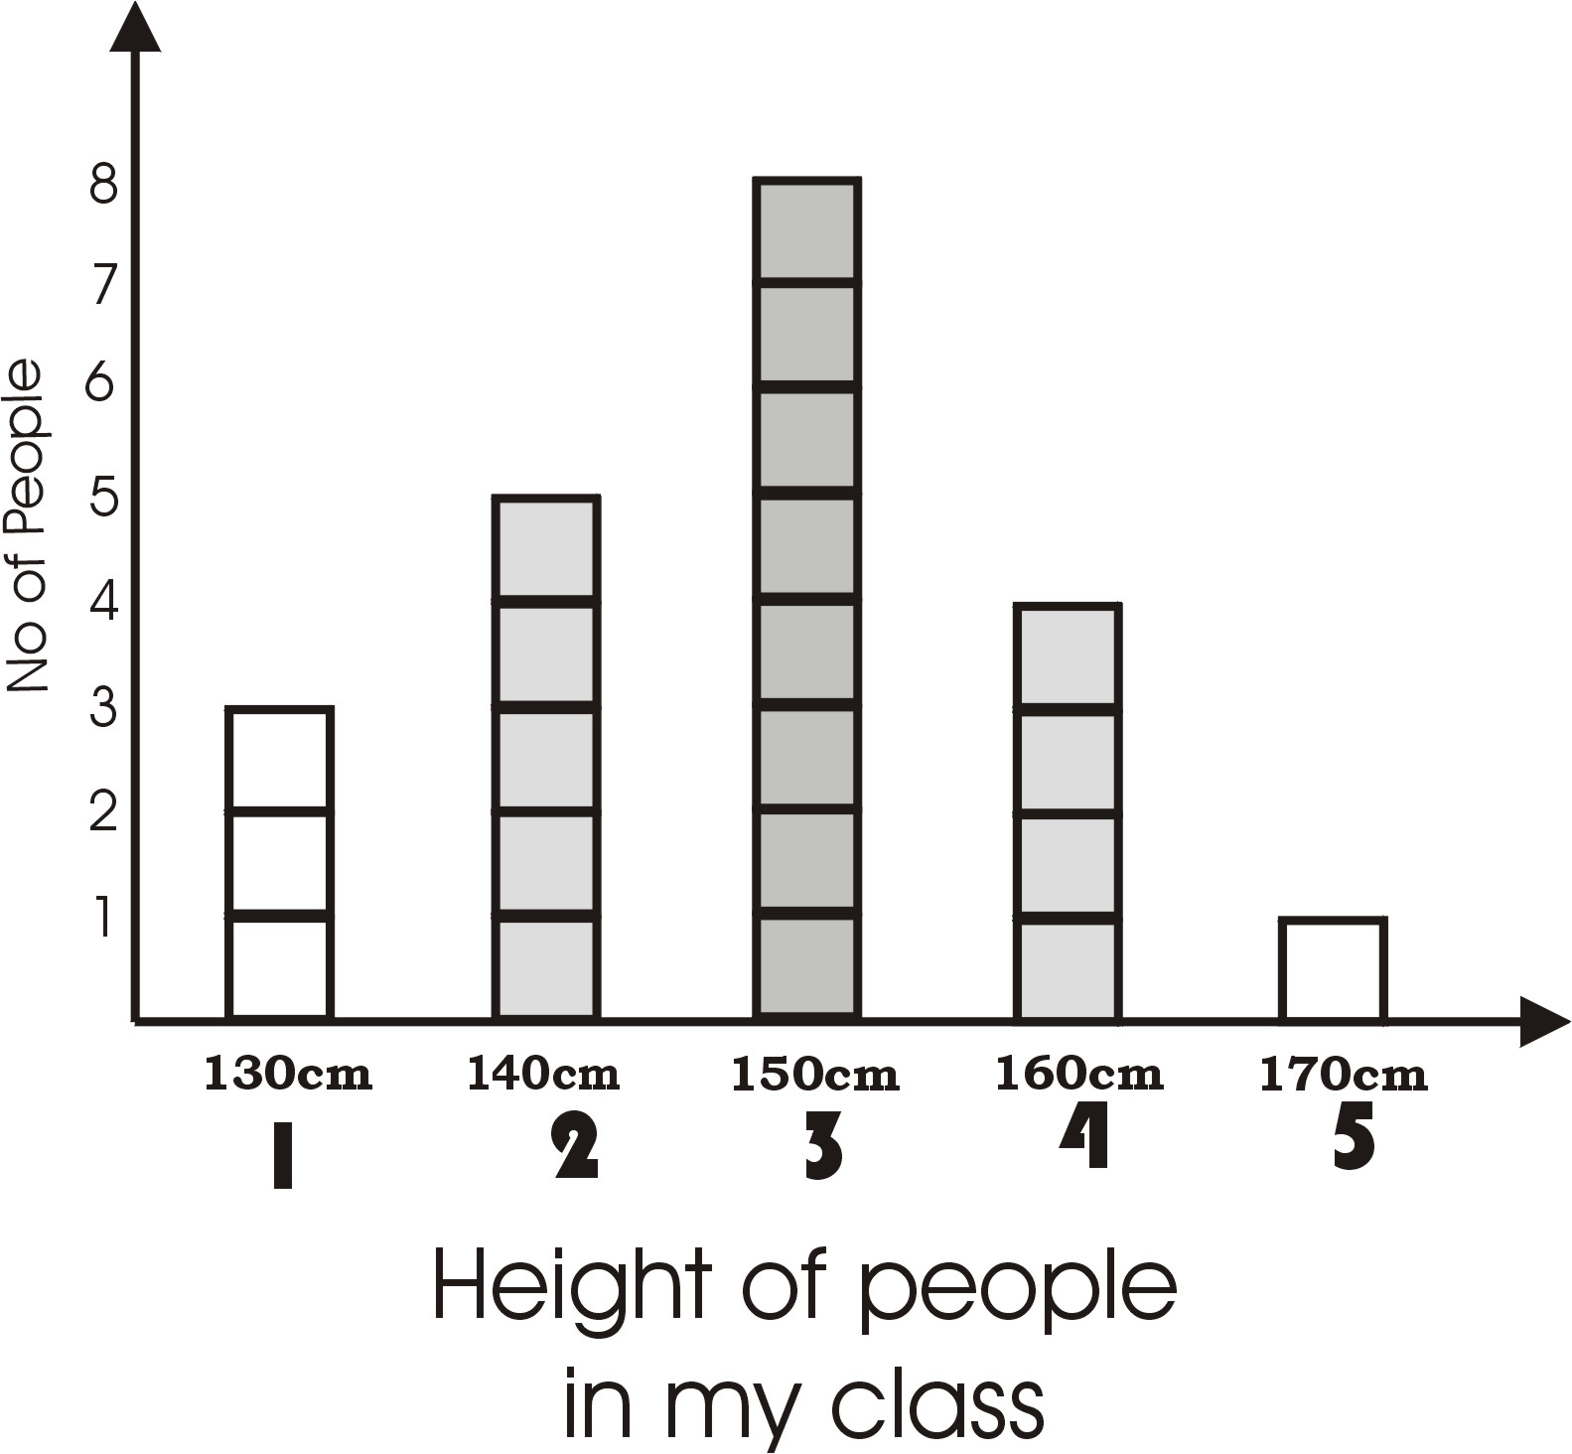

Bar Graphs
A bar graph allows you to compare different categories of data very easily.
This bar graph is called a Histogram, because the data in each category is organised in ranges (height from 130cm to 140cm).

C From your graph answer the following questions.
- What height range does most of the class fit best?
- Compared to your class are you taller or shorter than the range that most other people fit into.
- How many people fit into the shortest range?
- How many people fit into the tallest?
- “ Most people are an average height but a few are always sorter and a few are always taller.” Do you think that this statement is true or false, explain.

D Are boys shorter than girls are? Use the procedure above to collect data and produce charts for boys and girls separately to find out.

Activity 2

B Class Census
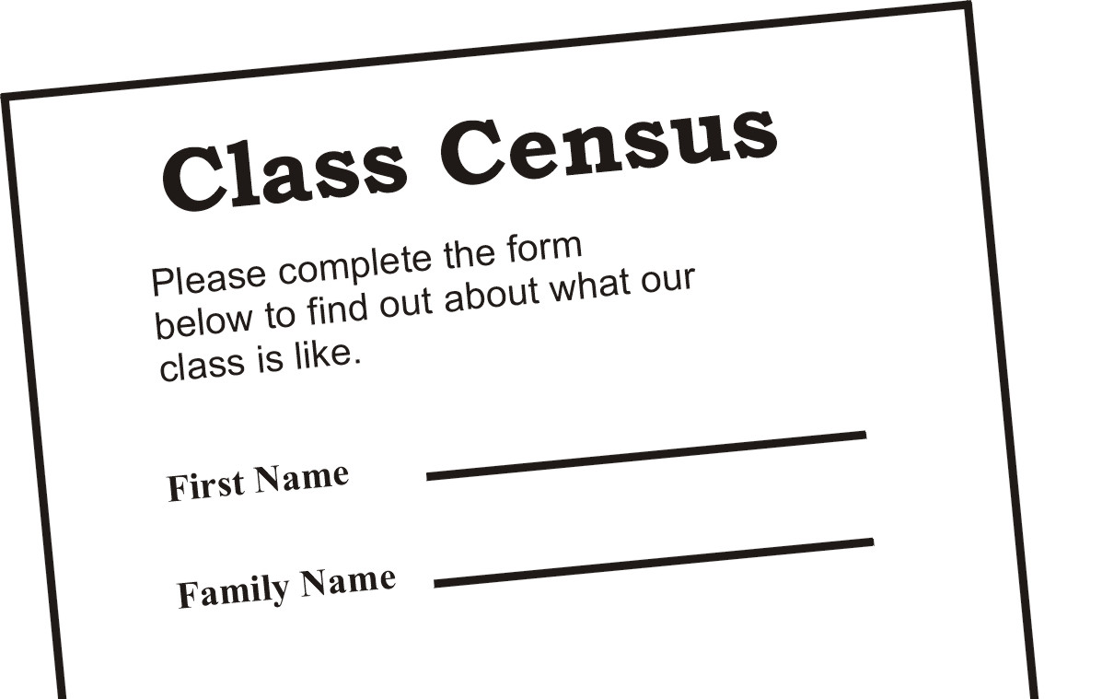
In this activity you will be developing a questionnaire to use to collect data from people in your class. You will then be analysing this data enable you to make general statements about what most of the people in your class are like.
Statistic South Africa has done a very similar but much bigger activity to allow them to make general statements about all the people in South Africa during Census 2001.
Tips on survey forms.
They must be:
- Have a clear title so that people know what it’s about.
- Easy to understand
- Easy to fill in (lots of space)
- Not too long.
- Data is facts, one word or one number answers are best.
2.1 Developing a survey form.
As a group, develop a survey form that you will use to collect information about your class. You must collect information about the list below. If you wish you can add a few more items to the list (but not too many, otherwise it takes too long for people to fill in).
- What is your first name
- What is your family name
- What is your age?
- What is your gender
- How tall are you?
- What is your shoe size
- How many brothers do you have living at home?
- How many sisters living at home?
- How many adults living at home?

2.2 Filling in the form
Note
If everyone has filled in one form then you have the data for the whole class.
Produce one form for yourself that is identical to your group’s form. Fill in the form with your own details. Then discuss the questions below.

- Was the form easy to fill in? Was there enough space for the answers?
- Were the answers easy to work out and write down using one word or number?
- Did it take a long time to fill in? Would a stranger be happy to fill in the form for you?
2.3 Data collection forms

Now you need to summarise the data for the whole class. One way of doing this is to create a table.
- Create a table like the one below, to summarise the data you have collected.
- Fill in one table between you with your group’s data.
Question | Member
 | 1 | 2 | 3 | 4 | 5 | 6
1 | Sipho | Susan | Sonto | Sjaan | Shamima | Sibongile
2
3
4
5
6
7
8
9

2.4 Analysing the data
Look at your group’s data in this table and answer the following questions.
- Who has the longest first name and last name?
- Does everybody in your group have a different first name? Can you say the same about your whole class?
- What age are most of the people in your group?
- What is the youngest and the oldest age in your group.
- What gender are most of the people in your group? Do you think most groups will have this result or is your group “non-typical” .or different from most of the other groups)
- Does your group have more brothers of sisters at home?
- Who is the tallest member of your group?
- Who is the shortest?
- Are the males or the females taller in your group?
- Do you think you can say this about your whole class?
- How many adults do most of you have at home?
- Based on your group’s data, are most of the people in your homes adults or children? Do you think this is rue of the whole class? What about the whole of South Africa?
2.5 Group averages and class averages
To find the AVERAGE of a list of values:
Add up all the values to give the TOTAL value.
Divide the TOTAL by the number of values. (n)

$$\text{AVERAGE}=\frac{\text{TOTAL}}{n}$$

In this activity you will be calculating the averages of the numerical data you have collected to try to summarise it further. You will first find the averages for your own groups data and then use it to find the averages for the whole class.

- Calculate the average values of the following.
- The average age of the people in your group.
- The average height.
- The average shoe size.
- The average number of brothers at home.
- The average number of sisters.
- The average number of adults.

- Make a table like the one below. Record your own values in this table and then send a representative to the other groups to collect their results.

 | Group 1 | Group 2 | Group 3 | Group 4 | Group 5 | Group 6
Age
Height
Shoe size
Brothers
Sisters
Adults

- Now calculate the average of all the averages. This should give you the class average for each of the data quantities you have collected.

- Use your results to answer the following questions.
- Are you older or younger than most of the people in your class? What about most people of your group?
- Do you think it will be easy or difficult for you to borrow shoes from your friends? How do you know?
- Is your family similar to those of your classmates? Explain why you think this.

  - Relationships and data

In this activity you will be comparing different data to see if there is any relationship. A relationship is a link that allows you to predict a possible value from something different. For example the older you are the taller you are. This might be true for children, but as soon as you reach 16 you might not get any taller. You could predict that a 10 year old will be taller that a three year old though. Based on data you might also be able to predict that a 3-year-old will be 75cm tall and a 10-year-old will be 130 cm tall. This would be based on the average height of 3 year olds and l0 year olds or the relationship between height and age.

Remember
In order to compare girls to boys you will need to calculate separate averages for boys and girls.
Collect the data you need and test the data to see if the following statements are true or false.
- Girls are taller than boys are.
- Boys have bigger feet than boys.
- The taller you are the bigger your feet.

2.7 Data and percentages

Sometimes you might want to compare data using ratios or percentages. You do this in order to be able to say how many of one thing there will be compared to another without knowing the exact numbers.
Remember
Percentages are about counting numbers, rather than measuring values.
Calculate the following percentages based on your data.
- What percentage of the class does not have any brothers or sisters at home?
- What percentage of the class are girls? What percentage are therefore boys?
- What percentage of the girls in your class is taller than the whole class average?
- From your whole class data, what can you say about the percentage of girls and boys in the families in your area?

How to work out percentages

1 Count how many of the data points (facts) agree with the statement
e.g. Count how many people do not have any brothers or sisters at home.
- Count the total number of data points you looked at. (class).
e.g. Count the total number of people in your class.
- Divide the data points that agree by the total number to give a ratio:
e.g. $\frac{\text{People with no brothers or sisters}}{\text{Total number of people counted}}$
- Multiply this ratio by 100 to give a percentage. (a fraction out of 100)
e.g. $\frac{\text{People with no brothers or sisters}}{\text{Total number of people counted}}×\frac{\text{100}}{1}$

Activity 3

Pie graphs and Bar graphs

In this activity you are going to be using bar graphs and pie charts to compare data collected during a Market Survey. Companies do this type odd survey to find out what people will prefer to buy so that they make the right number of products.

3.1 Popular Car Colours

A car manufacturer makes sports car for young and rich executives. They need to find out which colours will be the most popular so that they produce the right number of each colour in their factory.
Table 1: Bongani’s tally chart data
Car colour | Tally
Maroon | //// ///.
Metallic Grey | //// //// //
Yellow | //// //
Royal Blue | //// /
Gold | //// ////
Black | ////
Silver | ///.

Bongani was commissioned to do a small survey for them. Bongani used a tally chart to record the colours of 50 cars. For each car Bongani counted he put a tally mark like this / in the chart. If there are five tally marks, the fifth one is shown like this ////. The 8 maroon cars that Bongani counted are shown like this //// ///.

- Use the tally chart data in table 1 to translate Bongani’s results into numbers. Then fill in a table like the one below.

Car colours | Maroon | Metallic Grey | Yellow | Royal Blue | Gold | Black | Silver
No of cars

3.2 Bar graphs and Pie charts

For his report to the client Bongani had to present his data on a graph. Graphs are the most effective way of presenting information and Bongani came up with theses two different types of graphs.

Pie Chart

Bar Graph
A Study the graphs below carefully and answer the questions that follow.
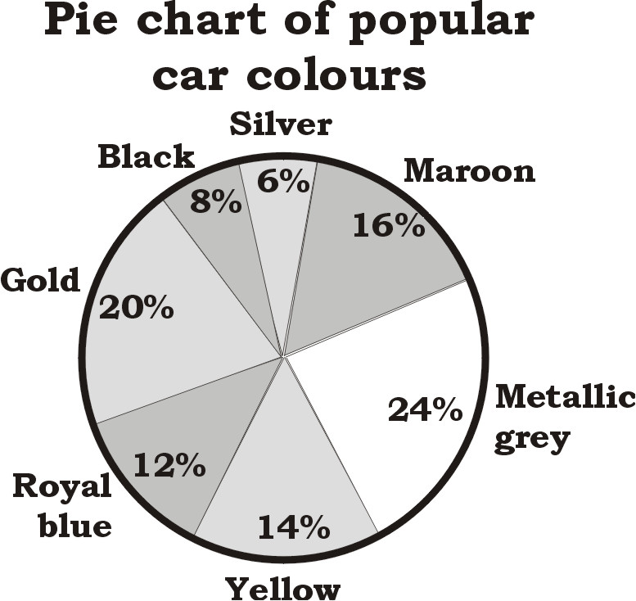
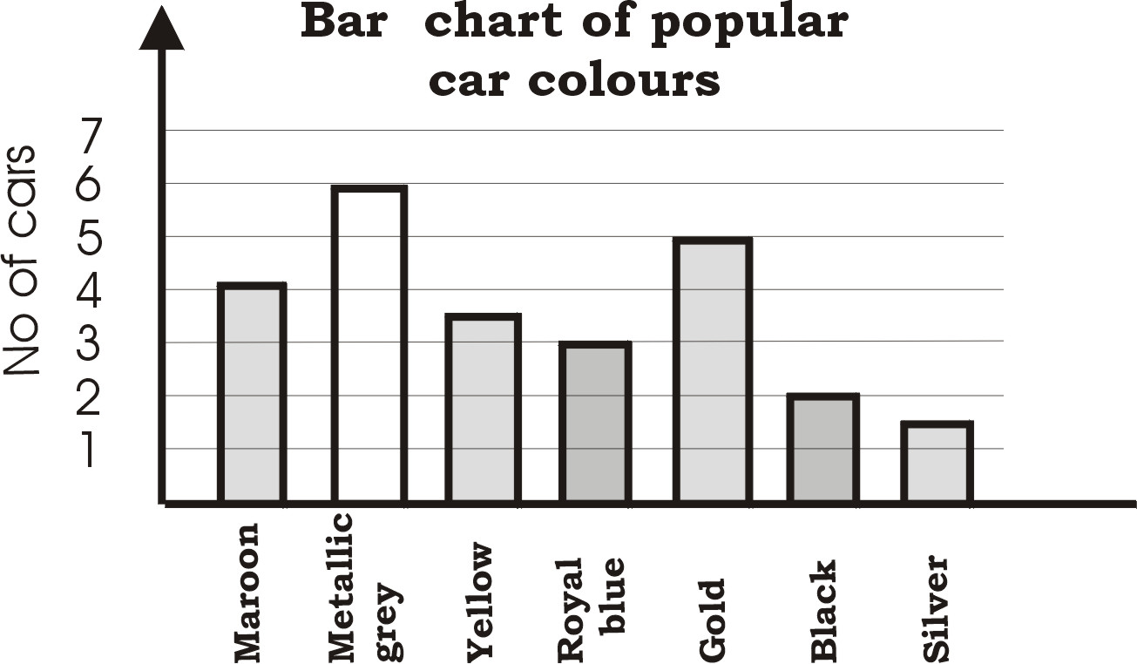
A pie chart looks like a pie cut into slices; Each piece is a fraction of the pie.
A bar chart looks like a set of bars with different lengths. The length of each bar shows how many of each category was counted.

- What is the most popular colour from this study?
- How many cars of this colour did he count out of the total of 50?
- What percentage of the total does this represent?
- Which chart shows the results in percentages and which shows the exact numbers Bongani counted?
- If the company makes 500 cars a week. How many of each colour would you recommend they made in order to satisfy the tastes of their customers?
- If the company wanted to drop two cars from its range, which colours would you recommend they stopped making?

- Answer the following questions about the difference between the two charts.
- Do you think these three graphs give the same information?
- If not, how are they different or if yes, how are they the same.
- Which graph do you think is easy to understand?
- How many cars is 20% of fifty cars?

Activity 4
Analysing and Presenting Data

In this activity you are going to present data that is given in tables and paragraphs using different types of graphs. You need to summaries the data and present it in a way that everybody can make sense of it. Graphs are easy to understand and they bring life to long and difficult paragraphs.

4.1 Pie Charts
(Reported rape cases for the three years1998-2000, South of Johannesburg)
Rape is one of the most common crimes in South Africa today, and the most vulnerable victims are young people, so it is important for young people to read and understand rape issue from news papers or any other kind of media. We often hear police reports about different types of crimes, assume this is one of their reports for the period 1998 – 2000 for Johannesburg South areas only.
Three out of every ten women in the South of Johannesburg, experienced rape between
1998 -1999
Four out of every ten women in the South of Johannesburg, experienced rape between
1999 - 2000.
- Write each of the two statements above in the form of a percentage
- Draw a pie chart that shows rape statistics for South of Johannesburg, from
1998 - 2000.
- Use your knowledge of angles to calculate the size of each angle in your pie.
(Remember a pie is a circle and therefore it forms an angle of 360 °)

4.2 Bar graphs

YEAR | 1994 | 1996 | 1997 | 1998
No of victims per year | 100 | 11000 | 52 160 | 49 280
Percentage of total population (100 00) | 1 | 11 | 52.16 | 49.28

The table opposite shows crime data for 1994 to 1998 at one police station.
- Use the number of victims and the percentage of population to draw a Bar graph that summarises the data.
- What happened between 1997 and 1998? What could the reasons for this have been?

4.3 Analysing Yizo-Yizo Data

Yizo-Yizo is a television drama series that is very popular amongst high school students.

This series is highly supported by the National Dept of Education and the SABC Education. SABC1 channel, as the channel that runs this series monitored the interest of viewers on the drama series and this is the information they have released.

Use the data in the table below to answer the questions that follow

Weeks of viewing | Percentage change per week | Number of viewer per week
Week 1 | 200 000 viewers | 200 000 viewers
Week 2 | 25 % less than the first week
Week 3 | 100 % more than the previous week
Week 4 | 30% less than in week 3
Week 5 | 50 % more than in week 4
Week 6 | 100% more than week 5

- How many viewers watched Yizo – Yizo in week 3?
- How many viewers watched the drama in week 6?
- Were viewers in week 6 (more than, less than, equal to) viewers in week1,
- If they were more, by how many viewers were they more?
- If they were less, by how many viewers were they less?
- By how many viewers were viewers in week 2 less than viewers in week 1?
- By what fraction were viewers in week 5 more than in week 4?
- Which week had the most viewers?
- Fill in the column three and draw a pie chart to represent the above data.
- Measure and label the angles of your pie.
- What percentage of the pie is the biggest number of viewers?
- Calculate the size of each piece and label it in percentage.

Activity 5

Investigating shoe size and height?

In this activity you are going to collect, organise and present data about the relationship between the size of your shoe and your height. You are going to write a statement of your conclusion about your work.

5.1 Is there a relationship between shoe size and height?

- Draw a list of names of all the members of your group.

- Record everybody’s shoe size next to their names

- Measure everybody’s height and record next to their names.

- Present your data in three different ways.

- Is there a relationship between one’s shoes size and their height?

- If yes describe this relationship in words.

- Write a mathematical sentence that represents this relationship.

Data Research project

Data and our Lives

In this activity you are going look at how data is represented in different Newspapers and Magazines and try to analyse it. Analysing data means making sense of the data, drawing conclusions and predicting future patterns where necessary. Newspapers are a source of information for many people in this country; they tell us about the economy of our country vs. other countries, and many other events that we want to hear about. Some articles are written only in English some are summarised in different types of graphs.

Using Newspapers and Magazines

- Collect newspaper and magazine articles with different types of graphs and bring them to school.
- You will mainly get these from the Money or financial section of the newspaper, and also look specifically for articles around HIV AIDS, Crime and Child Abuse or anything that is represented in graphs.
- Discuss these in your groups and see if you can understand them.
- Write a short paragraph about the graphs you looked at,
- Use the same information / data to draw a different type of graph.
- Look for other articles that are written only in words, around any of the above topics and it can be written in any languages. Read this article in your group and decide which of these is easy to understand.
- Decide on an event as a group that has a lot of comparing (statistics) numbers and write an article for the public, e.g. the kind of transport learners in your school use to come to school.

