Geometry | Unit 2 | Introduction to Parallelograms

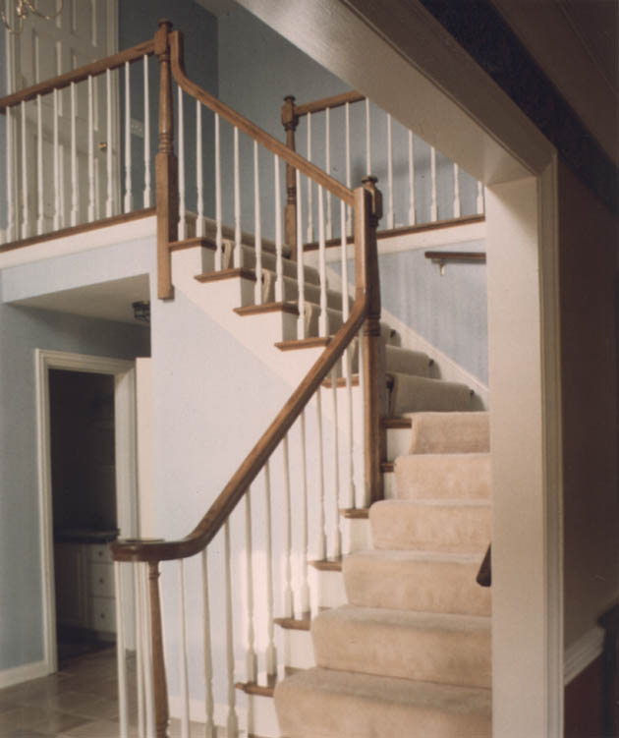
WHAT THIS UNIT IS ABOUT

In this lesson you will be learning about parallelograms. You will be exploring the geometric properties of parallelograms and discovering the link between parallelograms and triangles.

You will need to use all your previous knowledge of angles, triangles and parallel lines in order to prove theorems relating to parallelograms and you will then need to use the parallelogram theorems to solve some rider problems.

Railings of a staircase are parallel to the slope of the stairs. Any ramp with a rail will have parallelogram structures.
In this unit you will

- Cut a parallelogram into two triangles to show that the opposite sides of a parallelogram are equal and that the opposite angles are equal.

- Prove that the opposite sides of a parallelogram are equal using knowledge of parallel lines and triangles.

- Prove that the opposite angles of a parallelogram are equal.

- Prove the midpoint theorem, that the diagonals of a parallelogram bisect each other.

- Prove that a quadrilateral is a parallelogram if :
- the opposite sides are equal or
- the opposite angles are equal or
- the diagonals bisect each other.

- Solve some rider problems based on the geometric properties of parallelograms

Where you might see Parallelograms.
Parallelograms are used to make 3D drawings of objects. In the drawing of the bus, the front surface and the top surface of the drawing are parallelograms.

This is to show that the height and the width is the same at the back, the front, the top and the bottom.

In real life we know that the front of the bus is a rectangle but it looks like a parallelogram if you look at it from this angle. Remember, a rectangle is also a parallelogram but a special one.

Here are some other places you might see them. Look out for them when you see these things.:

- When you fold as box flat (Try it with a cereal box)
- When you fold up a push chair
- When you put up a collapsible clothes rack
- In Pop-up birthday cards
- In Ndebele patterns.
- Railings of a ramp or staircase.

Activity 1

Investigating the Properties of Parallelograms

Task 1 The opposite sides of a parallelogram are equal.
Draw a parallelogram like the one opposite on a piece of blank paper. Make it fit across the width of the paper.

Cut out the parallelogram and then cut it along the diagonal AC to make two triangles.

Place the triangles alongside each other and compare the lengths :

AD and BC
AB and DC

What can you say about the lengths of the opposite sides of a parallelogram?
Task 2 The opposite angles of a parallelogram are equal.
Draw a different parallelogram about the same size as the one above.

Cut it out as above. Compare the sizes of the following angles by placing them on top of one another.

b₁ and d₁
What can you say about the opposite angles of a parallelogram?
What can you say about ΔABC and ΔCDA?

a₁ and c₁
a₂ and c₂

Task 3 The diagonals of a parallelogram bisect each other.
Draw a third parallelogram on a blank piece of paper. Draw in both of the diagonals. (AC and BD)

Cut out the parallelogram and then cut it into the 4 triangles, ΔABO, ΔBCO, ΔCDO and ΔADO

Use different triangles to compare the lengths of :
What can you say about the diagonals of a parallelogram?
What can you say about ΔABO and ΔCDO ?
What can you say about ΔBCO and ΔADO ?

BO and DO
AO and CO

Task 4 Important Properties of Parallelograms

Complete the sentences below

- The opposite sides of a parallelogram are __________________________.
- The opposite angles of a parallelogram are _________________________.
- The ______________________ of a parallelogram bisect each other.
- If both pairs of opposite sides of a quadrilateral are equal then _________________.
- If the _____________ ____________ of a quadrilateral are equal then the quadrilateral is a parallelogram.
- If the diagonals of a quadrilateral _____________ ____________ ___________ then the quadrilateral is a parallelogram.

In order to prove these theorems we need to know the properties of Triangles and Parallel lines.

These properties are summarised below.

Properties of triangles.

- The sum of the angles of a triangle is 180º

- The exterior angle of a triangle is equal to the sum of the interior opposite angles.

- There are four ways to prove that a triangle is congruent (fit exactly onto each other)

SSS All three sides equal to each other
SAS Two sides and the angle between them equal
ASA Two angles and a corresponding side are equal.
90ºHS The hypotenuse and one side of a right-angled triangle.

Properties of Parallel lines

- Corresponding angles are equal

- The sum of the two interior angles is equal to 180º

- Alternate angle are equal

Activity 2

Proofs of Parallelogram theorems

Task 1 Prove each of the theorems below. Use the information in the help box as a guide.

Theorem 1 The opposite sides of a parallelogram are equal
Help box

- In ΔABC and CDA the alternate angles are equal because AB║CD and AD ║CB
- These triangles both share one side.
- Look for two congruent (equal) triangles. (SSS. SAS, ASA, 90⁰HS ?)

Given Parm ABCD with AB║CD and AD ║CB
Prove AB=DC and AD=BC
Construction Join AC

Remember

Explain your reasons where necessary
Statement | Reason

Theorem 2 The opposite angles of a parallelogram are equal
Help box

- In ΔABC and ΔCDA you now know that the opposite sides of a parallelogram are equal.
- If you prove that two triangles are congruent then their corresponding angles must be equal.

Given Parm ABCD with AB║CD and AD ║CB
Prove b₁=d₁ and a₁ + a₂=c₂ + c₁
Construction Join AC

Statement | Reason
Theorem 3 The diagonals of a parallelogram bisect each other
Help box

- In ΔAOD and COB the alternate angles are equal because AD║BC
- These two triangles have the sides we are interested in (AO & DO and CO & BO)
- Look for two congruent triangles.

Given Parm ABCD with AB║CD and AD ║CB
Diagonals AC and BD intersecting at O
Prove AO=OC and BO=OD

Statement | Reason

There are many ways to prove these Theorems. All you need to do is find the appropriate congruent triangles.

Task 2 Now prove the converses of these theorems

Converse 1 If the opposite sides of a quadrilateral are equal then the quadrilateral is a parallelogram

Converse 2 If the opposite angles of a quadrilateral are equal then the quadrilateral is a parallelogram

Converse 3 If the diagonals of a quadrilateral bisect each other then the quadrilateral is a parallelogram.
Help Box

- Try to look for relevant congruent triangles.
- If alternate angles are equal then it proves lines must be parallel.

Activity 3

Riders on Parallelograms

A quadrilateral is a parallelogram if

AD║BC and AB║CD (both pairs of opposite sides parallel)
$A=C\text{ and \{}B=D$AD = BC and AB = DC (both pairs of opposite sides equal)
(Both pairs of opposite angles equal) or
AO = OC and BO = OD (Diagonals bisect each other) or
AD║BC and AD = BC (One pair of opposite sides equal and parallel)

Task 1 Use the information above and your knowledge of Triangles and parallel lines to solve the following riders.
2 In the figure below prove that KLMN is a square given that

KLMN is a parallelogram
KM =LN and KM ┴ LN

- Prove that ABDE is a parallelogram

- Prove that the Parallelogram PQRS
is a Rhombus, given that

PR ┴ SQ at T

Task List Assessment
Task | Score  Comment | Weighting | Total Points
Correctly proved that the opposite sides of a parallelogram are equal.  Activity 2 Task 1 | 1 2 3 4 | 1
Correctly proved that the opposite angles of a parallelogram are equal.  Activity 2 Task 1 | 1 2 3 4 | 1
Correctly proved that the diagonals of a parallelogram bisect each other.  Activity 2 Task 1 | 1 2 3 4 | 2
Correctly proved converse 1, that if the opposite sides are equal then the quadrilateral is a parallelogram.  Activity 2 Task 2 | 1 2 3 4 | 2
Correctly proved converse 2, that if the opposite angles are equal then the quadrilateral is a parallelogram.  Activity 2 Task 2 | 1 2 3 4 | 2
Correctly proved converse three, that if diagonals bisect each other then the quadrilateral is a parallelogram.  Activity 2 Task 2 | 1 2 3 4 | 2
Correctly proved rider 1, that ABDE in the given figure is a parallelogram  Activity 3, Rider 1 | 1 2 3 4 | 3
Correctly proved rider 2, That KLMN is a square  Activity 3, Rider 2 | 1 2 3 4 | 3
Correctly proved rider 3, That PQRS is a Rhombus  Activity 3, Rider 3 | 1 2 3 4 | 4
Total Score | Max = 4 x 20 | 20

How to score 4 points = Perfectly correct, clearly explained and presented
3 points = Mostly correct, mostly understood and understandably presented.
2 points = Partially understood, some aspects correctly explained.
1 point = Completed with a little understanding.

Multiply score by weighting to get final score for that Outcome
Add up each outcomes score to get your Total Score

