Functions and Graphs | Unit 1 | Taxi Driver



WHAT THIS UNIT IS ABOUT

In this unit you will be working out how much profit a Taxi driver might make and how this will depend on how many passengers she carries and how much petrol she has to buy. You will be developing a mathematical relationship or function to help you calculate the Taxi Drivers profit and drawing a graph of the function.

In this unit you will

- Define a mathematical relationship or function from a real life situation.

- Calculate a table of profit values for different numbers of passengers in a taxi.

- Draw a graph of the relationship or function that shows how profit changes with the number of passengers in the taxi.

- Demonstrate understanding of the terms domain and range and accurately describe the domain and range for given examples.

Activity 1
The profit function, The Relationship between Passengers and Profit.

1.1 The Situation

Shadrack Taxi Service is trying to work out how much money they should be able to make on each of their journeys. They operate a service between Rustenburg and Mafikeng. The table below shows the prices and the costs for the journey.

Cost of Petrol for each trip | R120.00
Price paid by each passenger | R20

Each Taxi is allowed to carry 15 passengers.

A Complete the table below to show how much money is collected for different numbers of passengers.

No of Passengers | 2 | 4 | 6 | 8 | 10 | 12 | 14 | 15
Money collected | R40 |  |  |  | R200

B Now add a column which subtracts the cost of petrol. This value will be the profit for the journey
E.g. For 10 passengers.
Profit = 10 x R20 – R120 = R200 – R120 = R80

No of Passengers | 2 | 4 | 6 | 8 | 10 | 12 | 14 | 15
Money collected | R40 |  |  |  | R200
Profit for the journey | R40  – R120  = -R80 |  |  |  | R200  - R120  = R80

To transform the above situation into a mathematical relationship what we do is we say that the number of passengers is a variable called x. This means that it can change for every taxi journey. Let us also use the letter P for Profit.

C Transform the word relationship below into a mathematical relationship by using the letter P for Profit and the letter x for passengers.

Profit = Passengers x R20 – Petrol cost.

In this relationship the profit depends on the number of passengers, which we have now called x. In mathematics we say that the profit is a function of x, or in Mathematical notation

P= f (x) = 20x - 120

  - Increasing Shadracks Profit

A Shadrack Taxi’s have decided that they are not making enough profit and want to charge each passenger R25 for the trip from Rustenburg to Mafikeng. Fortunately the petrol cost has also come down and they only use R100 for each trip’.

Using mathematical notation write down the function that can be used to calculate the new profit for each trip.

B Use the new function to calculate the following

- The new profit made if 12 people travel.
- How much extra profit Shadrack make if 15 people travel (compared to 15 people travelling before the price increase).

Activity 2
Drawing graphs of functions

Now we will draw graphs of these functions and use them to get a picture of how healthy Shadrack Taxi’s profit might be if they change their prices.
The variable (x) and the function (y)
In general the x - axis is used for the variable (passengers in this case) and the y – axis is used for the calculated value of the function (the profit in this case).

2.1 Plotting graphs on a x-y plane.

A Copy the table in task 2 into the table below and plot each point onto the graph. On the x-axis plot the number of passengers and on the y – axis plot the Profit.

 | Profit = y = f(x) = 20x - 120
x  (Passengers) | 2 | 4 | 6 | 8 | 10 | 12 | 14 | 15
20x  (Money Paid) | R40 |  |  |  | R200
y= f(x)  (Profit) | - R80 |  |  |  | R80

2.2 The increased profit function on the same axes

A Draw up a table showing how much profit Shadrack will make for different numbers of passengers using the increased profit function in activity 1.2 above.

 |  | Profit = y = f(x) = ______________________
x  (Passengers) |  | 2 | 4 | 6 | 8 | 10 | 12 | 14 | 15
P = f(x) = y
(Profit)

B Plot this function on the same graph as the one above then answer the following questions.

- How much profit will they make from a trip with 12 people?
- How much more profit will they make for 12 passengers than they did before?
- How many passengers does Shadrack need to carry so that they don’t lose money on a trip?
- Shadrack have decided not to travel unless they can make at least R100 profit. How many passengers do they need to carry to make R100?
5. What is the maximum amount of profit they will make if they don’t carry an illegal number of passengers?

2.3 The Domain and the Range
The Domain of a function is always the list of acceptable values for the variable (x). In our example for example you cannot have 1½ passengers, and neither should you have more than 15 and certainly not less than zero.

The RANGE IS the set of possible calculated values, in this case the values for profit. Notice that some of these values can be negative. What would the smallest value be?

Draw up a table of complete values for the Domain and the Range of possible values used in task 7. Then answer the following questions.
- What is the minimum value and maximum value of the domain?
- What is the increment between each value of the domain?
- What is the minimum value and maximum value of the range?
- What is the increment between each value of the range?

Activity 3
Mathematical Properties of Linear function
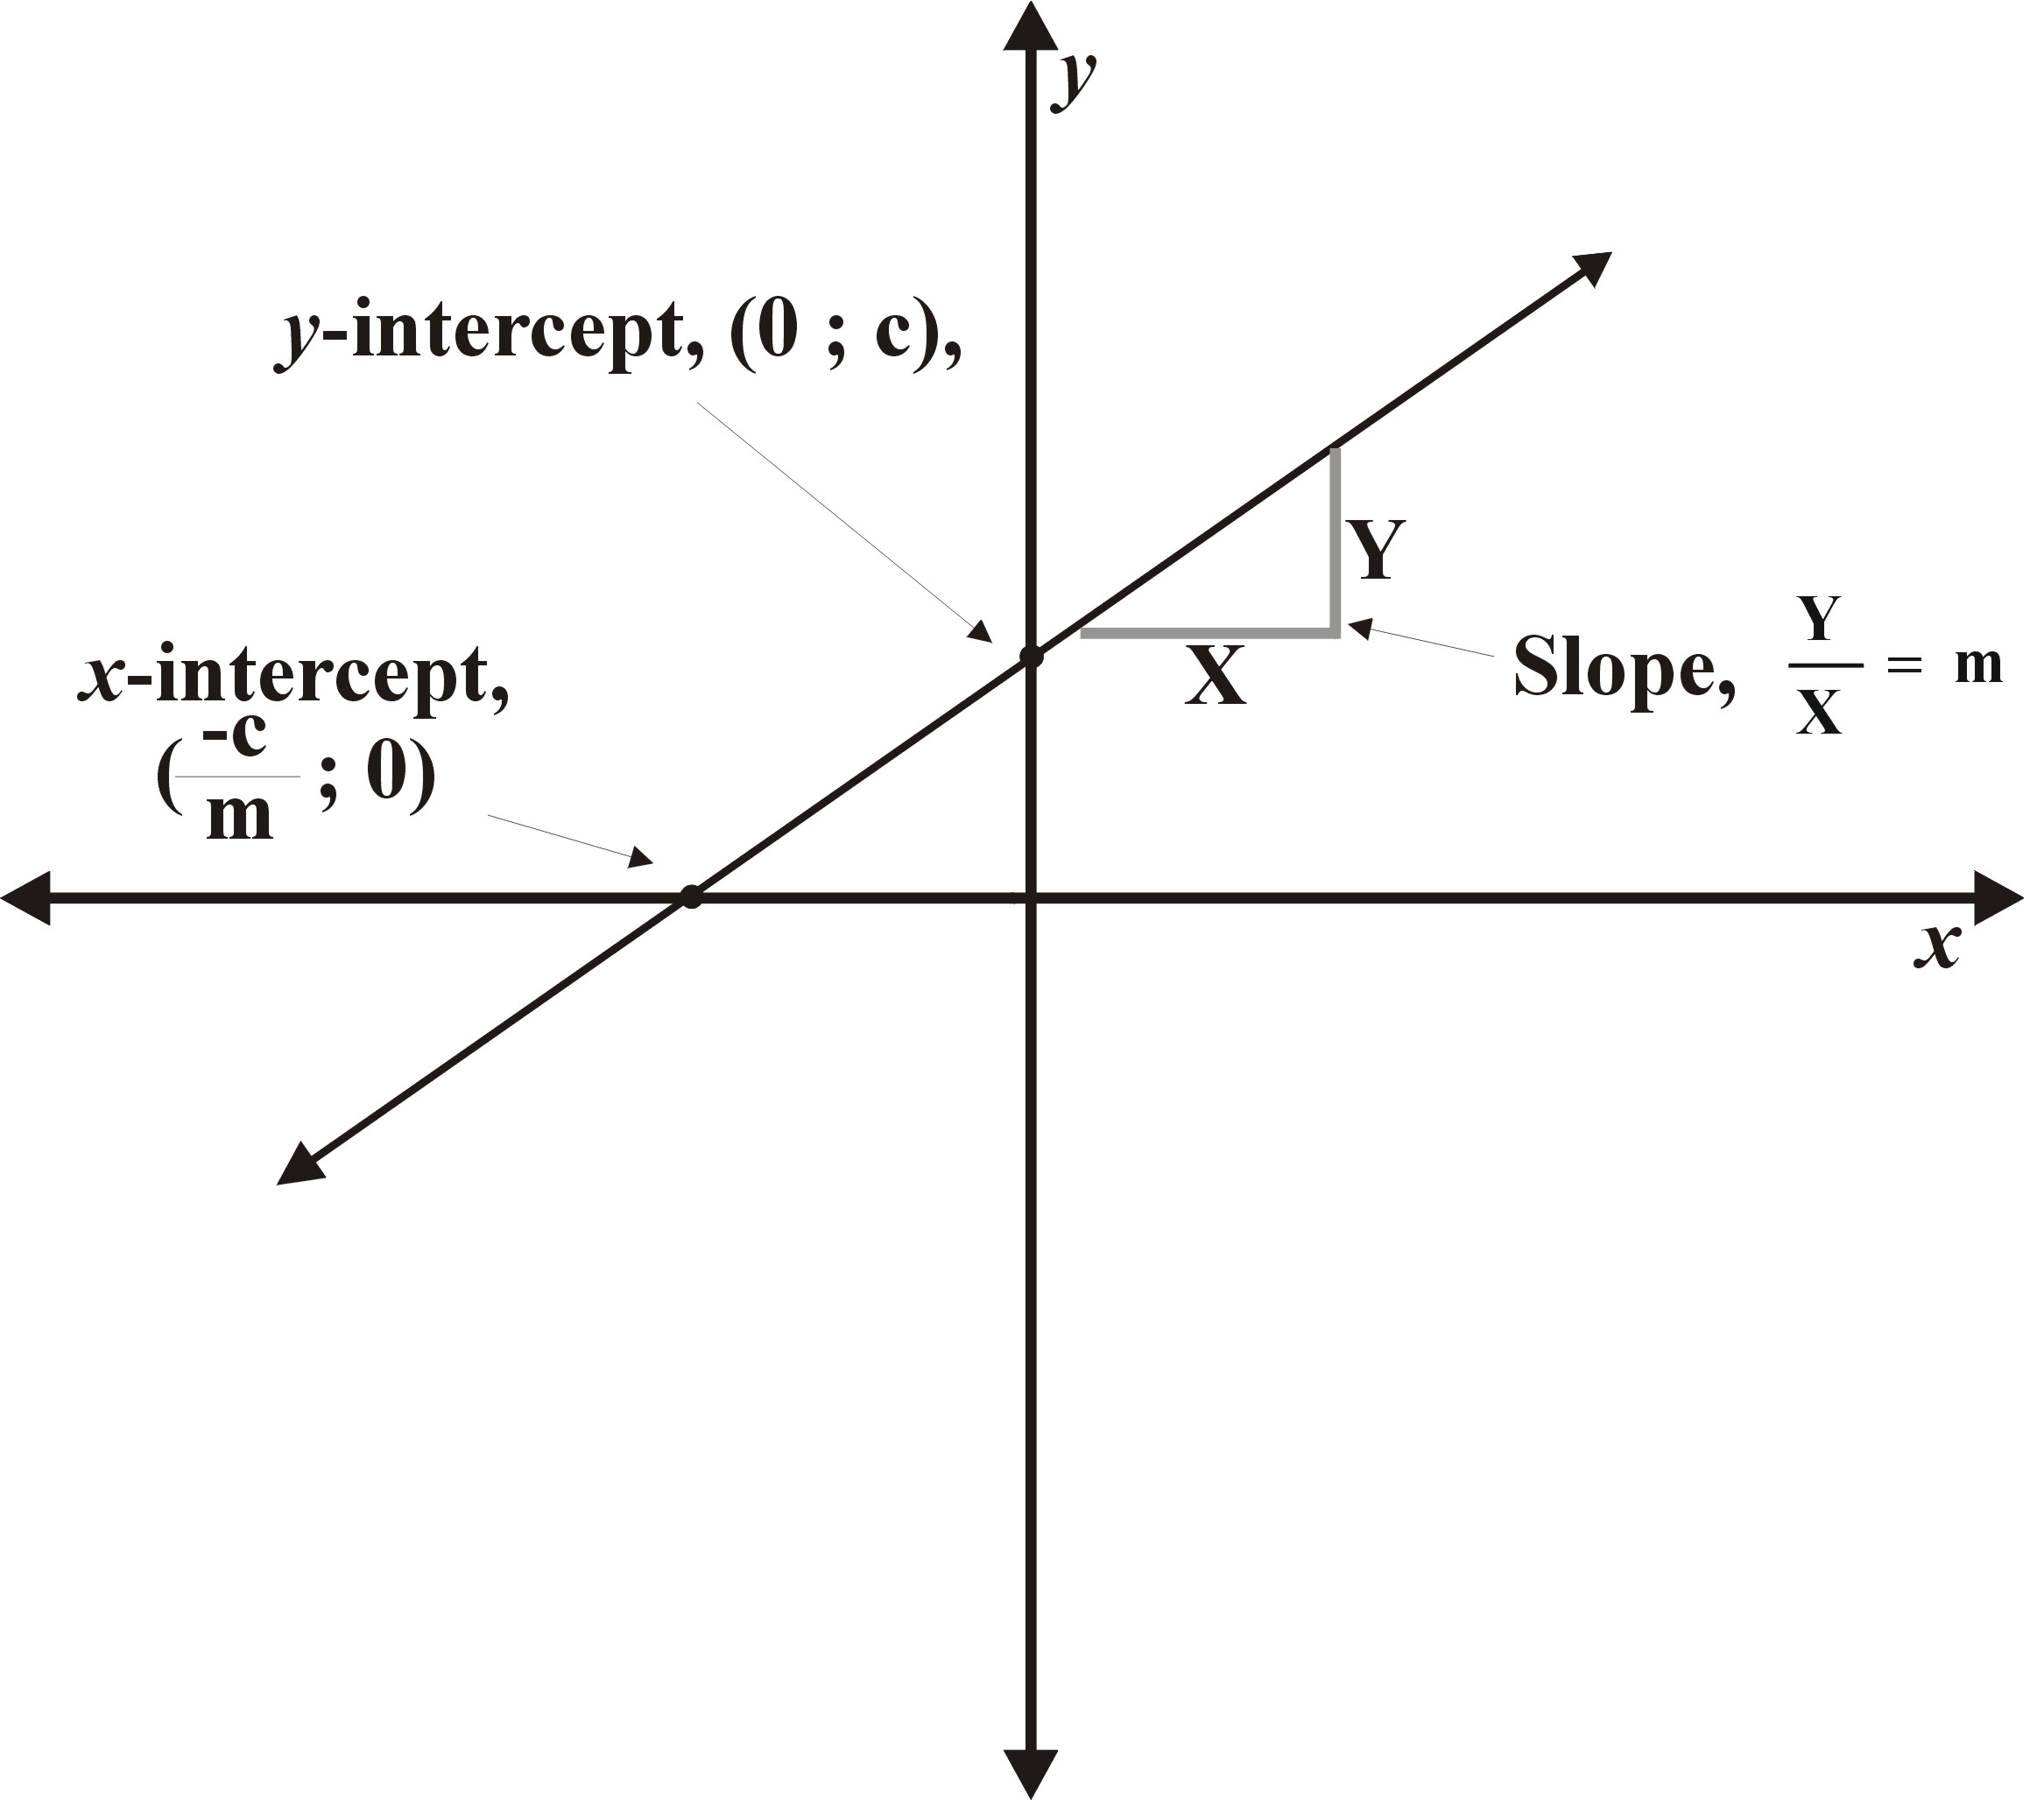
3.1 Properties of linear functions

Use the information opposite to identify the following properties about the linear function y=f(x) = 2x + 1:

- Write down the y-intercept of the function as an ordered pair. (the point on the graph where x=0)
Properties of
Linear Functions y=mx+c
- m = is called the slope or gradient and can have a positive or negative value. Positive gradients slope up and negative gradients slope down as x increases.
- c is the y - intercept. It is the point where the line cuts the y-axis. It can be calculated by letting x = 0 to give y=f (0) = c. It should be written as an ordered pair (0; c)
- The x - intercept can be found by letting y=0 and solving the equation
y=f(x) = mx+c = 0.
This is called the root of the function. It should be written as an ordered pair. (0 ; -c/m)

- Write down the slope or the gradient of the function.
- Write down the x-intercept or the root of the function as an ordered pair.
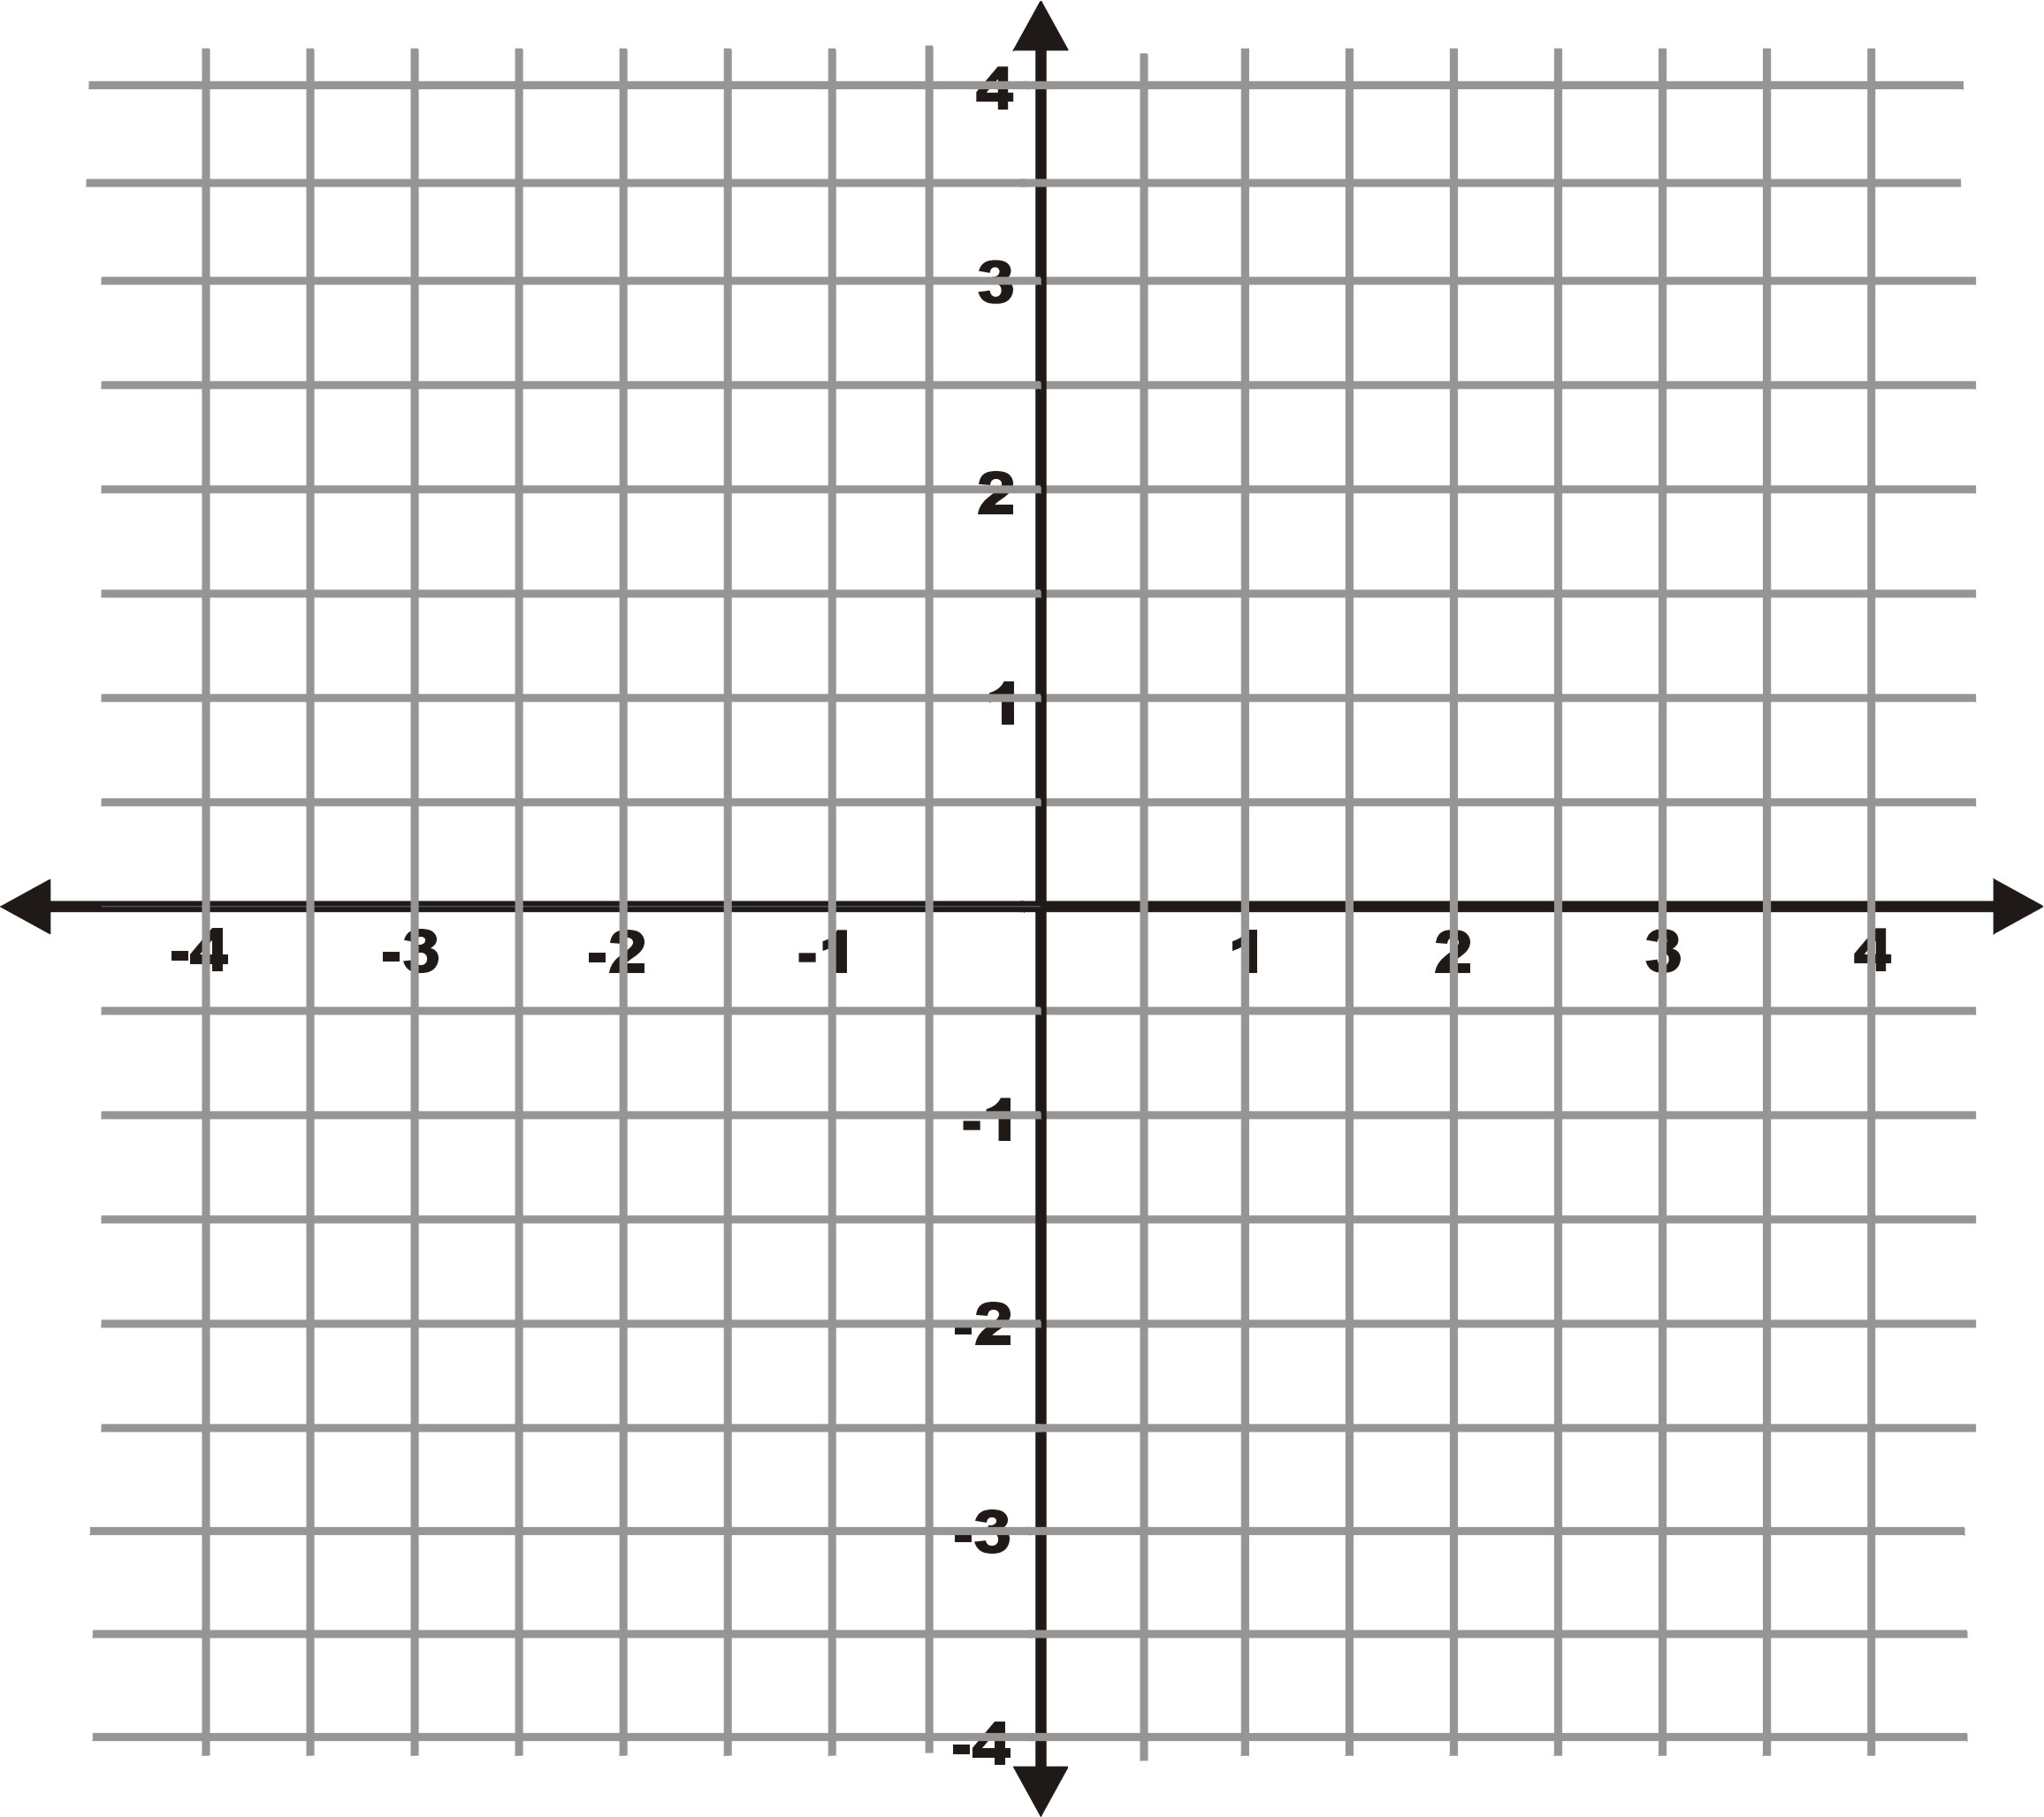
3.2 Using properties to draw a graph of a linear function.

Draw the graph of the linear function:
y =f(x) = 2x + 1 on a set of x-y axes (Cartesian plane) like the one below using the information above on properties of the linear function. Label the three properties you identified in activity 3.1 above.

Task List Assessment
Task | Score  Comment | Weight | Total Points
Defined the mathematical function that describes how a Taxi Drivers Profit is related to the number of passengers she carries.  Activity 1.2 A & B, Correctly defined the increased profit function | 1 2 3 4 | 3
Calculated a table of profit values for a taxi dricver carrying different numbers of passengers.  Activity 2.1, Table of increased profit values | 1 2 3 4 | 2
Drawn a graph of the function describing a taxi drivers profits.  Activity 2.1 and 2 B, Both profit function graphs on the same set of axes. | 1 2 3 4 | 4
Demonstrated an understanding of the terms Domain and Range and identified the domain and the range for the Taxi Driver problem.  Activity 2.3, Questions 1 to 4. | 1 2 3 4 | 1

How to score 4 points = Perfectly correct, clearly explained and presented
3 points = Mostly correct, mostly understood and understandably presented.
2 points = Partially understood, some aspects correctly explained.
1 point = Completed with a little understanding.

Multiply score by weighting to get final score for that Outcome
Add up each outcomes score to get your Lesson Score

