Equations & Inequalities | Unit 4 | Formulae

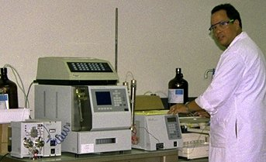

WHAT THIS UNIT IS ABOUT

In this unit you will be learning about formulae (equations that have a use or a meaning in real life). You will be learning about the formulae used to calculate real quantities like area and volume. You will make simple 3D models of containers out of flat pieces of paper or cardboard.
Mathematical Formulas are used all the time by Scientists

You will be using mathematical formulae for area and volume to calculate how much card you will need to make the containers and how much the container will hold.

You will also be learning about different formula like the ones used in Science to calculate different quantities. You will be learning how to rearrange the subject of a formula so that you can calculate the missing or unknown quantity.

In this unit you will

Design and make a container for liquid washing soap that can be made from flat material.

Use the formula for area to calculate how much material is needed to make a container.

Use the formula for volume to calculate how much washing soap the container will hold.

- Find the sizes of a container that will contain twice as much soap as a given container.

- Calculate the volume and the surface area of rectangular prisms & cylinders by substituting values into formulas.

- Change the subject of formulas so that you can calculate unknown quantities.

Activity 1

Soap container

The Situation
Hoover Bro's
Liquid Soap

Hoover Brothers SA are a company who make Washing Powder for Automatic washing machines. They have developed a new Soap that is in liquid form. They have asked you to come up with a Container for the Soap.
Hoover Bro's
Liquid Soap

The Task

Design and make a sample of a container that you can show to the Hoover Bro’s SA people. The container must be made out of flat material. You can use paper or cardboard to model your container. The company also wish to know the volume of soap your container will hold (in cm³ or ml) and how much material they will need to use (in cm²)

1.1 Identifying the Problem

- In groups of 5 or 6, discuss what you think you need to do. Make sure someone takes some notes.
- Write out a summary of what your group have been asked to do.

1.2 Some Ideas.

- Suggest some shapes that you could use for containers. Write down their names or draw a sketch of what the container might look like.
- Come up with a name for the product.
- Draw a label that can be printed as a sticker to go onto the container
- Choose which idea you prefer and draw a 3D sketch of what it will look like.

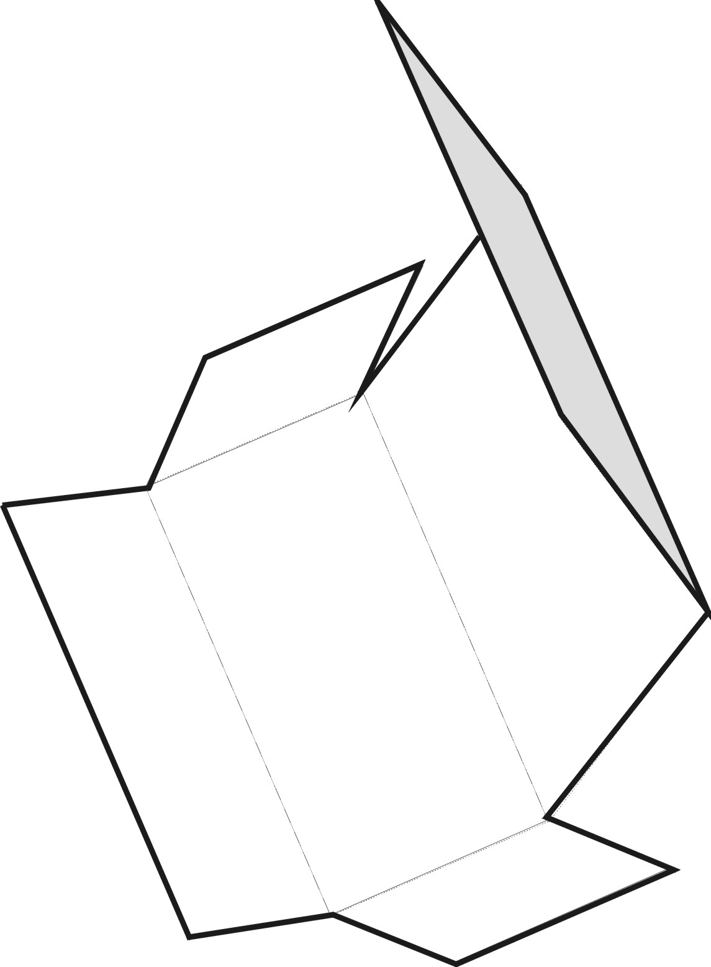
1.3 Making the container.

- Take 6 pieces of A4 Paper or Card and see if you can make a 3D model of your container. You can either make it by folding the flat cardboard or by joining pieces together.
- Calculate the area of each piece of your Container.
You will Need

- Pieces Card
- Prestic or Masking Tape
- Pair Scissors
1 Ruler or Tape Measure
- Add up the individual pieces to calculate the total area of cardboard you will need for your container.
- Calculate the Volume of Soap that your container can hold.

Some Useful Formulas.

-
L
h
B
B
Area (each surface) $=L×B$
L
Volume $=L×B×h$

Circles and Cylinders
r
r
Area = ${πr}^{2}$
h
Volume (Cylinder) $=\text{area}×h$
$={πr}^{2}h$

Cube and half a cylinder

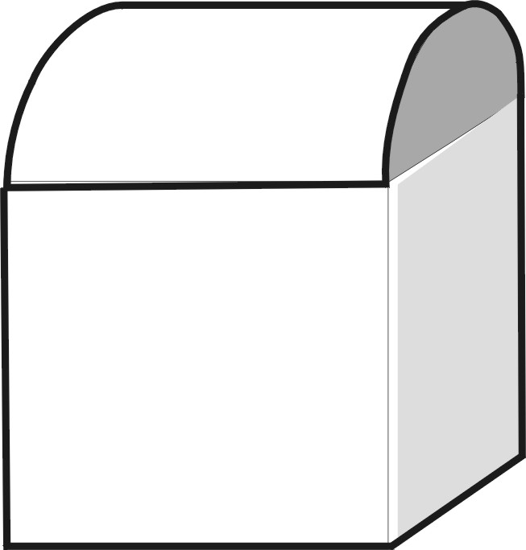
Volume $=\text{Volume of cube}+\frac{1}{2}\text{volume of cylinder}$
h-=S
$=3×S+\frac{1}{2}{πr}^{2}h$
S
For this example, $h=S$
And

$r=\frac{S}{2}$$⇒r^{2}=\frac{S^{2}}{4}$
$=3S+\frac{{πS}^{3}}{8}$

Activity 2

A Bigger Container

Congratulations. Your design has been approved by Hoover Bro’s SA. Now they want you to make a container that will look the same but it must hold exactly twice as much Soap.

2.1 Double the Volume.

- Make a container similar to the one made in Activity 1 that contains exactly twice the volume of soap.
- Sketch the container showing the important sizes.
- Calculate how much cardboard the new container will need to make it, i.e. the surface area.
- Compare the surface area to the smaller container. Is it more economical to make smaller containers or bigger ones? Explain.

Activity 3

Investigating different containers
In this activity you will be investigating what the volume might be for some different containers. You will need to substitute some real numbers into the formula’s to find the volume.

3.1 Cans for Drinks

- A cool drinks company wish to have cans made to contain their products. Calculate the Volume of cool drink the cans will contain if they choose the following sizes:

Volume of a Cylinder
$$V={πr}^{2}h$$
Cubic centimetres are the same as milliliters.
$${\text{cm}}^{3}=\text{ml}$$
- r = 3cm, h = 10cm, $π=3\text{.}\text{14}$
- r = 4cm h = 10cm $π=3\text{.}\text{14}$
- r = 3cm, h = 12cm, $π=3\text{.}\text{14}$

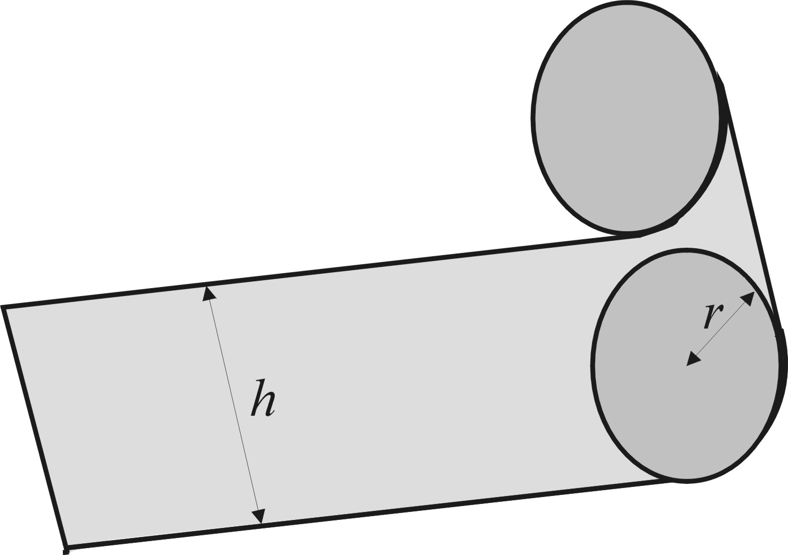
- If the drinks company wish to have 3 different sizes, 340ml, 500ml and 750 ml, all with the same radius of 3cm, calculate the heights of the three cans.
- Calculate the area of tin needed to make the 340ml, 500ml and 750ml cans.

Surface area of a cylinder

A can could be made from two circles and a flat strip.
The length of the flat strip must wrap around the perimeter of the circles ($2πr)$
Area of strip =$2πr×h$
Area of each circle = ${πr}^{2}$
Total surface area = $2π\text{rh}+2{πr}^{2}$

3.2 Milk containers.

- A supermarket want to sell milk in cardboard containers coated with plastic. Calculate the volume and the surface area of cardboard needed for containers with the following measurements.

Volume of a Cylinder
$$V={πr}^{2}h$$
Cubic centimetres are the same as milliliters.
$${\text{cm}}^{3}=\text{ml}$$
- l = 8cm b = 8cm h = 15cm
- l = 12cm b = 8cm h = 20cm
- l = 12cm b = 12cm h = 15cm,

- Come up with a range of 3 milk cartons that will contain 500ml, 1 litre (1000ml) and 2l (2000ml). You need to choose the length and the breadth and then calculate the height.

Activity 4

Using formulas

In this activity you will need to re-arrange a formula so that you can calculate the unknown quantity.

4.1 Pressure, Force and Area, a Scientific formula

A car jack works by pumping oil into a piston so that it forces the car to lift. The formula that is used to describe the relationship between Pressure (P), The lifting force (F and the area of the Piston (A) is:
$$P=\frac{F}{A}$$
For formulas that look like this you can always use the equation triangle.

To use the triangle, simply cover the unknown quantity with your finger and write down the equation as you see it.
Where P is the Pressure of the oil
F is the lifting force
A is the surface area of the piston
Calculate the force lifting the car if the pressure in the jack is 100 N/cm² and the area of the piston is 50cm²

Calculate the radius of the piston that will give a surface area of 50cm² by rearranging the formula for the area of a circle, i.e.
To Find F, cover F
Write down what you see:
$$P×A$$
$$A={πr}^{2}$$

Cross multiply to get F (the unknown) on its own

$\frac{P}{1}$ $\frac{F}{A}$
gives
$\text{PA}=F$ or $F=\text{PA}$

Cross Multiply to get r² on its own

$\frac{A}{1}$ $\frac{{πr}^{2}}{1}$
$\frac{A}{π}=r^{2}$ or $r^{2}=\frac{A}{π}$
Take the square root of both sides
$$r=\sqrt{\frac{A}{π}}$$

4.2 Velocity, Acceleration & Time, An equation of Motion.

The formula that describes the relationship between velocity, acceleration and time can be written as:

Where
$v_{1}$is the final velocity
$v_{2}$is the initial velocity
$a$ is the acceleration
$t$ is the time in seconds.

Formulae Tip

When you read a problem always write down a list like this of the values you know.

$v_{1}=v_{0}+\text{at}$

- A car is travelling at 20m/sec (72km/h) when the driver sees a little girl run out in front of the road. He puts on the brakes causing the car to decelerate at (–4m/s², a negative acceleration means slowing down). Calculate:
How much time the girl has to run across the road without being hit by the car. (How long will it take the car to stop)
If the driver delays by 1 second putting on the brakes, How fast will the car be going when it hits the girl if she takes the time calculated above to cross the road?
If the driver were travelling below the speed limit at 15m/s (54km/h) and delays by 1 second, would he have hit the girl?

4.3 Money Lending, A formula for monthly repayments.
A money lender has come up with a simple formula to calculate how much money people should pay her back every month. She has decided that she will only lend money to people over a one year period (12 months) and she will charge 10% interest per month plus an “administration fee” of R50 per month. She has developed the following formula to calculate monthly repayments from loans:
$P_{\text{month}}=L_{\text{amount}}×\frac{\text{10}}{\text{100}}+\text{50}$
Where
$P_{\text{month}}$ is the monthly payment
$L_{\text{amount}}$ is the Loan amount.

- What is the monthly payment she will receive from a R1000 loan?
- How much money will she have made after she has received all 12 payments.
- If a customer can afford R200 per month on repayments, How much money can she borrow? How much money will she have to pay back in total?

