Equations & Inequalities | Unit 3 | Solving Linear Inequalities

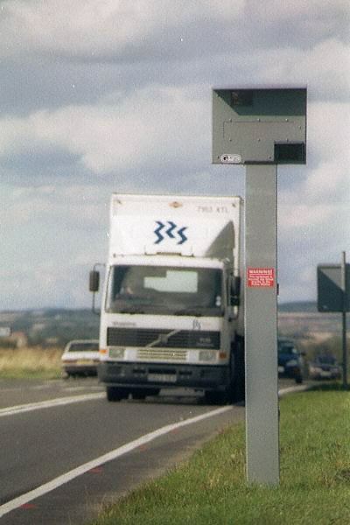
WHAT THIS UNIT IS ABOUT

In this unit you will be learning about the linear inequalities and their solutions. Inequalities are used when it is not necessarily one answer you are looking for but a range of answers that are greater than or less than a number or quantity.

A business for example may need to make a minimum amount of money each month to pay all their bills. They may then try to make a profit that is greater than that amount, rather than equal to it.

You will be learning about how to represent inequalities using the appropriate symbols and how to represent a set of numbers that are less than or greater than a given number on a number line. You will learn how inequalities behave when you add and multiply equal quantities to both sides. You will then use all this knowledge to solve linear inequalities and to represent their solutions.
Traffic police use cameras to photograph motorist that drive at speeds greater than the speed limit.

In this unit you will

- Use the symbols for inequalities to correctly represent “greater than”, “less than”, “greater than and equal to” and “less than and equal to”.

- Use number lines to represent a set of whole numbers, a range of real number and to show whether the end points are included or excluded.

- Solve linear inequalities involving addition and subtraction

- Solve linear inequalities involving Multiplication.

- Solve linear inequalities that involve both addition and multiplication

- Represent solutions to linear inequalities as number lines and using set notation.

Activity 1

Identifying Inequalities

1.1 Are you over 18?

It is illegal for a liquor seller to sell liquor to a person under the age of 18.

- Describe the age of all the people who can buy liquor?
- Describe the age of people who cannot be sent to buy liquor?
- The following list is the ages of 14 different people: {3, 4, 4, 6, 7, 7, 9, 10, 16, 19, 21, 21, 23, 25}.
- How many people can be sent to buy liquor?
- Write down the list of the ages of these people?
- How do you know they can buy liquor?
- What are the ages of the people who cannot be sent to buy liquor?
- How could you describe their ages?

Symbols for Inequalities
The symbol > indicates ‘is greater than’ i.e.
$\text{LHS}>\text{RHS}$Means that the left-hand side is greater than the right hand side.
The symbol ≥ Indicates ‘is greater than or equal to’ i.e.
$\text{LHS}≥\text{RHS}$ Means that the left-hand side is greater than or equal to the right hand side’.
The symbol < indicates ‘is less than’ i.e.
$\text{LHS}<\text{RHS}$ Means that the left-hand side is less than the right hand side’.
The symbol ≤ indicates ‘is less than or equal to’ i.e.
$\text{LHS}≤\text{RHS}$Means that the left-hand side of the symbol is less than or equal to the right hand side’.

- Use >, ≥, < or ≤ to replace the ? in the following statements. Add other real-life examples, then use the symbols relevantly:
- My mother’s age ? My age.
- An employee’s salary ? his superior’s salary
- You need to be ? 18 to get a driving license.
- An acute angle is any angle ? 90⁰
- An obtuse angle is ? 90⁰ but ? 270⁰

1.2 Inequalities and numbers

Place the correct sign >, ≥, < or ≤ between the two numbers

- 12 19
- -12 -19
- -2 -7
- 2 7
- 3 3
- 0 -4

1.3 Inequalities, addition and subtraction

- Yvonne has 10 apples while Kabelo has 8 apples. Who will have more apples if:
- Each gives 2 apples away?
- Each is given 5 apples?

- Place the correct sign in the spaces below.

- 10 8
- 10 – 2 8 – 2
- 10 + 5 8 + 5

- Which of the two statements is correct? How do you know?

- Adding or subtracting the same amount to or from both sides of an inequality changes the inequality.
- Adding or subtracting the same amount to or from both sides of an inequality leaves the inequality unaffected.

1.4 Inequalities and multiplication

- Complete the multiplication table shown by multiplying the row heading by the column heading.
× | -2 | -1 | 0 | 1 | 2
2 |  |  |  | 2 | 4
1 |  |  |  | 1 | 2
0
-1
-2

Remember
2 × -3 means -3 + -3 which equals –6.
If you owe two debts of R3.00 for example, you actually owe R6.00.

- Place the correct sign between the LHS and the RHS of the inequalities shown below.

- 2 > 1 ⇒ 2 × 2 1 × 2 (Both sides of the inequality multiplied by 2)
- 2 > 1 ⇒ 2 × -2 1 × -2 (Both sides of the inequality multiplied by -2)
- –1> -2 ⇒ -1 × 1 -2 ×1 (Both sides of the inequality multiplied by 1)
- –1 < 2 ⇒ -1 × -1 2 ×-1 (Both sides of the inequality multiplied by -1)
- 2 > 1 ⇒ 2 ÷ 1 1 ÷ 1 (Both sides of the inequality divided by 1)
- 2 > 1 ⇒ 2 ÷ -1 1 ÷ -1 (Both sides of the inequality divided by -1)

- From the above answer, what is the effect on the inequality symbol of:

- Multiplying or dividing both sides of the inequality by a positive number?
- Multiplying or dividing both sides of the inequality by a negative number?

Activity 2
Solving Linear Inequalities
Inequalities involving a variable like x are called linear inequalities.


2.1 Integers, Real numbers and Number lines

- Find the possible ages of people who cannot be sent to buy liquor, given that the age restriction is 18 years. Let x represent the possible ages and use the following information to find the ages for each problem:

- Ages must be selected from the set of ages below
$x∈${1, 2, 3, 4, 5, 6, 7, 8, 9, 10, 11, 12, 13, 14, 15, 16, 17, 18, 19, 20, 21, 22, 23, 24, 25}
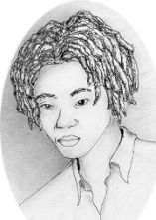
- All possible ages must be considered.

Use A number line to show your solutions
In this inequality, the set of numbers to choose from is given and they are all whole numbers.

A person who is 12½ can also not buy liquor so if everyone were included the solution would be real numbers between 0 and 18.

Drawing Number Lines

- A solution like x∈{1, 2, 3, 4, 5, 6, 7, 8, 9, 10, 11, 12, 13, 14, 15, 16, 17} can be represented on the number line as follows: A solid dot is used to show exact numbers on the number line.

- Ages like 1½ years (18 months) and all others in between must be reflected in the final solutions. This means that we are even going to have to consider all rational and irrational ages less than 18. A solid line is used to show all the real numbers between one point and another.
The circle at 18 shows that 18 itself is not part of the solution.

- Represent the possible solutions of the following on the number line. Then see if you can think of what these may represent in real life?

- x > 2, x is a natural number.
- x > 2, where x is any possible real number.

- There are three senior national soccer squads in South Africa – Bafana Bafana, Amaglug-glug (under-23s) and the under-20s. Each player can only play for one squad according to his age.
If x represents the age of a player in Bafana Bafana squad, y represents that of a player in Amaglug-glug squad and z represents the age of a player in the under-20 squad, use inequalities to represent x, y and z
Expressing an In-between inequality
The oldest acceptable age for a player to belong to a national team is 34 years.
age ≤34.
The youngest is 17
17 ≤ age
Combining the two to represent ages between 17 and 34 you can write
17 ≤ age ≤ 34.

If a player can only belong to a national squad when he is 17 years or older and 34 years and younger, use number lines to represent x, y and z.

2.2 Solving linear inequalities involving addition and subtraction.

- I had a certain number of oranges (x). I gave three oranges to a beggar. (-3). The number of oranges I now have is less than 25. What could be a possible number of oranges I started with? Represent the possible solutions on the number line.

Remember
Adding or subtracting the same number to or from both sides of an inequality leaves the inequality unchanged.
Use the additive inverse when reversing the operation (-3) to find the input (x)
Anything you do on the LHS you must also do on the RHS.
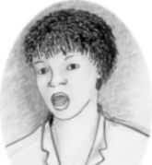
This problem only deals with whole numbers of oranges. It is not sensible to talk about a negative “certain number” of oranges.

- Use the number line to represent the possible solutions to the following inequalities. Give, where possible, practical example that could be described by the inequality.

- x + 5 ≤ 20
- x – 12 ≥ 10
- x – 3 ≥ -7

2.3 Solving linear inequalities involving multiplication and division.

- A certain number of people (x) have two apples each. If the total number of apples is less than 27, what are the possible numbers of the people? Use trial and error method to try and identify the number of people, and then use inequality to solve for these unknown numbers. Identify the maximum possible number and the minimum one.

Remember
When you multiply both sides of an inequality by a positive number the inequality remains unchanged.
When you multiply both sides of an inequality by a negative number, you need to change the inequality sign. (Greater than to less than or less than to greater than)
Use the reciprocal or multiplicative inverse when reversing the operation (x2) to find the input (x)

- Use the number line to represent all the possible values of x for which
4x ≤ 100

2.4 Linear inequalities involving multiplication, division, addition and subtraction.

- Find all possible values of x for which:

Remember
Use additive inverses before you use multiplicative inverses.
- 2x-3 ≤5
- -3x+7 ≥10
- 3x-5 < 7

Solving inequalities is very nearly the same as solving equations. Just remember to swap the inequality around when you multiply or divide by a negative number.

.

