Equations & Inequalities | Unit 1 | Equations and Business

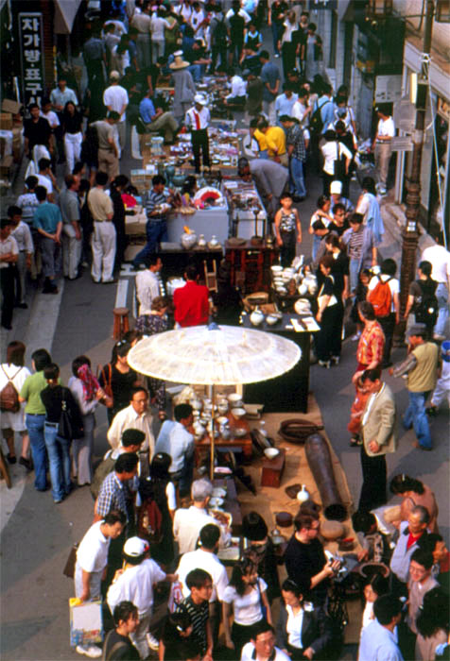

WHAT THIS UNIT IS ABOUT

In this unit you will be learning how algebra is used to help to solve real life problems.

You will be learning how to construct equations from problem situations to find an ‘unknown number’. You will then learn how to solve for the ‘unknown value’ by keeping the equation balanced across an equals sign.

You will need to be able to multiply, divide, add and subtract terms on both sides of an equation so that the left hand side becomes your unknown value and the right hand side becomes the value that balances the equation or makes it true.

A street market where traders make a living by buying products and selling them at a higher price.

In this unit you will

Co-operate in a group to find an ‘unknown number’ from different clues.

Use mathematical notation to write down a list of possible ‘solutions’ from a clue written in words.

Demonstrate understanding of the relationship between Cost price, Selling Price and Profit for a Peanut business.

- Translate a real life problem situation into an algebraic equation in one unknown.

- Cross multiply an equation to get the unknown value on its own on the left hand side and solve the equation.

- Solve for the unknown value of an equation by adding and subtracting terms on both sides of the equation to keep it balanced.

Activity 1

Mpho’s Secret Number
Solving an equation is finding the ‘unknown’ answer to a problem.
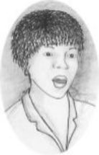
Problem solving is about using clues to find answers. In this activity you will need to use several clues to come to a solution. Each member of your group will be responsible for one clue. You will then need to co-operate with each other to find your answer.

1.1 Finding out Mpho’s secret number

A Organise your group into the following people. Make a label for each member using the letters shown in brackets and stick them on as badges.
- Clue 1 Investigator (CI-1)
- Clue 2 Investigator (CI-2)
- Clue 3 Investigator (CI-3)
- Clue 4 Investigator (CI-4)
- Clue 5 Investigator (CI-5)

B Read your own clue (in the boxes below) and quietly note down what you think the answer might be.

C Starting with CI-1, Read out your clue to the rest of the group. Listen carefully to the reader and note down the clue for yourself. After each clue try to work out what Mpho’s number might be.

D Discus all the clues and as a group find Mpho’s secret number.
CL-2
My number is a multiple of 4

CL-1
My number can be divided by 16

CL-4
The Sum of the digits in my number is 9

CL-5
My number is less than 150

CL-3
My number is the sum of odd numbers, starting at 1.

1.2 Feedback your result

Prepare to feedback your groups response to the following questions.

A What is Mpho’s secret number
B How do you know?
C What does this have to do with equations?

1.3 Equations and Inequalities.

Working on your own, let Mpho’s secret number be x, then do the tasks below.
Remember
An Equation is a mathematical way of saying what an unknown quantity is equal to, e.g.
$x=9×\text{16}$ or $x=1+3+5+\text{.}\text{.}\text{.}+\text{21}+\text{23}$
An Inequality is a mathematical way of showing what an unknown is not equal to, e.g
$x<\text{150}$
A Write down three values that might have been correct for each clue alone,
Use the format x ={a, b, c, ...} to express your possible solutions.
B Test your group's answer to show that it is one of the possible answers for all of the clues.

Activity 2

The Peanut Business

The Situation
You are a business advisor that helps small businesses to set up in our area. Mpho has asked you to advise on a Peanut Business that she has been invited to start. She has given you the following information:
- She can buy 1kg bags of peanuts for R6 each.
- They sell in the shops for R15
- She will have to pay R60 per day for a stall at the bus depot.
- She wants to take home at least R100 per day profit to make it worth her while.
Advise Mpho on what she should do.

2.1 Discuss the problem
In your groups discuss what your think Mpho should do? You should tell her:
  - How many bags of peanuts she might sell on a good day
  - How many bags she might sell on a bad day.
  - The price she should sell them for.
  - How much money she might make?
  - What you think she should do.

2.2 Feedback your Advice
Present the advice you will give Mpho to the class. Be prepared to explain why you think she should listen to you. You must support your argument with amounts that Mpho might earn on good days and bad days.

2.3 Linear Equations and the peanut Business.
Linear equations can be used to help Mpho. You will need to construct a linear equation from the situation and then solve it by keeping both sides of the equation balanced.

When two values on opposite sides of an equals sign are the same you have an Equation. To solve an equation you need to find the unknown value that balances or makes the equation true.

LHS

RHS

e.g. $(4×x)−\text{60}=\text{100}$ will be balanced if $x=\text{40}$

2.4 An equation for the money Mpho takes in.

A Write down the amount of money Mpho will make for selling each 1kg bag of peanuts.
To write an equation, always let the ‘unknown number’ be x
B Now write down an expression for the amount of money she would make for selling ‘an unknown number’ of bags of peanuts.
C Choose some values (for a good day and a bad day) and use the expression to see how much money she might collect.
D If Mpho wants to take in R200 per day, write down an equation to find out how many bags of peanuts she will need to sell.
E Now solve for x, i.e. find the unknown number of bags of peanuts that Mpho must sell. (See help box below)

Solving an equation that has a single term on each side.

Example solve for x: $4x=\text{100}$

- Divide the LHS and the RHS by 4 to get x by itself $\frac{4x}{4}=\frac{\text{100}}{4}$
on the LHS
3 The ‘unknown number’(x) equals the RHS

- Check that the solution ( x =25) balances the original
equation

$x=\text{25}$
$\begin{aligned}\text{LHS}=4×\text{25}=\text{100} \\ \text{RHS}=\text{100} \\ \text{LHS}=\text{RHS}\end{aligned}$

2.5 Extending Mpho’s equation to include her costs.
A Let the number of bags of peanuts Mpho sells be x (as before). Write down on the LHS the amount of money she will make for selling the peanuts but subtract her costs this time.
B Make the equation by putting the amount of money Mpho wants to make in a day on the RHS of the equals sign.
C Solve the equation for the unknown number x (See Help below).
D Make some different equations (for different selling prices) to see if you can help Mpho any more.
E Write two paragraphs giving your final advice to Mpho. Remember to give her some accurate numbers she can think about.
Solving an equation that has more than one term.

Example solve for x: $6x−\text{80}=\text{100}$

1 Add 80 to LHS and to the RHS. $6x−\text{80}+\text{80}=\text{100}+\text{80}$
$6x=\text{180}$
2 Divide the LHS by 6 and the RHS by 6 $\frac{6x}{6}=\frac{\text{180}}{6}$
$x=\frac{\text{180}}{6}$
3 The ‘unknown number’(x) equals the RHS $x=\text{30}$

4 Check that the solution $\begin{aligned}\text{LHS}=6×\text{30}−\text{80}=\text{180}−\text{80}=\text{100} \\ \text{RHS}=\text{100} \\ \text{LHS}=\text{RHS}\end{aligned}$

Activity 3

The speed equation
$$\begin{aligned}\text{Distance}=\text{Speed}×\text{time} \\ D=S×t\end{aligned}$$

3.1 Distance, Speed & Time

David and S'busiso were competing the 100m athletics on Sports Day. David can run faster than S'busiso. It takes David $\frac{3}{4}$of the time it takes S'busiso to complete 100m.
The Equation Triangle
For all equations like this you can make a triangle to help you.

If the unknown is S, simply cover S and write down what you see, i.e.
$$S=\frac{D}{t}$$

A If David’s time in the 100m trials was 12 secs, how long would it take S'busiso to run the same race?
B What was the speed that David was running at?
C What speed was S'busiso running at?

Example, Solving Equations with fractions.

Solve for y: $\frac{y}{3}=\frac{3×\text{17}}{2}$

- Multiply both sides by the Lowest Common Denominator (L.C.D.), i.e. 6

$6×\frac{y}{3}=6×\frac{3×\text{17}}{2}$

- Simplify the denominators on each side

$$2×y=3×(3×\text{17})⇒2y=\text{153}$$
3 Divide both sides by 2

$$y=\frac{\text{153}}{2}=\text{76}\text{.}5$$
Example, Solving Equations with fractions by cross multiplying.
Solve for y: $\frac{y}{3}=\frac{3×\text{17}}{2}$
- Multiply the numerator of the LHS by the Denominator of the RHS,
and
Multiply the numerator of the RHS by the denominator of the LHS
$y×2=\left(3×\text{17}\right)×3$
$$2y=\text{153}$$
- Divide both sides by 2

$$y=\frac{\text{153}}{2}=\text{76}\text{.}5$$

D A number n divided by 9 is equal to 55. What is n?

Activity 4

Practice, Practice, Practice

  - Solving Algebraic equations

The equations below all have one ‘unknown number”. Use your knowledge of equations and algebra to find these unknown numbers.

- 14 = n + 12

- 2 = $\frac{r}{2}$

- 2x + 14 = 5 – x

- y - 5 = 2y + 3

- 5 + 3y = 6 + 4y - 5 - 2y

- 4x - 2 -3x + 8 = 1 2x - 4 + 5x

- 2(x - 2) - (x - 1) = 2x – 2

- p + 5 = 1 - p
3

- 2(m + 1) - 3(2m - 1) - m + 2 = 0

10. $\frac{2x−5}{(2+2)(x−4)}$ = $1\begin{aligned}\frac{2(x−4)}{}\end{aligned}$

4.2 Equations from word problems

Write a word problem for each of the following problems, then solve for the unknown value.

- A father is twice as old as his son. He was six times his son's age twenty years ago. How old is the father? (HG)

- You bought 12 metres of curtaining. Some of the material came from a roll with a slight flaw in it and cost R7.00 per metre instead of the normal R8.00 per metre. If you paid R93.50 altogether, how many metres of the damaged material did you buy? (HG)

- The unit digit of a two-digit number is half the tens digit. If the digits are reversed, the new number is 36 less than the original number. Find the original number.(HG)

- There were 579 spectators at the soccer match. Of these 123 spectators were children and there were twice as many men as women. How many women were there? How many men were at the match?

- What do these figures tell you about the attitude and values of men as opposed to women towards soccer matches?

