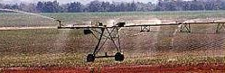  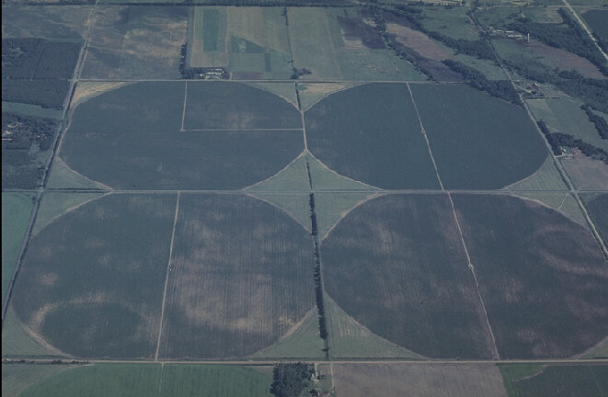  Functions and Graphs  A radial irrigation pipe used to water fields in a circle  An Arial photo of fields prepared for circular irrigation. | Unit 2 | Circles, Fences & long journeys

WHAT THIS UNIT IS ABOUT

In this unit you will be learning about two new functions and their graphs, the circle and the hyperbola. Both of these can be represented as functions using$x$ and$y$variables. These functions can be used to calculate the set of points that can be used to plot a graph. We will be using this technique to help a farmer to build a fence around a circular field and a truck company to work out how long it will take trucks to complete a journey at different speeds.

You will need to use the property of symmetry to help you to plot these graphs. You will also learn what is meant by an asymptote on a hyperbola graph and how this relates to a real situation.
.
In this unit you will

- Calculate the set of$y$co-ordinates on the circumference of a circle, given the radius and the$x$ co-ordinates.

- Use the equation $x^{2}+y^{2}=r^{2}$ to plot a circle onto a set of axes.

- Use the property of symmetry to correctly deduce new points on a graph from given points.

- Identify the radius of a circle from a range of different given equations.

- Use the equation $\text{xy}=c$ to plot a hyperbola onto a set of axes.

- Demonstrate understanding of an asymptote and how it relates to the hyperbola graph.

Activity 1
A graph of a circular field

The Situation
A farmer wants to make a circular field on her farm. This will allow her to use an irrigation system that waters the field in a circle, from a radial pipe attached to the centre of the field. The pipe will automatically revolve watering the whole field over night.
The graph of the relation:

$$x^{2}+y^{2}=r^{2}$$

Is a circle of radius r with the centre at the origin.
Your task is helping the farmer to build a circular fence around the field. The radius of the field is to be 40 metres. You will need to calculate a position map of where she should place the fence posts so that they form a circle around the field. The map should us a scale of 1:1000 (i.e. the radius of the map should be 4cm)

1.1 Calculating the table of values.
The farmer will be able to measure distances from the x and y-axes to locate the positions of her fence poles. The equation opposite will allow her to calculate the y co-ordinates from a given x and a given radius.
$\begin{aligned}x^{2}+y^{2}=r^{2} \\ y^{2}=r^{2}−x^{2} \\ y=\sqrt{r^{2}−x^{2}}\end{aligned}$
Complete the table of values below for the x values given. These represent positive x and y values on the circle. Use the formula opposite to calculate the y-values. Remember the radius of the map is 4cm that will represent 40m for the farmer.

+ x position of fence post | 0 | 1 | 2 | 3 | 3.5 | 4
$$r^{2}−x^{2}$$ |  | 15
+y position of fence post.  $$y=\sqrt{r^{2}−x^{2}}$$ |  | 3.9
Check  $$x^{2}+y^{2}=r^{2}$$ |  | 16

If you do not have a calculator, use the table of values below to work out the square root (SQRT) of $r^{2}−x^{2}$.

Number ($r^{2}−x^{2}$) | 1 | 2 | 3 | 4 | 5 | 6 | 7 | 8 | 9 | 10 | 11 | 12 | 13 | 14 | 15 | 16
SQRT of number | 1.0 | 1.4 | 1.7 | 2.0 | 2.2 | 2.4 | 2.6 | 2.8 | 3.0 | 3.2 | 3.3 | 3.5 | 3.6 | 3.7 | 3.9 | 4.0
1.2 A plan of the first quarter of the fence

Use the table of calculated values to draw the graph of the first quarter of the circular fence. Plot the fence posts as dots on the graph below and then join up the dots to make a quarter circle.
If the y value for x = 1 is 3.87, what is the x value for y = 1? Add this point to your graph.

1.3 Symmetry about the y- axis.

Complete the table below for the points in the second quadrant of the graph. You should be able to deduce the values by looking at the graph and the table of values above. When you have completed the table, plot the positions of these fence posts.

-x position of fence post | 0 | -1 | -2 | -3 | -3.5 | -4
+ y position of fence post. |  | 3.9

1.4 Symmetry about the x-axis, the bottom half circle

You already know that there are two values of x for every value of y, There are also two values of y for every value of x. Complete the table below with the negative y-values of the circle, i.e. quadrants 3 and 4. Then plot the position of all the fence posts on the new graph below. On the fence-posts to make a freehand circle representing the fence.

x – position of fence post | -4 | -3.5 | -3 | -2 | -1 | 0 | 1 | 2 | 3 | 3.5 | 4
-y position of fence post. |  |  |  |  |  |  | -3.8

How do you think a farmer might map out a grid on her field so she could use this information?

Do you think there is an easier way of placing the fence-posts in an accurate circle?
1.5 Identifying the radius of a circle from its equation.

In this activity you will need to look at one of these equations and quickly pick out the radius of the circle represented by the equation. Remember this is often the square root of the number shown (16 in this example)
For a radius of 4 the equation is :

$$\begin{aligned}x^{2}+y^{2}=\text{16} \\ \text{or} \\ y=\sqrt{\text{16}−x^{2}}\end{aligned}$$

Write down the radius of the circle represented by the following equations.

Equation | Radius of circle represented.
$$x^{2}+y^{2}=\text{25}$$
$$y^{2}=9−x^{2}$$
$$y=\sqrt{4−x^{2}}$$

$$x^{2}+y^{2}=\frac{\text{25}}{9}$$
$$y=\sqrt{\text{36}−x^{2}}$$

$$y^{2}=\text{25}−x^{2}$$
$$9x^{2}+9y^{2}=\text{25}$$

  - Proof that the equation of a set of points on a circle is:
$x^{2}+y^{2}=r^{2}$

Take any point P(x;y) on the circle and drop PN perpendicular to the x-axis. This will form the right-angled triangle $Δ\text{PNO}$.

Now from Pythagoras in Geometry we can write that:

PN² + NO² =PO²

Or

$$y^{2}+x^{2}=r^{2}=4^{2}$$

Therefore the equation of a set of points on a circle is:$x^{2}+y^{2}=r^{2}$

1.7 Applying Pythagoras to circle graphs.

On the graph opposite show, read off the lengths for PN and NO, then calculate:

PN² + NO² = ________________________

PO² = ________________________

What does this show?

Now draw any other radius on the same graph, Label the end point Q and drop a perpendicular line onto the x-axis to meet at R.

Read off the lengths for QR and RO, then calculate:

QR² + RO² = ________________________

QO² = ________________________

Activity 2
Hyperbola

2.1 Plotting a hyperbola function.
What is a hyperbola

Any relationship or function that can be written in the form below is a hyperbola.

xy = constant.

Or in words, If the product of two variables is constant, then the function is a hyperbola.

Trucks travelling from Johannesburg to Bloemfontein use a motorway that has no stop streets or traffic lights. The route is straight and the distance is 400km.
A transport manager wants to work out how long it will take her trucks to cover the distance in different circumstances. A heavily loaded truck can only travel at an average speed of 40km/h while an empty truck can travel at 120km/h average speed.
A Complete a table of values like the one opposite to show how long it will take to complete the journey for speeds between 40km/hand 120km/h in 10km/h intervals
B Draw the points on a graph like the one below, with units representing speed along the y-axis and those representing time along the x-axis.
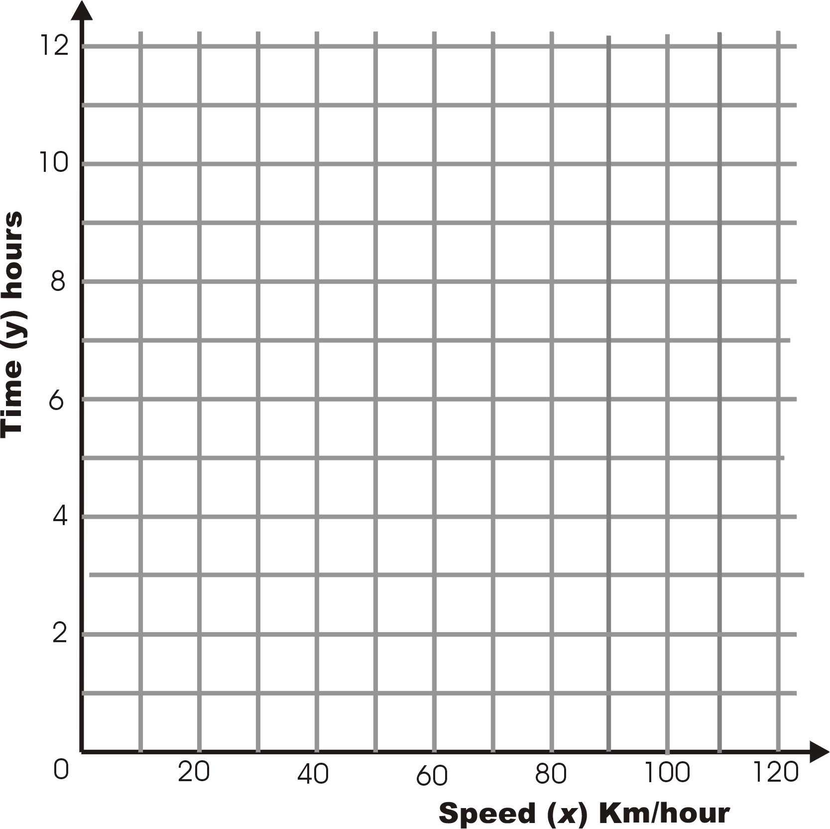
Time (Hours) | Speed (km/hour) $\text{speed}=\frac{\text{Dis}\text{tan}\text{ce}}{\text{time}}$
40
50 | $$=\frac{\text{400}}{\text{50}}=8\text{hours}$$
60
70
80
90
100
120

2.2 Exploring the Hyperbola function

Answer the questions below about the hyperbola graph you have just drawn.
- How fast would a truck driver have to go to complete the journey in 1 hour?
- How long would it take if a truck driver travelled at 10km/hour the whole way?
- Can the time taken to complete the journey ever be zero? Explain.
- What happens to the speed as the journey time gets smaller?
- What happens to the speed as the journey time gets longer?
Hyperbola and Asymptotes
An asymptote is a line on a hyperbola graph that the function gets closer to but never reaches as one of the variables tends towards infinity (gets very big)
In the example above:
The journey time gets closer to zero as the average speed gets very big. We say that the journey time tends to zero as the average speed tends to infinity. The x-axis is an asymptote for the hyperbola function.
The journey time tends to infinity (will take forever) as the average speed tends to zero, (gets slower). The y-axis is an asymptote for the hyperbola function.

2.3 Drawing the graph of xy=k, where k is a positive constant and x and y can be negative or positive.
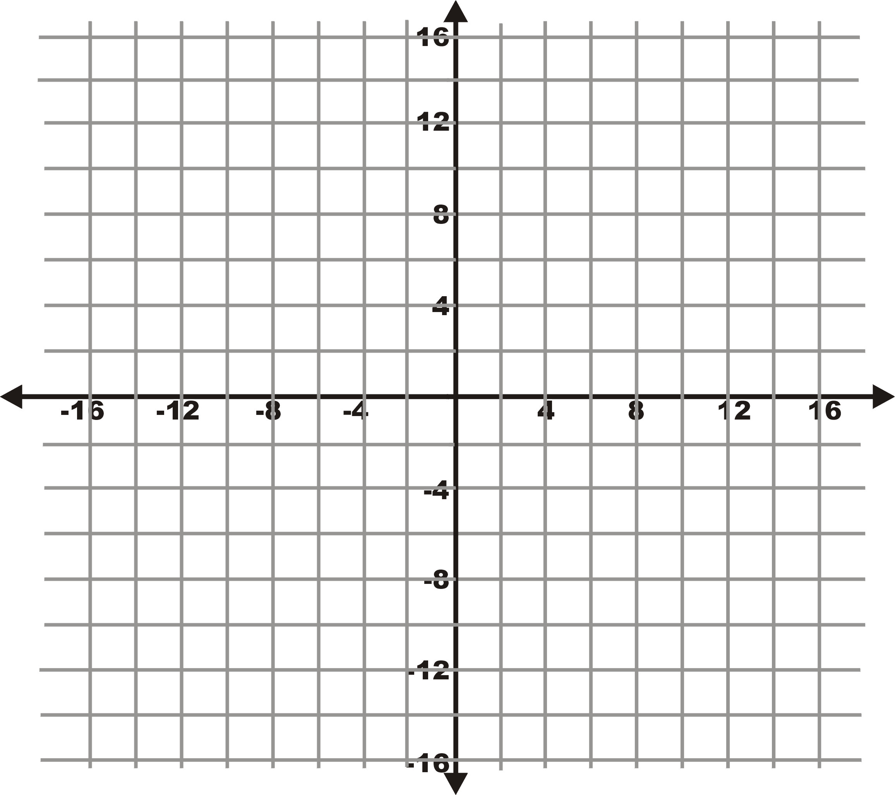
A Use x,y ∈ {-32, -16, -8, -4, -2, -1, 1, 2, 4, 8,16, 32} to draw up a table of x and y values such that:
xy =32
B Then plot the co-ordinates on a set of xy axes like the ones shown.

C Now plot the graph of xy =16 using the same set of axes and the same set of points, Then answer the questions below:
- How would you describe the difference between the curves of xy=32 and xy=16?
- What are the values of x and y that are not allowed in this function?
- How do these values affect the curves?
- The function has two separate curves. Why?
- Where do you think the curves will be on for the function xy=-16?
- Why do you think this?

2.4 Drawing the graph of xy=-k, where k is a negative constant and x and y can be negative or positive.

A Draw up a table of x and y values fore the function:
xy = -16 and xy = -32.
B Then plot these two functions on a set of axes similar to the one used in activity 2.3 above.
C What can you say about the difference and similarity between this graph and the one you produced in activity 2.3?

2.5 Summarising the properties of Hyperbola functions

A Choose the correct word in bold italics in the sentences below and then rewrite the sentences to summarise the properties of the hyperbola function.

- The equation of a rectangular hyperbola in standard form is xy=k/xy=0, where k is a non-zero constant.

- Neither x nor y can be zero/infinity, because k≠0.

- If k > 0, the product xy is positive/negative , which is possible only if x and y have the same/opposite sign. Therefore the hyperbola lies in the first and third/second and fourth quadrants.

- If k < 0, the product xy is positive/negative, which is possible only if x and y have the different signs. Therefore the hyperbola lies in the first and third/second and fourth quadrants.

