Algebraic Fractions | Unit 2 | Multiply, Divide, Add & Subtract

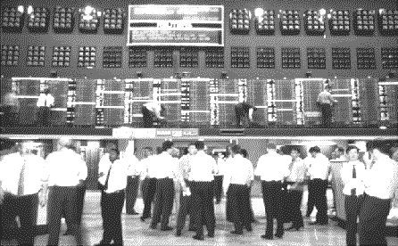
WHAT THIS UNIT IS ABOUT

In this unit you will be learning how to multiply, divide, add and subtract fractions and algebraic fractions.

You will be using the fraction board to demonstrate how these operations work. When you multiply two fractions you multiply the numerators and the denominators. Dividing by a fraction is the same as multiplying by its inverse and when you add or subtract fractions you have to find a common denominator first.
Traders working on the Johannesburg Stock Exchange, where shares (or fractions) of companies are bought and sold.

In order to simplify algebraic fractions you will need to use all the skills you have learned about algebraic products and factorising algebraic expressions.

In this unit you will

- Use a Fraction Board and fraction strips to show that when you multiply two fractions, you multiply numerators together and denominators together.

- Multiply algebraic fractions and simplify the expressions by factorising and cancelling out common factors in the numerators and denominators.

- Use a Fraction Board and fraction strips to show that dividing by a fraction is the same as multiplying by its inverse.
- Divide algebraic fractions and simplify the expressions by factorising and cancelling out common factors.

- Use a fraction board and fraction strips to show that that when you add or subtract fractions, the result will have a common denominator that is a multiple of both the denominators in the original fractions.

- Add, subtract and simplify algebraic fractions.

Activity 1

Multiplication of Fractions

In this activity you will be learning how you multiply fraction. You will using fraction strips to work out the pattern for multiplying fractions together correctly,
×
means
of
e.g that $\frac{1}{2}$× $\frac{1}{5}$ = $\frac{1}{\text{10}}$
  - Make fraction strips for the fractions below and use them to multiply the fractions in the table. (see example)
  - Make your own table to record your results.
  - Work out what you could multiply to get the same result.

Example
Multiply $\frac{1}{2}$×$\frac{1}{5}$ or Find $\frac{1}{2}$of$\frac{1}{5}$.
- Cut a $\frac{1}{5}$ fraction strip
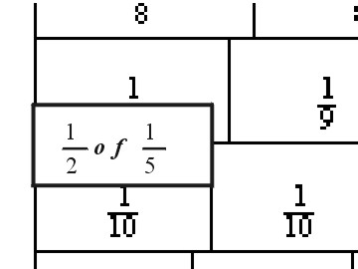
- Fold the $\frac{1}{5}$ fraction strip into two equal parts. Each of these parts will represent $\frac{1}{2}$of $\frac{1}{5}$
- Use the Fraction board to find an equivalent fraction for the folded length.

 | Fractions to Multiply | Equivalent length | What you can multiply to get this result
1 | $$\frac{1}{2}×\frac{1}{5}$$ | $$\frac{1}{\text{10}}$$ | Multiply 1 x 1 to get the numerator, 1 and 2 x 5 to get the denominator, 10
2. | $$\frac{1}{3}×\frac{1}{2}$$
3. | $$\frac{1}{3}×\frac{2}{3}$$
4. | $$\frac{1}{2}×\frac{3}{5}$$
5 | Try some of your own

Sometimes you can ‘cancel’ the numerator of one fraction with the denominator of the other fraction.

‘Cancelling ’ means dividing both the numerator of a fraction and the denominator of another fraction by a common factor.

1.4 Use fraction strips to demonstrate how a factor in the numerator (top) of a fraction can ‘cancel out’ a factor in the denominator (bottom). Use the fractions in the table below & then make up some of your own.

Example
Multiply $\frac{1}{2}$×$\frac{2}{3}$ or Find $\frac{1}{2}$of$\frac{2}{3}$.
- Cut a $\frac{2}{3}$ fraction strip
- Fold it into two equal parts.
- Use the Fraction board to find an equivalent fraction for the folded length.

 | Fractions to Multiply | Equivalent Fraction | What is (or are) the common factor you can ‘cancel out’ from the numerator and the denominator.
1 | $$\frac{1}{2}×\frac{2}{3}$$ | $$\frac{1}{3}$$ | 2
2. | $$\frac{1}{3}×\frac{3}{5}$$
3 | $\frac{1}{3}$ × $\frac{3}{8}$
4 | $$\frac{3}{4}×\frac{2}{3}$$
5 | $\frac{3}{4}$× $\frac{4}{9}$
6 | Try some of your own

Remember
To multiply two fractions we must multiply the numerators together and the denominators together.

In Algebra, fractions can be parts of ‘x’, i.e. the whole is ‘x’, a placeholder or variable that can take on any value.
1.5 Multiply the algebraic fractions below by multiplying the numerators and the denominators to make new fractions. Remember to cancel out any common factors

$\frac{1}{5}$ of ‘x’ is written as $\frac{x}{5}$ and
$\frac{1}{2}$× $\frac{x}{5}$ = $\frac{x}{\text{10}}$. Similarly,
$\frac{1}{2}$× $\frac{2x}{3}$= $\frac{x}{3}$.

Example
Multiply $\frac{x}{2}$×$\frac{2(x−1)}{3}$ i.e. find $\frac{x}{2}$ of $\frac{2(x−1)}{3}$
- Cancel out the 2 in both the top and the bottom. $\frac{x}{1}×\frac{(x−1)}{3}$
- Multiply the numerators together for the numerator $\frac{x(x−1)}{?}$
- Multiply the denominators together to give the denominator $(3×1)=3$
$⇒\frac{x}{2}$×$\frac{2(x−1)}{3}$ = $\frac{x(x−1)}{3}$

- $$\frac{x}{6}×\frac{2(x+2)}{x+3}$$

- $$\frac{x−1}{x+1}×\frac{(x+1)^{2}}{x−1}$$

- $$\frac{x^{2}−x}{3}×\frac{9(x+1)}{(x−1)(x+1)}$$
- $\frac{(x−1)(x+2)}{(x+1)(x+3)}$ × $\frac{(x+1)^{2}}{(x−1)}$

- $\frac{x^{2}−y^{2}}{3}$ × $\frac{6}{(x−y)^{2}}$

1.6 Now multiply and simplify these examples. You will need to factorise the expressions first so that you can ‘cancel out’ common factors.

- $\frac{2p^{2}+7p−4}{3p+\text{12}}$ × $\frac{6}{4p−2}$
- $\frac{x^{2}−y^{2}}{x^{2}+2\text{xy}+y^{2}}$× $\frac{3x+3y}{4}$ × $\frac{2x−2y}{x^{2}−2\text{xy}+y^{2}}$

Activity 2

Dividing Fractions

In this activity you will be learning that dividing one fraction by another is the same as multiplying the fraction by its inverse or reciprocal.
The inverse of a fraction is the fraction turned upside down.
i.e. The inverse of $\frac{5}{x}\text{is}\frac{x}{5}$

For example

$\frac{1}{3}$ ÷ 2 is the same as $\frac{1}{2}$of $\frac{1}{3}$ which is the same as
  - Use fraction strips to check for yourselves that dividing by a fraction is exactly the same as multiplying by its inverse.
  - Record your results in a table like the one below.

Example
Divide $\frac{1}{3}$ ÷ 2
- Cut out a $\frac{1}{3}$ strip and fold it into two parts. Each part being $\frac{1}{3}$ ÷ 2
- Use the fraction board as before to find an equivalent fraction.
- Find the equivalent fraction for $\frac{1}{2}$of$\frac{1}{3}$ (as above for multiplication)

 | Fractions to Divide | Is equal to: | Is equivalent to Multiplying
1 | $\frac{1}{4}$÷ 3 | $$\frac{1}{\text{12}}$$ | $\frac{1}{3}$×$\frac{1}{4}$
2. | $\frac{1}{2}$÷2
3 | $\frac{3}{4}$÷3
4 | $$\frac{4}{5}÷4$$
5 | Try some of your own

Remember
To Divide two fractions invert the second fraction then multiply the numerators together and the denominators together.

  - Divide and simplify these examples of algebraic fractions.

- $\frac{2x−2}{4}$÷$\frac{x^{2}−2x+1}{6}$

- $\frac{{\text{px}}^{2}−{\text{py}}^{2}}{x^{2}−2\text{xy}+y^{2}}$÷$\frac{p^{2}y−p^{2}x}{(x−y)^{2}}$

- $\frac{a^{4}+a^{3}+a^{2}}{a^{3}−1}$ ÷ $\frac{\text{20}a^{3}}{a^{2}−1}$
- $\frac{(p−1)^{2}}{1−p}$ ÷ $\frac{(1−p)+p(p−1)}{1−p^{3}}$

- $\frac{1−2p+p^{2}}{{\text{mp}}^{2}−m}$÷$\frac{m−{\text{mp}}^{3}}{(m^{2}p+m^{2})(1+p^{2}+p)}$

- $\frac{1}{x^{3}−y^{3}}$ ÷ $\frac{1}{{\text{px}}^{2}+\text{pxy}+y^{2}p}$

Activity 3

Common Denominators
You can only add or subtract fractions that have the same denominator (bottom)

This activity is about adding and subtracting fractions. You can only add or subtract fractions if they have the same denominator. If they have different denominators, then we must first find the Lowest Common Denominator, (LCD) and find equivalent fractions using the new denominator.

Example

Using a fraction strip to add $\frac{1}{2}$+$\frac{1}{3}$
- Cut out a $\frac{1}{2}$and a$\frac{1}{3}$ strip and join them together.
- Use the fraction board as before to find an equivalent fraction.

$\frac{1}{2}$+$\frac{1}{3}$=$\frac{3}{6}+\frac{2}{6}=\frac{5}{6}$
or
$\frac{1}{2}$+$\frac{1}{3}$=$\frac{6}{\text{12}}+\frac{4}{\text{12}}=\frac{\text{10}}{\text{12}}=\frac{5}{6}$

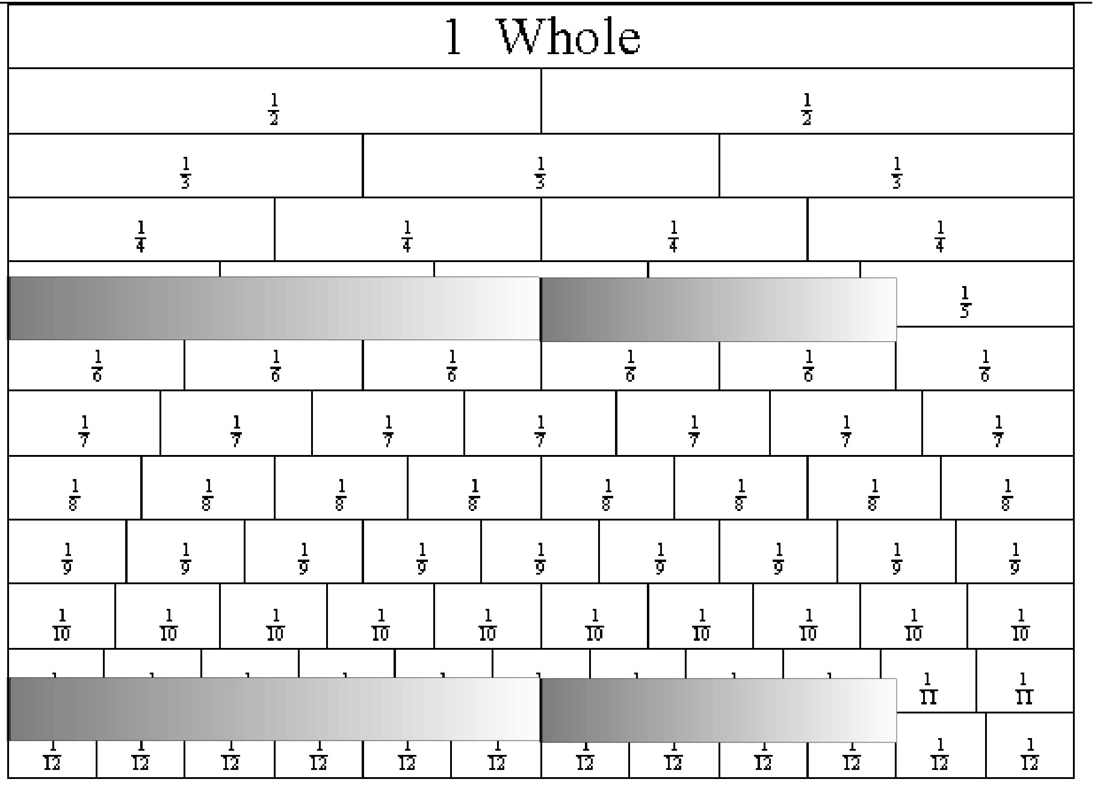

  - Add the fractions in the table below by sticking fraction strips together as in the example above.

 | Fractions to Add | Sum (fraction strip length) | Denominator of the sum. (Common Denominator) | Fractions with the common denominator
1 | $$\frac{1}{2}+\frac{1}{4}$$ | $$\frac{3}{4}$$ | 4 | $$\frac{2}{4}+\frac{1}{4}$$
2. | $$\frac{1}{3}+\frac{1}{6}$$
3 | $$\frac{1}{6}+\frac{1}{4}$$
4 | $$\frac{3}{4}+\frac{2}{8}$$
5  To add or subtract algebraic fractions you must find a common denominator first.  You may need to factorise the numerators and denominators in to simplify them. | $$\frac{x}{2}+\frac{4x}{5}$$

Example To add $\frac{1}{x+1}+\frac{1}{x−1}$
- Multiply the two denominators to find a common denominator
- Divide the new denominator by ($x+1$) and multiply the numerator by the result, $(x−1)$ to give the equivalent fraction for the first term.
- Divide the new denominator by ($x−1$) and multiply the numerator by the result, $(x+1)$ to give the equivalent fraction for the second term.
- Add the two equivalent fractions.

$\frac{1}{x+1}+\frac{1}{x−1}$$=\frac{x+1+x−1}{(x+1)(x−1)}=\frac{2x}{(x+1)(x−1)}$$\frac{1}{x+1}=\frac{x−1}{(x+1)(x−1)}$$\frac{1}{x−1}=\frac{x+1}{(x+1)(x−1)}$$(x+1)(x−1)$
  - Simplify the algebraic fractions below by finding a common denominator then adding or subtracting the equivalent numerators.

Tips for finding a Common Denominator

- If the denominators do not have a common factor, then Common Denominator is their product.
- If one denominator is a multiple of another, the common denominator is the multiple denominator.
- If the two denominators have a common factor, factorise them first before finding their common denominator

- $$\frac{1}{x}+\frac{2}{x^{2}+2x}$$

- $$\frac{3x}{x^{2}−\text{16}}−\frac{1}{x+4}$$

- $$\frac{1}{2x+2}−\frac{2}{3x−3}+\frac{4}{1−x^{2}}$$
- $\frac{2x−3}{2}−$$\frac{x}{x+2}−$$\frac{x^{2}−2x}{2x^{2}−8}$

- $\frac{1}{x^{2}−4y^{2}}−$$\frac{1}{x^{2}−4\text{xy}+4y^{2}}$

