Project 4
Analyzing Store Visits
Module
3
student Lesson

In Module 3, you will learn how to enter the data gathered during your store visit into a Microsoft Excel worksheet. Then, your team will need to use their analytical skills to examine the team’s data and research and make conclusions about which store offers the overall best pricing for the products selected for your five-item meal. Finally, after the data from all class teams is merged together into one worksheet, your team will again analyze the results, and prepare a Microsoft PowerPoint presentation to provide a summary.
Compiling and Analyzing Research Information
One of the most important research skills you should develop is to be able to synthesize, integrate and organize information from a variety of sources. Following that step, you should be able to present your information so that it is understandable and valid.
Exercise 3.1: Entering and Compiling Shopping Data about Pricing
Each team member’s data on five menu items from a store visit will first be entered into the Microsoft Excel worksheet template, ShoppingData (located in the Student Lessons folder). The Step-by-Step Microsoft Excel XP: Data Input guide provides assistance on how to complete this Shopping Data worksheet, and to compute the “Cost Per Unit” column.
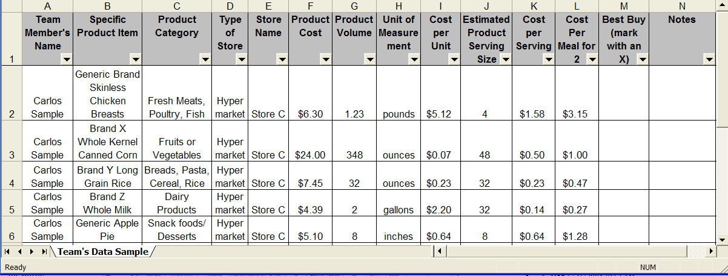
Team’s Data Sample: The following sample illustrates a completed chart, with one team member’s data on five menu items after a store visit.
Exercise 3.2: Analyzing Shopping Data from the Team
Your team will analyze the compiled results of your team’s data in order to recommend the best overall store where consumers will get the Best Buy value for all five items in your meal plan. Your team will analyze the numerical data from your worksheet in Exercise 3.1. Your team will write up an analysis in a Microsoft Word document.
The following questions are provided as guidelines for you as you analyze the data:
- Which store had the best price for each item? Provide data to support your answer.
- Which store was the most expensive of the three or four visited? Provide data to support your answer.
- Overall, which store had the best buys per unit cost for the five meal items?
- Are there any circumstances where buying the best-priced product would not be a good idea?
The answers to these questions will be used by in your final project presentation in Exercise 3.4.
Transfer your team’s information from the Excel worksheet, TeamNameShoppingData, completed in Exercise 3.1 to the two charts below, to determine the meal cost for each team member, and to also determine the “Best Buy” store.
Determining Meal Cost for Each Team Member
Team Member’s Name | Product Cost | Cost per Serving | Cost per Meal for 2

Determining “Best Buy” Store
Specific Product Item (for Menu) | Store Name | Type of Store
1.
2.
3.
4.
5.

Presentation Recommendation: Where to Shop?
Exercise 3.3: Compiling and Analyzing Shopping Data from the Entire Class
Now your team will analyze the results of the data compiled by all of the class teams. With the teacher’s supervision, each team will be combining their team’s worksheet data into the Microsoft Excel worksheet template, ClassData. Your team will then copy the new ClassData worksheet into your team’s ShoppingData workbook.
Use the Step-by-Step Microsoft Excel XP: Class Shopping Data guide for assistance on how to complete this exercise.
Your team must now filter and analyze the data. Ask yourselves how the results from the entire class compare with the results of your own team (in the previous Exercise 3.2). Are they the same or are they different – and how?
Your conclusions will be used to develop the summary presentation in Exercise 3.4.
Exercise 3.4: Analyzing Shopping Data
Your team will develop a Microsoft PowerPoint presentation using the template SmartConsumer (located in the Student Lessons folder). Using your team’s data, you will present summary recommendations about the best place to shop based upon the pricing of your five menu items.
Your team’s presentation (about 5 minutes in length) should present both the individual team’s data and how it compares to the other teams’ data. The presentation should provide strong arguments about ‘where to shop’ and why your team’s recommendations (for meal and pricing) should be chosen by Smart Meals!
The Microsoft PowerPoint template, Smart Consumer, consists of hidden slides that provide guided instructions for each viewable slide within the presentation.
Your presentation should include the following, as instructed on the template:
- Summary of individual team data
- Summary of product pricing for five items for each store visited
- Recommendations about where to shop, based upon price and other factors (based upon team data)
- Comparison of team data to class data
- Further recommendations about store with “Best Buy,” and other conclusions and comparisons (based upon class data)
- Reflections and conclusions about being a smart consumer

