Step-by-Step Microsoft Excel XP:

Data Input

Step-by-Step Microsoft Excel XP: Data Input provides guided instructions for completing Exercise 3.1: Entering and Compiling Shopping Data about Pricing. In this exercise your team will enter data on the pricing of the products researched by each team member.
Below is an illustration of the ShoppingData Excel workbook your team will use to enter your data with information entered for one team member (your team’s ShoppingData workbook is blank). The ShoppingData workbook consists of one worksheet, Team’s Data.
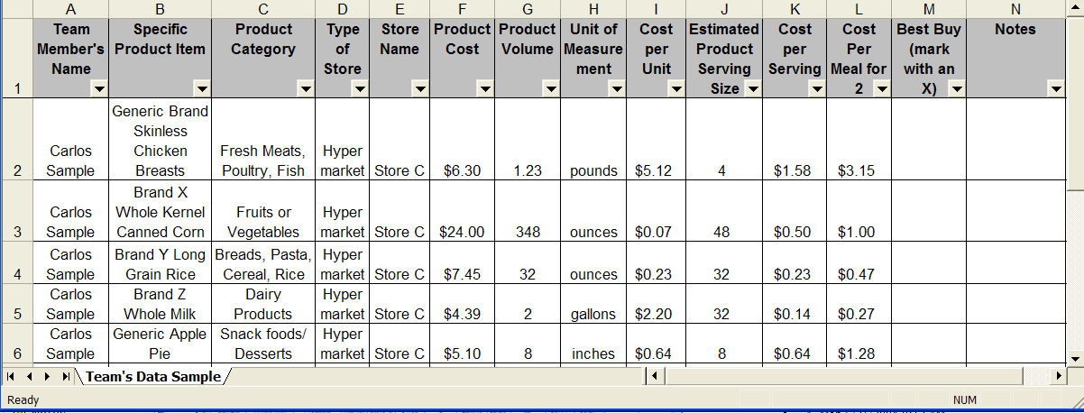
In the above illustration on the Team’s Data worksheet, one team member named Carlos Sample researched product pricing for the five menu items at Store C.
- Open the Excel template ShoppingData (the file can be found in the Step-by-Step folder for Project 4 – Consumers\Student Lessons\).
- Save the file as “TeamNameShoppingData”.
- Fourteen columns (A-N) will be used for this exercise. Each column is labeled in the Row 1 cell for that column:
Column A = Team Member’s Name
Column B = Specific Product Item
Column C = Product Category
Column D = Type of Store
Column E = Store Name
Column F = Product Cost
Column G = Product Volume
Column H = Unit of Measurement
Column I = Cost per Unit
Column J = Estimated Product Serving Size
Column K = Cost per Serving
Column L = Cost per Meal for 2
Column M = Best Buy (mark with an X)
Column N = Notes
Formatting Cells for Text, Currency or Number Data Entry
See Step-by-Step Excel XP: Product Pricing for illustrations of the Column Headings and Format Cells dialog box.
- From the open workbook, ShoppingData, select the Team’s Data Worksheet Tab.
- In columns A, B, C, D, E, H, M and N, the data entered will be text. Each column must be formatted for text data entry.
- On the Shopping Data worksheet, select Column Heading A, then hold down CTRL and select Column Headings B, C, D, E, H, M and N.
- On the Format menu, select Cells. The Format Cells dialog box will appear.
- Click the Number tab, then under Category select Text.
- Click on the Alignment tab and under Text control select the Wrap text check box. This will allow the text to wrap within a cell and increase the height of the row.
- Click OK to close the Format Cells dialog box.
- Columns F, I, K and L will be formatted for currency data entry.
- Select Column Headings F, I, K and L by following step 3 above.
- On the Format menu, select Cells, then in the Format Cells dialog box, click the Number tab.
- Under Category select Currency.
- Next to Decimal places type or select 2.
- Under Symbol select the monetary value symbol ($).
- Click OK to close the Format Cells dialog box.
- Column G and J will be formatted for number data entry.
- Select Column Heading G and J by following step 3 above.
- On the Format menu, select Cells, then in the Format Cells dialog box, click the Number tab.
- Under Category select Number.
- Next to Decimal places type or select 2.
- Click OK to close the Format Cells dialog box.
- Save your file.
Entering Research Pricing Data
Each team member will be entering the information they gathered from their research completed in Exercise 2.4: Choosing Product Category, Specific Products, and Type of Store.
- Select Cell A2 and type the team member name.
- Select Cell B2 and type the name of the Specific Product Item the team member researched.
- Select Cell C2 and type the Product Category.
- Select Cell D2 and type the Type of Store.
- Select Cell E2 and type the Store Name.
- Select Cell F2 and type the Product Cost.
- Select Cell G2 and type the Product Volume
Be cautious when buying in bulk. For example, the can size is 14.5 ounces, but you purchased 24 cans. You will need to multiply the ounces by the number of cans purchased to accurately display the actual amount of volume purchased.
- Select Cell H2 and type the Unit of Measurement.
- In Cell I2, create a formula to calculate the Cost per Unit of the product item by dividing Product Cost (Column F) by the Product Volume (Column G).
  - Select Cell I2
  - Type = (an equal sign)
  - Select cell F2
  - Type / (the forward slash sign)
  - Select cell G2
  - Press Enter
- Select Cell J2 and type the Estimated Product Serving Size. (Estimate the number of servings based on the product volume; i.e. 4 chicken breasts per package would serve 4 people, or one 14.5 oz. can of corn would serve 2 people, multiplied by the 24 cans you purchased, 2 x 24 = 48 servings of corn)
- In Cell K2, create a formula to calculate the Cost per Serving of the product item by dividing Product Cost (Column F) by the Estimated Product Serving Size (Column J).
  - Select Cell K2
  - Type = (an equal sign)
  - Select cell F2
  - Type / (the forward slash sign)
  - Select cell J2
  - Press Enter
- In Cell L2 create a formula to calculate the Cost per Meal for 2.
  - Select Cell L2
  - Type = (an equal sign)
  - Select cell K2
  - Type * (Hold SHIFT, type 8)
  - Type 2
  - Press Enter
- In Cell N2, you may type any notes about the product pricing or you may leave it blank. NOTE: You can not mark the “Best Buy” (Column M) until all the team members have entered their data.
- Type in rows 3 through 6, cells B, C, F, G, H, J, and N the following data: your name and all of the research data for the other four menu items.
- In rows 3 through 6, cells A, D and E, copy the information from cells D2 and E2.
  - Select cell A2.
  - Hold down CRTL.
  - Select cell D2 and cell E2.
  - On the Edit menu, click Copy.
  - Select cell A3.
  - On the Edit menu, click Paste.
  - Repeat steps e and f for cells D4, D5, and D6.
- Create a relative reference in columns I, K and L. Select Cell I2, grab the Fill Handle and drag down to Cell I6.
- Repeat step 16 for columns K and L.
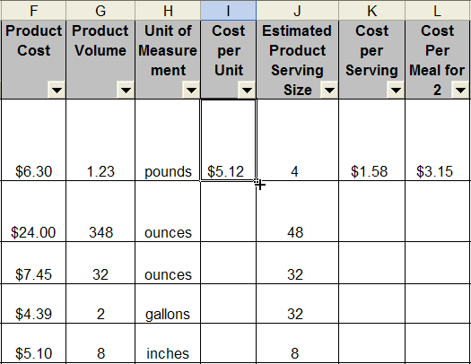
Fill handle
(pointer becomes
the fill handle when placed over the lower right corner
of the cell)

- Save the file.
Calculating Costs of Meal for Each Team Member
Each team member will calculate the total cost for Product Cost (Column F), Cost per Serving (Column K), and Cost per Meal for 2 (Column L).
Continuing with the same team member as above:
- Select Cell A6, then grab the Fill Handle and drag down to Cell A7 (this will copy your name into cell A7).
- Select Column F7 (Product Cost).
- Type =SUM(F2:F6)
  - (F2:F6) identifies the range of rows within column F to be totaled.
- Press ENTER
- Select Cell F7, then Right-Click and select Copy from the list.
- Select Cell K7 (Cost per Serving), then Right-Click and select Paste.
- Select Cell L7 (Cost per Meal for 2), then Right-Click and select Paste.
- Select Row Heading 7, on the Formatting Toolbar select the Fill-color icon and select a color to shade in the row.
- Save the file.
- Have another team member begin entering their data (into Row 8 at Cell A8) following steps 1- 28.
- Continue until all team members have entered their data.
Filtering Data in an Excel Worksheet
To help analyze your data you will set filters. Filtering displays only the rows that have the data you have chosen to display from a column.
- Select Row Heading 1.
- From the Data menu, select Filter, then AutoFilter.
- You can now filter data from one or more columns by clicking the cell arrow and selecting your filtering options.
  - In Cell E1 (Store Name) click the arrow and select a store name. The only rows that are displayed will be those that have the selected store name in Column E.
  - In Cell A1 (Team Member) click the arrow and select a team member. You will now only see the rows that have the selected team member and the store from the previous filter.
  - To see all the rows, click the Cell A arrow and select All.
  - Repeat for any other Columns that you have filtered (notice that in a filtered Column, the down arrow changes color).
Determining Meal Costs for Each Team Member
- To Filter Column A (Team Member), from the list choose a team member.
- In the last row for the team member selected, the totals for Product Cost (Column F), Cost per Serving (Column K), and Cost per Meal for 2 (Column L) will be displayed. Record this information on the chart provided in Exercise 3.2 (“Determining Meal Cost for Each Team Member”).
- Repeat steps 1-2 for each team member.
Determining “Best Buy” Store
- To Filter Column B (Specific Product Item) from the list choose one product item.
- Analyze Column I (Cost per Unit).
- Type an X in Column M (Best Buy) for the product with the lowest cost per unit.
- Repeat steps 1-3 for each of the other Specific Product Items.
- Record your results for “Best Buy” on the chart provided in Exercise 3.2 (“Determining “Best Buy” Store”).

