Step-by-Step Microsoft Word XP:

Creating a Flyer

Step-by-Step Microsoft Word XP: Creating a Flyer provides guided instructions on creating a promotional flyer in Word. Instructions are provided for inserting text boxes, graphics and WordArt, and for converting the flyer into a web page.
Planning Your Flyer
- Plan what text and/or images will go onto flyer.
- Your flyer can be created in Portrait or Landscape Orientation.

Portrait
Orientation

Landscape Orientation

Preparing Word to Create a Flyer
- On the Start button, click Programs, select Microsoft Word.
- On the Tools menu, click Options, then select the General tab.
- In the Measurement units box, select Centimeters.
- If selected, unselect Automatically create drawing canvas when inserting AutoShapes.
- Click OK.
- On File menu, click Page Setup, select the Margins tab.
- Under Orientation, select either Portrait or Landscape.
- Under Margins, in the Top and Bottom boxes, select or type 2.5 cm.
- Under Margins, in the Left and Right boxes, select or type 2.5 cm.
- Select the Paper tab, under Paper Size select the size of your paper from the list. (Select Letter if you are using 8 ½” x 11” paper.)
- Click OK.
Creating Text Boxes
- On the Draw toolbar, select the Text Box icon .
- On your document, click and drag the pointer to create a text box.
- Your pointer should be blinking inside the text box. If not, click inside the text box, and type your text.
- If the box is too small or you do not see all of your text, enlarge the text box:
  - Select the text box by clicking on the text box border.
  - Drag a sizing handle until the text box is the size you want.
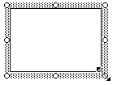
Sizing handles
- To change the Font style, point size or color within the text box:
  - Select the text.
  - On the Format menu, select Font.
  - In the Font dialog box, select the changes you want.
- To change the position of the text box:
  - Select the border of the text box.
  - Click and move to the location desired.
- Create as many text boxes as you need, positioning them in the desired locations.
Inserting Graphics
You can choose a picture, scanned image, or clip art to insert into your flyer.
- On the Insert menu, select Picture, then click on the type of image you will insert. If you choose:
  - Clip Art – this will bring up the ClipArt task pane. Under Search for, in Search in box, type a description (a word or phrase) of your clip art and click Search. In the results box, click the clip to insert it.
  - From File - this will bring up the Insert Picture dialog box. In the Look in text box, navigate to the location where you saved your picture, select your picture, then click Insert.
  - From Scanner or Camera – the computer will search for an attached scanner or camera and bring up available images for you to choose from. It is recommended that you first use your scanner or camera software to resize and save these images, then insert them using the From File procedure described above.
- Graphics can be resized by selecting the graphic, then drag a sizing handle until the graphic is the size you want.
- Graphics can be positioned by selecting the graphic, then click and drag to the desired location.
- Experiment with graphics by doing the following:
  - Right-click on the graphic, select Format Picture.
  - From the Format Picture dialog box, experiment with changing the layout (text-wrapping style), colors or size. To be able to move your graphic around, select the Layout tab, and choose any of the Wrapping style options other than “In line with text”.
  - Select the graphic. On the Drawing toolbar (see directions below if the Drawing Toolbar is not showing), click Draw, point to Order, and then click Bring in Front of Text or Send Behind Text, if you want to have your picture appear behind or in front of text.
Using WordArt
- On the View menu, select Toolbars, then click Drawing (complete this step only if your Drawing Toolbar is not showing or not checked).
- On the Drawing toolbar, click the Insert WordArt icon 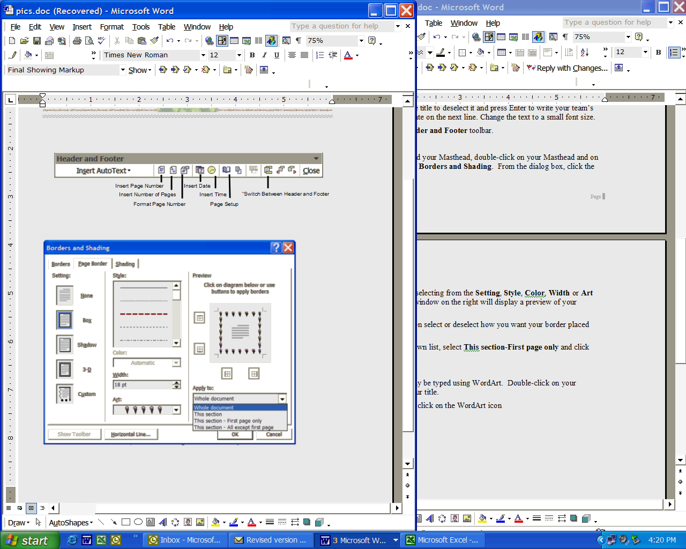.
- From the WordArt Gallery dialog box, select a WordArt style, then click OK.
- From the Edit WordArt Text dialog box, in the Text box, type your text.
- In the Font box, type or select a font (or you may use the default setting).
- In the Size box, type or select a point size (or you may use the default setting).
- Click OK.
- Use the WordArt Toolbar to make adjustments to the WordArt.
Use any of the above features of Word to create your Flyer.
Saving As a Web Page
- As a final step, you may save the flyer (the Word document) as a Web page. You may use Word to create a Web page to convert an existing document to HTML, which is the format used for Web pages.
- Open the Word document.
- To create the web page, on the File menu, click Save as Web Page. The Save As dialog box will open.
- Click Change Title, in the Set Page Title dialog box, type the name (title) of your flyer page. (This title will appear in the upper left corner of the title bar when the file is opened in a web browser.)
- Click OK.
- In the File name box, type in the name that you would like the file to be saved as. The file must have a web-safe name. Use only numbers and letters in lower case, no spaces or unusual characters, and make the file name short. Example: teamflyer.
- In Save as type, select Web page (*.htm; *.html). Make sure your Save in location is the correct place where you want to save your new file.
- Click Save. Word may give you a warning screen about how certain elements of your flyer may not ‘translate’ properly.
- Click Continue.
- You now have two separate documents: one Word file (your original flyer document) and one HTML file (the file you just saved). (Also notice a folder that has also been created with additional files necessary for the page to be viewed properly.) The two documents have different names, different file extensions (.doc for the Word file and .htm or .html for the HTML file). After the save, Word shows you the new HTML document as if you were looking at it in a Web browser. You may notice that the margins change and graphics shift.
- To properly view the flyer as a web page, open your web page file in your web browser (i.e., Internet Explorer).

