Step-by-Step Microsoft Word XP:

Creating a Brochure

Step-by-Step Microsoft Word XP: Creating a Brochure provides guided instructions on creating a tri-fold brochure in Word (composed of two files). Instructions are provided for inserting text boxes, graphics and WordArt.
Planning Your Brochure
- On a sheet of 8 ½” x 11” plain paper, in landscape view, fold into thirds.

- Plan what text and/or images will go on the inside and back of the brochure. There are six sections of the two-sided, tri-fold brochure.
Section 1
Inside
Section 6
Outside (or Front) Flap
Section 5
Back

Section 4
Inside Flap
Section 2
Inside
Section 3
Inside

Preparing Word to Create a Brochure
- On the Start button, click Programs, select Microsoft Word.
- On the Tools menu, click Options, then select the General tab.
- In the Measurement units box, select Centimeters. Also, if checked, uncheck the box next to “Automatically create drawing canvas when inserting AutoShapes.” Click OK.
- On File menu, click Page Setup, select the Margins tab.
- Under Orientation, select Landscape.

- Under Margins, in the Top and Bottom boxes, select or type 2.5 cm.
- Under Margins, in the Left and Right boxes, select or type 2 cm.
- Select the Paper tab, under Paper Size select the size of your paper from the list. (Select Letter if you are using 8 ½” x 11” paper.)
- Click OK.
Preparing Two Sides (Inside and Back) of Brochure
- Sections 1, 2, 3 – The Inside of Brochure
Section 2

Section 1
Section 3

Sections 1, 2, and 3 are the inside sections of the brochure. When you open a tri-fold brochure, you will see all three sections.
- To help you visualize the three sections on the inside of your brochure:
  - On the View menu, click Rulers (only do this if your rulers are not showing)
  - On the Draw toolbar, select the line icon .
  - On your document, click and drag to create a vertical line at approximately 8 cm. Hold the Shift key down as you drag, to constrain the line.
  - Select the line icon to create another vertical line at approximately 16 cm.
- Save your file. From the File menu, click Save. In the Save As dialog box, in the File name box, type the file name, i.e., TeamNameBrochureInside.doc. Keep this file open.
- Later, you will be using text boxes, graphics, and/or WordArt to place your promotional information within these three sections. Sections 1-3 will contain most of the information about your product.
- Sections 4, 5, 6 – The Back of Brochure
Sections 4, 5 and 6 will be on the back side of your brochure. If you make a paper mock-up of the two-sided brochure, you can easily see that Section 4 will be ‘behind’ Section 3, Section 5 will be ‘behind’ Section 2, and Section 6 will be ‘behind’ Section 1.
Section 5

Section 4
Section 6

- To make things simple, you will be re-saving your BrochureInside file as the back side of your brochure, in a second file. You should have your team’s BrochureInside file open.
- From the File menu, select Save As. In the Save As dialog box, in the File name box, type the file name for this second file, i.e., TeamNameBrochureBack.doc.
- Now you should have two files in the same location – one for the inside of the brochure (sections 1-3), and one for the back of the brochure (sections 4-6).
- Later, you will be using text boxes, graphics, and/or WordArt to place your promotional information within these three sections.
Contents of Sections 4, 5, and 6
When the two-sided brochure is folded in three sections, Section 6 will be the front flap, the first thing a customer will normally see, so it should be eye-catching. At the least, it should contain the name of your product and the name of your company.
When folded in three sections, Section 5 will be the back panel of the brochure. It should contain additional product or company contact information.
When folded in three sections, Section 4 will be the inside flap of the brochure. You will need to determine the content of this section for yourself.
Creating Text Boxes
- On the Draw toolbar, select the Text Box icon .
- On your document, click and drag the pointer to create a text box.
- Your pointer should be blinking inside the text box. If not, click inside the text box, and type your text.
- If the box is too small or you do not see all of your text, enlarge the text box:
  - Select the text box by clicking on the text box border.
  - Drag a sizing handle until the text box is the size you want.
Sizing handles
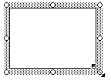
- To change the Font style, point size or color within the text box:
  - Select the text.
  - On the Format menu, select Font.
  - In the Font dialog box, select the changes you want.
- To change the position of the text box:
  - Select the border of the text box.
  - Click and move to the location desired.
- Create as many text boxes as you need, positioning them in the desired locations.
Inserting Graphics
You can choose a picture, scanned image, or clip art to insert into your brochure.
- On the Insert menu, select Picture, then click on the type of image you will insert. If you choose:
  - Clip Art – this will bring up the ClipArt task pane. Under Search for, in Search in box, type a description (a word or phrase) of your clip art and click Search. In the results box, click the clip to insert it.
  - From File - this will bring up the Insert Picture dialog box. In the Look in text box, navigate to the location where you saved your picture, select your picture, then click Insert.
  - From Scanner or Camera – the computer will search for an attached scanner or camera and bring up available images for you to choose from. It is recommended that you first use your scanner or camera software to resize and save these images, then insert them using the From File procedure described above.
- Graphics can be resized by selecting the graphic, then drag a sizing handle until the graphic is the size you want.
- Graphics can be positioned by selecting the graphic, then click and drag to the desired location.
- Experiment with graphics by doing the following:
  - Right-click on the graphic, select Format Picture.
  - From the Format Picture dialog box, experiment with changing the layout (text-wrapping style), colors or size. To be able to move your graphic around, select the Layout tab, and choose any of the Wrapping style options other than “In line with text”.
  - Select the graphic. On the Drawing toolbar (see directions below if the Drawing Toolbar is not showing), click Draw, point to Order, and then click Bring in Front of Text or Send Behind Text, if you want to have your picture appear behind or in front of text.
Using WordArt
- On the View menu, select Toolbars, then click Drawing (complete this step only if your Drawing Toolbar is not showing or not checked).
- On the Drawing toolbar, click the Insert WordArt icon 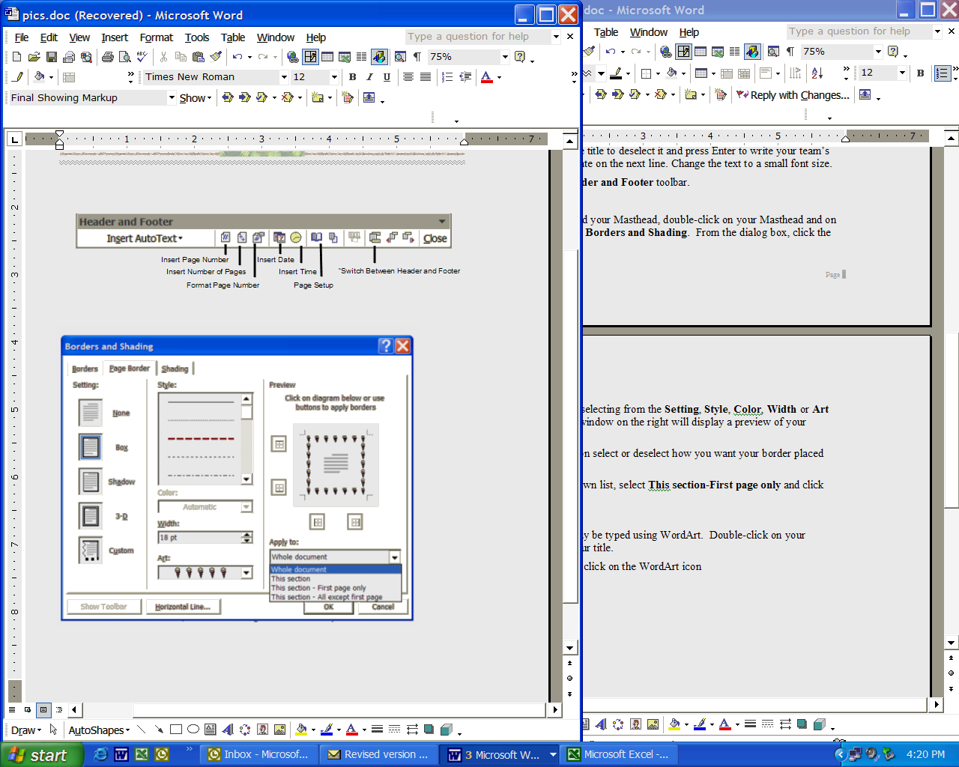.
- From the WordArt Gallery dialog box, select a WordArt style, then click OK.
- From the Edit WordArt Text dialog box, in the Text box, type your text.
- In the Font box, type or select a font (or you may use the default setting).
- In the Size box, type or select a point size (or you may use the default setting).
- Click OK.
- Use the WordArt Toolbar to make adjustments to the WordArt.

