Step-by-Step Microsoft Excel XP:

Pricing Worksheet

Step-by-Step Microsoft Excel XP: Pricing Worksheet provides guided instructions for completing Exercise 2.5: Product Development Costs and Pricing Worksheet. In this exercise you will use the Excel template, PricingWorksheet, to estimate your team’s product development costs.
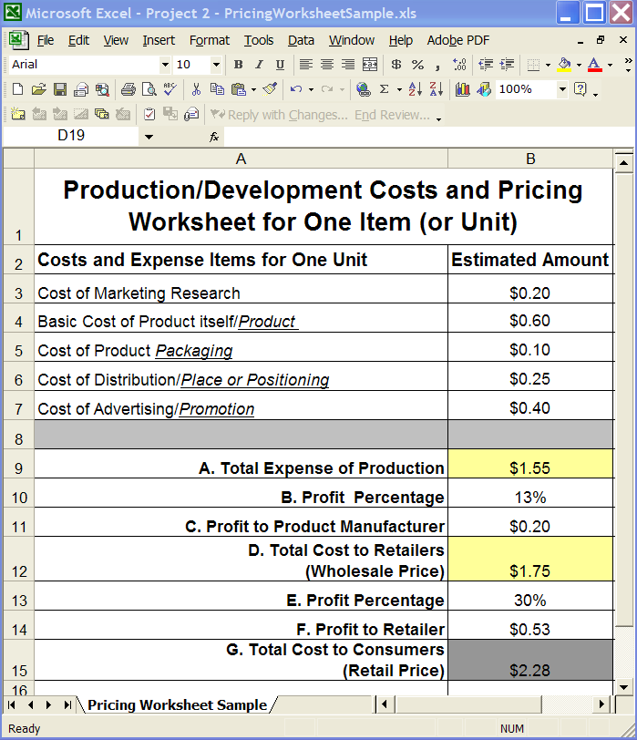
Below is an illustration of PricingWorksheetSample, Excel worksheet with estimated pricing included (PricingWorksheet, in the student folder does not have estimated pricing included):

- Open the Excel template PricingWorksheet (the file can be found in the Step-by-Step folder for Project 2 – Marketing\Student Lessons\Step-by-Step folder).
- Save the file as “YourTeamPricingWorksheet”.
- Select Cell B3.
- On the Format menu, select Cells, then in the Format Cells dialog box, click the Number tab.
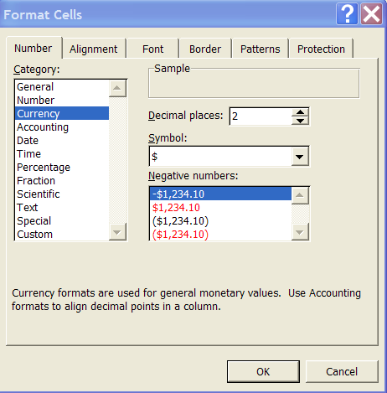
- Under Category select Currency.
- Next to Decimal places type or select 2.
- Under Symbol select the monetary value symbol ($).
- Click OK to close the Format Cells dialog box.
- Select Cell B3.
- On the Standard toolbar, double-click the Format Painter icon .
- Select Cells B4, B5, B6, and B7 (the format for Cell B3 will be duplicated into these cells). Press Enter.
- Select Cell B3, enter your team’s estimated Cost of Marketing Research.
- Select Cell B4, enter your team’s estimated Basic Cost of Product itself.
- Select Cell B5, enter your team’s estimated Cost of Product Packaging.
- Select Cell B6, enter your team’s estimated Cost of Distribution.
- Select Cell B7, enter your team’s estimated Cost of Advertising..
- Select Cell B9 (A. Total Expense of Production), follow steps 4-8 above to format cell for currency input.
- Create a formula in Cell B9 to add Cells B3 through B7:
  - Type = (equal sign)
  - Type SUM
  - Type ( (left parenthesis)
  - Type B3
  - Type : (colon symbol)
  - Type B7
  - Type ) (right parenthesis)
  - You should have typed =SUM(B3:B7)
  - Press Enter
- Select Cell B10 (B. Profit Percentage).
- On the Format menu, select Cells, then in the Format Cells dialog box, click the Number tab.
- Under Category select Percentage.
- Next to Decimal places type or select 0.
- Click OK to close the Format Cells dialog box.
- Select Cell B10, type the percentage your team has determined for your profit percentage.
- Select Cell B11 (B. Profit to Product Manufacturer), follow steps 4 – 8 above to format Cell B11 for currency data input.
- Create a formula in Cell B11 to calculate the profit to product manufacturer by multiplying Cell B9 by B10:
  - Type = (equal sign)
  - Select Cell B9
  - Type * (asterisk)
  - Select Cell B10
  - Press Enter
- Select Cell B12 (C. Total Cost to Retailers), follow steps 4-8 above to format cell for currency input.
- Create a formula in Cell B12 to add Cells B9 and B11.
  - Type = (equal sign)
  - Select Cell B9
  - Type + (plus sign)
  - Select Cell B11
  - Press Enter
- Select Cell B13 (D. Profit Percentage).
- On the Format menu, select Cells, then in the Format Cells dialog box, click the Number tab.
- Under Category select Percentage.
- Next to Decimal places type or select 0.
- Click OK to close the Format Cells dialog box.
- Select Cell B13, type the percentage your team has determined for your profit percentage.
- Select Cell B14 (E. Profit to Retailer), follow steps 4 – 8 above to format Cell B14 for currency data input.
- Create a formula in Cell B14 to calculate the profit to the retailer by multiplying Cell B12 by B13:
  - Type = (equal sign)
  - Select Cell B12
  - Type * (asterisk)
  - Select Cell B13
  - Press Enter
- Select Cell B15 (F. Total Cost to Consumers), follow steps 4-8 above to format cell for currency input.
- Create a formula in Cell B15 to add Cells B12 and B14.
  - Type = (equal sign)
  - Select Cell B12
  - Type + (plus sign)
  - Select Cell B14
  - Press Enter

