Vectors | Unit 1 | Scalar and Vector Quantities


WHAT THIS UNIT IS ABOUT

This unit is an introduction to vector quantities. All physical quantities are classified either as vectors or scalar quantities. Vectors are quantities that have direction as well as “size” or magnitude.

Vectors are very important for navigation (sea, air travel and space). Ships, aeroplanes and spacecraft need to find their way to harbours, airports and space stations without roads or paths. The effects of water and air currents will also push them off course so that they can end up travelling in the wrong direction. The knowledge of vector quantities helps captains, pilots and astronauts to keep moving in exactly the correct direction so that they arrive at their destination safe and sound.

Forces acting on structures such as bridges, buildings and cranes for example are also vector quantities. It is very important to know the direction of a force so that you can calculate what the reaction will be.

Vector properties are very important in the study of objects in motion, projectiles, and collisions between bodies.

In this unit you will:

- Make a direction spinner and use it with a dice to play a game involving vector quantities.

- Demonstrate understanding of the difference between vector and scalar quantities

- Express vector quantities using the compass and bearing methods to describe the direction.

- Represent a vector quantity as an arrow drawn accurately to scale in a particular direction.

Activity 1
Scalars and Vectors

In this activity you will be making a game and using it to develop your understanding of the difference between scalar quantities and vector quantities.
Scalars are quantities that have magnitude (amount) only. They obey ordinary arithmetical rules of addition and subtraction.

E.g. mass, m = 50kg
time, t = 10 s
length l = 15 m

A vector quantity is a measurement that needs a direction for it to make sense. If someone asks you to where is the bathroom and you tell him or her it is 40 metres away, they will ask which way. To find where something is exactly, you need to know both the distance and the direction of where it is from where you are standing; i.e. you need a vector quantity.
Vectors are quantities that have both magnitude and direction and are represented by arrows with different lengths. They obey special rules of addition and subtraction.

E.g. displacement, s = 5 m; 50 º or NE
velocity, v = 20 m. s ^{–1} SW
force F = 10 N; downwards

  - Winning holidays.

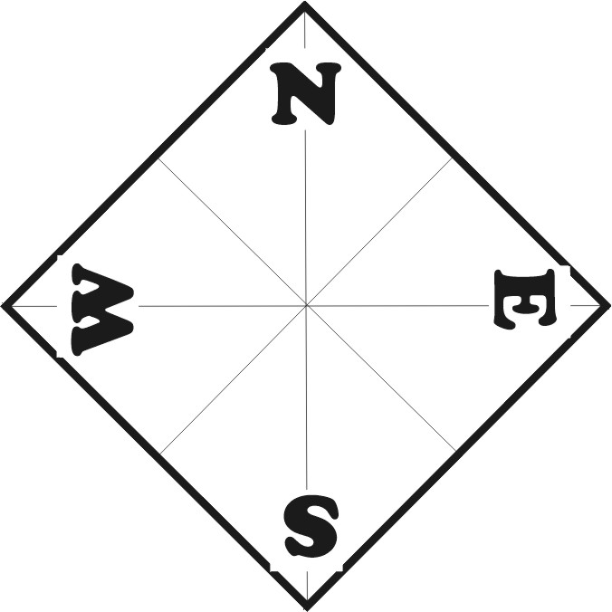
Use the Procedure below to make a Direction Spinner.
- Take two pieces of A4 paper and make two squares with sides of 210mm. You can do this by folding the top edge to line up with the left-hand edge, then cutting off the unfolded piece at the bottom.
- Draw in the diagonal lines from corner to corner of each square.
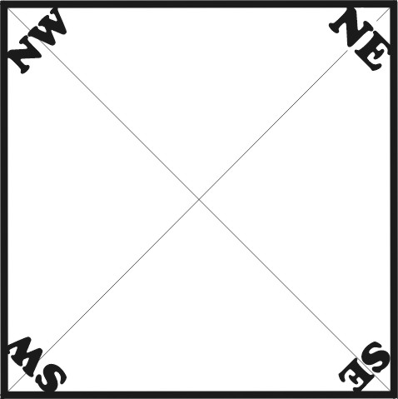
- Fold the square into four and then draw in the dividing lines through the centre.
- Turn the first square so that one corner points towards the top. Mark in N for North in the corner.
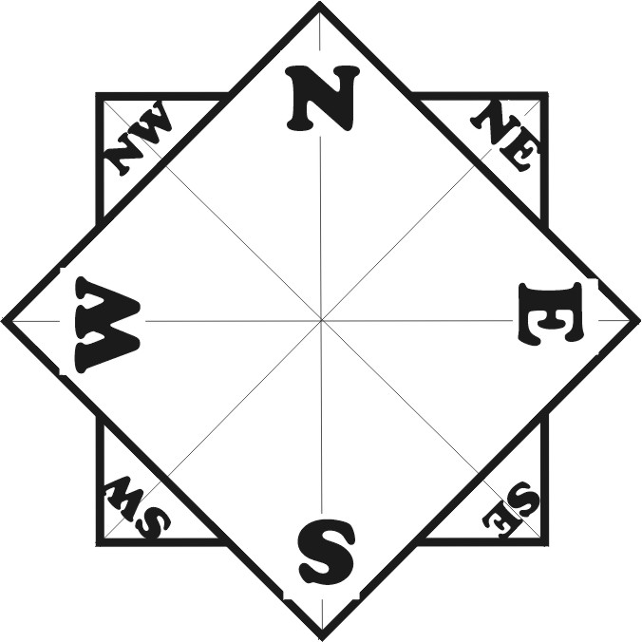
- Now mark the other corners E for East, S for South and W for West making sure they are in the right order.
- Do the same on the second square, but mark the corners NE (for NorthEast), SE for SouthEast, SW for SW and NW for NorthWest.
- Glue the second square behind the first so that the corners of the square point in the right directions.
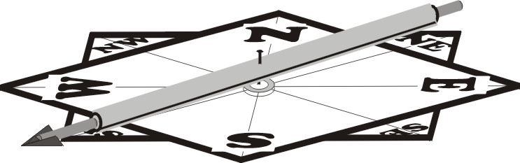
- Place a steel washer (or any plastic disc) over the centre and then pin a plastic straw into the centre of the spinner.
- Slide a sosatie-stick or a piece of wooden dowel into each end of the straw so that it balances nicely.
- Sharpen, mark or place a paper arrow on one end to be the pointer.
  - How to play

Each member of your group will spin the direction spinner once and throw a dice once to see where you can go. The spinner shows which direction you can travel to your holiday and the number on the dice shows you how far away you can go.
You will need
- One direction spinner.
- One dice
- A target map

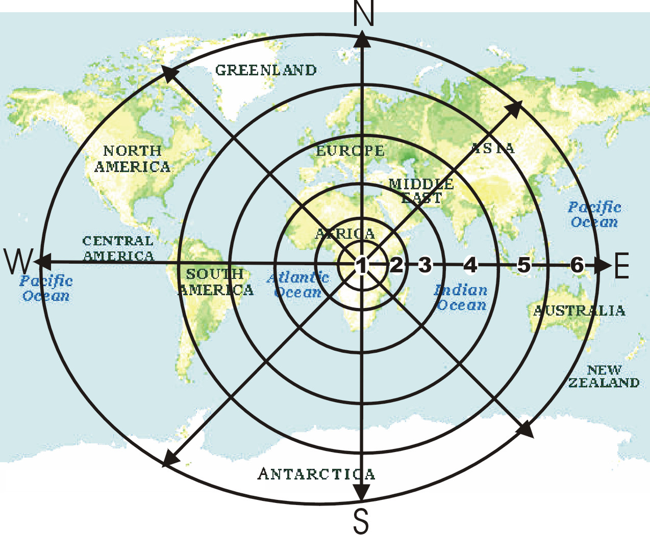
Choose any holiday destination on the target map below that is in the same direction as you have spun at the radial distance you have thrown on the dice.

  - Scalars and Vectors

- How many people in the class threw a 6?

Remember

A vector quantity has magnitude and direction.
- Do you think everyone who threw a 6 went to the same place? Why not?
- What can you say is the difference between a scalar and a vector quantity?
- Vector quantities are very important for pilots, captains of ships and people travelling in space, Why do you think this is?
1.4 Measuring direction using a compass
N = 0⁰
W
30º
60º
E
S

The angle is measured from any one of the compass points near the line whose direction we are trying to measure, for example, the direction of line a can be measured from either North or East.

Measured from East, the direction would be 60º North of East
Measured from North, the direction would be 30º East of North

1.5 Using North as the reference direction (Bearings).

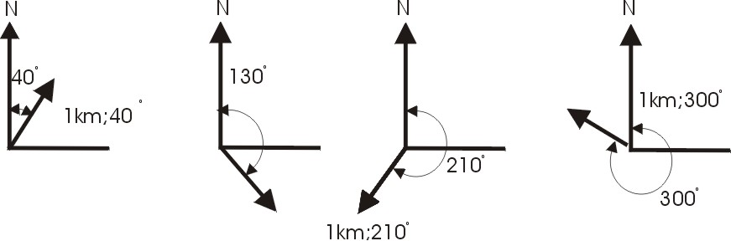
Where directions are measured as angles in a clockwise direction from North, they are called bearings. When using bearings the direction North is taken as 0⁰.

Activity 2
Drawing Vectors

A vector quantity can be represented by an arrow drawn with a length representing the magnitude and pointing in the correct direction. We often need to use a scale so that large magnitudes can be drawn to fit on the page.

Scale
When you draw something to scale. You usually divide its magnitude by an easy fixed number (like 10 or 20) so that you can fit the drawing onto a piece of paper.

2.1 Use the guide below to represent the following vectors as accurate scale diagrams.

- Draw the following displacement vectors:
5m East
500m West
6 m; 200 º west of North
8 m at a bearing of 210 º

- Convert the following ‘compass directions’ to ‘bearing’ directions,

50º East of North
30º west of South ……………………..

How to draw vectors accurately to scale.

- The first step is to choose a scale (the number you divide by), The scale must be simple (easy to divide by); this means sticking to easy whole numbers. For example, 5, 10, 20, 50, 100, etc. Choose a scale that allows the arrow to fit on the page when you draw it. It must not be too small though or it will be difficult to read. As a rule of thumb, it should be between 2 and 10 cm long. Write down the scale as 1:chsen number and then divide the magnitude by the scale.
- Draw a vertical line first to represent the direction North. Don’t forget to write a tiny N (north) or 0º (for naught degrees) on top of the line.
- Draw a light guideline in the direction of the vector by measuring the correct angle from the North Line.
- Divide the magnitude of the vector by the scale factor, then measure and mark off the correct length along the direction guideline.
- Draw on the arrowhead at the end of the vector and then darken the vector line.

- Measure and write down the magnitude and direction of the vectors shown below.
N or 0º

N or 0º

Scale: 1 cm = 10m Scale: 1 cm = 100m

- Draw to scale diagrams of the following vectors.

20 m at 40º West of North
300m at a bearing of 230º
A girl pushing a trolley, with a force of 70 N at an angle of 30º below the horizontal.
An aeroplane flying with a velocity of 200 km/h at a bearing of 300º.

