Energy & Change | Unit 2 | Light flows
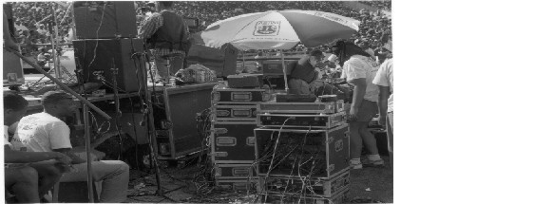
WHAT THIS UNIT IS ABOUT

This unit is about using electrical energy to do useful work. You will be building circuits that could be use for the headlights of a motorcar. You will explore the difference between series and parallel connections. You will measure the current and voltage in the different circuits and calculate the resistance of the lights. You will then do some calculations about energy and power and work out how long a battery might last if you accidentally left the lights on.

In this unit you will

- Investigate potential difference, current flow and resistance of both parallel and series electrical circuits. (SO1 AC1 to AC9)

- Demonstrate understanding of potential difference, current flow and resistance in an electrical circuit. (SO2 AC1).

Assessment Evidence

You will need to
- Design and build an electrical circuit to make it safe for a car to travel at night.
- Build both series and parallel electrical circuits to solve the problem above and choose which is more suitable for the task.
- Use ammeters and voltmeters to accurately measure potential difference and current flow, and use the information to calculate the circuit resistance.
- Calculate the Energy and the Power output of electrical circuits and the costs involved.
- Give a range of examples of electrical circuits being used in technological products.

- Solve a problem relating to the need for motorcars to travel safely at night. (SO3 AC1 to AC8)

- Show an understanding of how science and technology are used in society. (SO9 AC

Introduction!

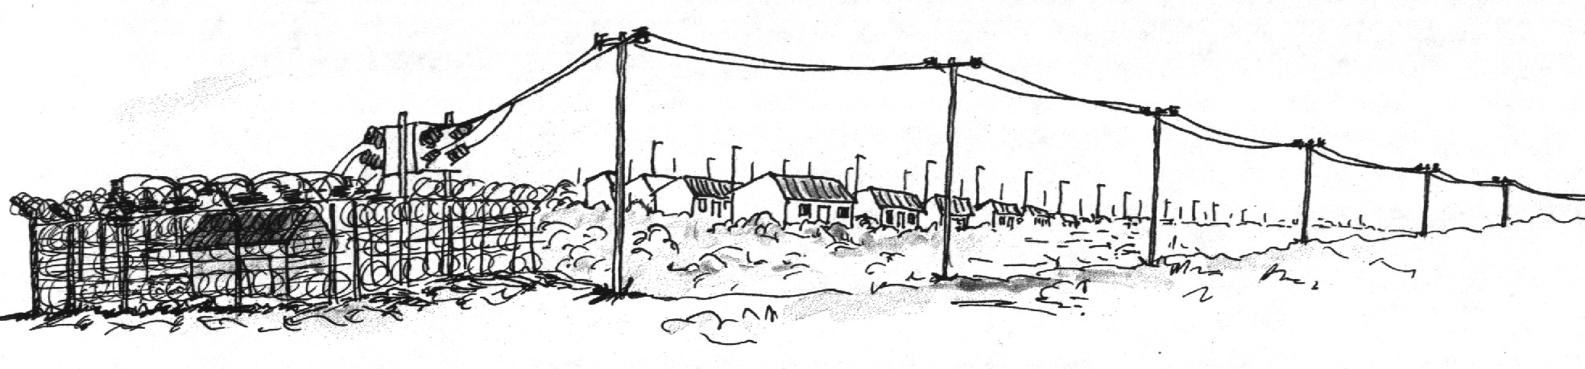

In this unit you will learn about form of energy called electricity. Electricity is generated far away from our homes and it is carried to us through wires called conductors. We then use it to operate different appliances in our homes.

A circuit is a path / route of electricity from a battery or generator, through a lamp or some other piece of electrical equipment, and back to the battery or generator.

All electrical circuits have at least three elements:

- A conductor which is a material through which the electricity flows.
- A load which is the equipment that is being powered in order to do a specific job.
- An energy source, which is something that supplies the electricity like a battery.

These elements can be represented as follows in a circuit:

+
Energy source
-

Load or
Output device

Conductor

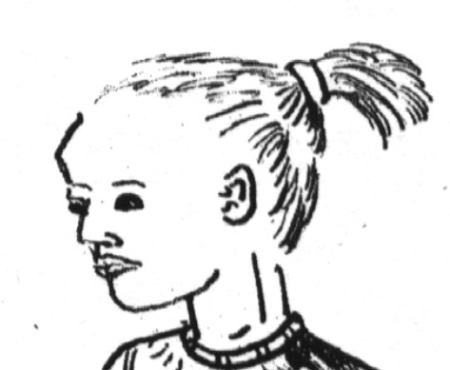
Electricity cannot flow if the components are not connected to each other.

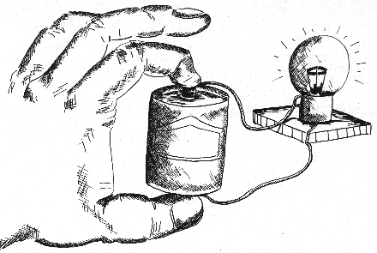

Flowing electricity known as an electric current, carries energy which can do jobs like lighting bulbs or heating the house. All circuits have to have a switch. A switch is a device that makes a gap in a circuit and stops the flow of electricity

In an electric circuit, tiny particles called electrons move around the circuit. They are pushed by the energy from the cell. The cell has terminals, one negative and another positive.

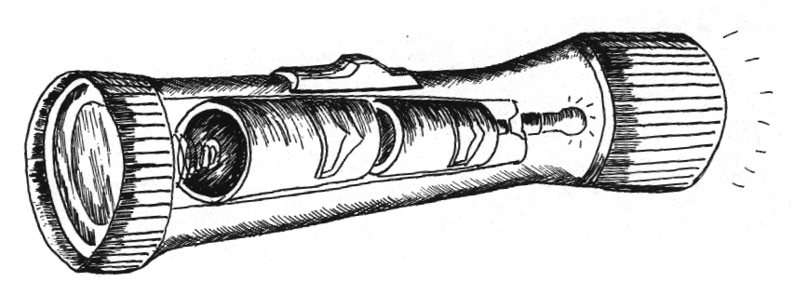
The difference in the total number of electrons at the negative and positive terminal of a cell is known as the potential difference. It is measured in volts with the symbol “V”. This is also known as the voltage. It indicates the amount of energy available to push the electrons to move in a circuit.
A cell has 1.5 volts (i.e. 1,5 V). Many electrical Circuits need more than 1,5 volts so you have to connect two or more cells together to increase the voltage. The more energy a battery can give, the bigger the voltage. In systems that use a battery as the
source of energy, such as radios and games, there is usually an instruction that shows how the cells are to be placed in the battery holder, the size of the cells and the voltage needed to drive the system.

The measurement of the amount of electric current in the circuit is the current. It is measured in Amps with a symbol “A”. This is also known as the amperage.

Electricity flows best through metal conductors made from copper. All materials however resist the flow of electricity. This property of the material is called resistance and it is a measure of how easily current can flow through the material. Materials that cannot conduct electricity are known as insulators.

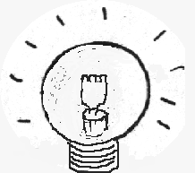
Wires with high resistance get hotter than those with less resistance when conducting electricity. Some of those that get hot may glow red and others glow with a bright white light. The thin wire in a light bulb glows with a bright white light to give us light.

Resistance is measured in Ohms with a symbol, Ω. This is named after George Ohm who found how voltage and current strength were related

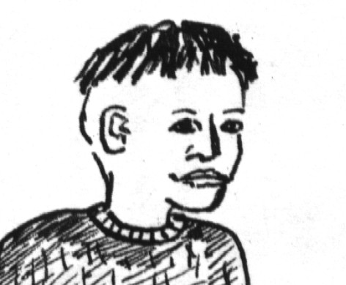
Current ,voltage and resistance are the three things we need to control to make electrical circuits work.

Practical Activity 1.1

Light Flows

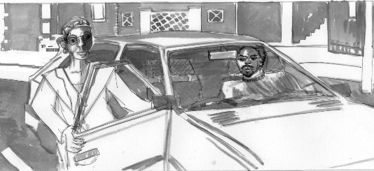
Motorcars need to be able to travel safely at night.

Using electrical circuits, design, build and test a suitable electrical circuit to solve this problem.

- Look at the situation above and identify the problem that you have been asked to solve. Write this down under the heading “Identifying the Problem”.
- Now write a list of relevant information that you may need to help you to solve this problem. (see below for some tips).

Remember the other people on the road, They must not be put in danger by your solution.
What Scientific knowledge do you think you may need? (List the topics)
- Discus in your groups how this problem is solved in real life and try to list all the electrical components that make the system work.

Investigation Activity 1.2

Building and Testing Electrical Circuits.

We will now be connecting up electrical circuits using components like switches, cells (or a battery), and light bulbs. You will be exploring and discovering the effects of potential difference (voltage), current flow and resistance in electrical circuits and working out what you need to do to solve the car problem .

What you will need.

- Builds the circuit shown above in the diagram. And test it to make sure that the light comes on. When you close the circuit. Then answer the questions below.

- In the circuit diagram above, is the switch shown open or closed?
- Will the bulb light when it is in the position shown? Explain.
- What do the + and the –shown on the battery mean?
- What is the potential difference of the Battery (voltage)
- If you switch on the bulb and then disconnect any wire, what happens? Why?

Each group of 4 learners will need:

- Three bulbs
- Bulb holders
- 3 conductors
- A cell (or battery)
- A switch
- An Ammeter
- A Voltmeter

Circuit laid out ready to connect.

We will now start using ammeters and voltmeters to work out the relationship between potential Difference, Current and Resistance.
An ammeter measures current in amps and must be connected in series with your circuit (in line)

- Connect an ammeter and a voltmeter into your circuit.(as shown I the diagram) Note down the readings on the meters when

A The switch is open

B The switch is closed.(

A voltmeter measures Potential Difference in volts and is always connected across the circuit (in parallel)

3 Now move the ammeter and measure the current flow in the places shown in the circuits below. What do you notice about the current in these circuits?

$R=\frac{V}{I}$

3 Use the formula opposite to work out the resistance of the bulb in this circuit. (R is the symbol for resistance and it is measured in ohms $Ω$)

3 Use the formula opposite to work out the resistance of the bulb in this circuit. (R is the symbol for resistance and it is measured in ohms $Ω$)
Investigation Activity 1.3
Series and parallel connections.

Bulbs connected in series

If you need to connect up more than one bulb or motor in an electrical circuit you can connect them in two ways. If you connect them all in a single loop, the circuit is connected in series. If the circuit splits into branches, the components are connected in parallel.

1 Complete the table below by connecting a voltmeter and an ammeter to circuits with one, two and three bulbs in series.

$R=\frac{V}{I}$Number of bulbs in series | Voltage (V)  (volts) | Current(I)  (amps) | Resistance(R)

One bulb
Two bulbs
Three bulbs

- Discuss the following questions in your group and record your findings.
- Do two bulbs connected in series burn as brightly as one bulb on its own?
- What happens to the current flowing in the circuit when you add bulbs in series.
- What can you say about the amount of current flowing through a bulb and the brightness of the bulb?
- If one bulb is badly connected or blown in a series circuit, what will happen to the other bulb?
- Do you think this would be a good way to connect a car’s headlights? Why?

Bulbs connected in parallel

- Complete the table below by connecting a voltmeter and an ammeter to circuits with one, two and three bulbs in Parallel. Make sure you connect the ammeter to measure the total current flowing.

$R=\frac{V}{I}$Number of bulbs in parallel | Voltage (V)  (volts) | Current(I)  (amps) | Resistance(R)

One bulb
Two bulbs
Three bulbs

2 Discuss the following questions in your group and record your findings.
- Do two bulbs connected in parallel burn as brightly as one bulb on its own?
- What happens to the total current flowing in the circuit when you add bulbs in parallel.
- Can you say how much current is flowing through each bulb connected in parallel? How do you know?
- Move the ammeter to measure the current flowing through a single bulb. Is it the same as your prediction?
- If one bulb is badly connected or blown in a parallel circuit, what will happen to the other bulbs?
- Do you think this would be a good way to connect a car’s headlights? Why?

Investigation Activity 1.4
Calculating the Energy and the Power in Electrical circuits.

When a current flows through a bulb, it uses up some of the electrical energy by doing work. The electrical energy is transformed into light energy that can help the driver to see at night. During this investigation you will investigate t how the work done and the power are related to the potential difference (voltage), the current and the resistance.

Power is the rate of doing work or the amount of work being done every second.
When you buy a light bulb you need to know the Voltage and the Power of the bulb, e.g A bulb for your house may be 240V and 60W

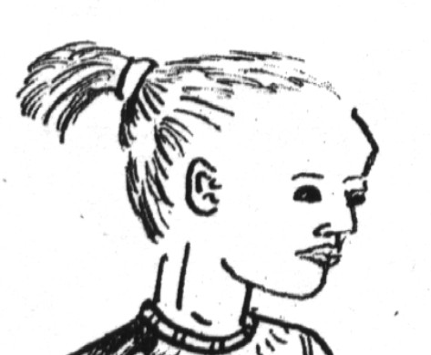

- Use one of the formulas alongside to calculate the following and complete the table below.:-
- The Power output of one bulb in a simple series circuit.
- The power output of two bulbs connected in series
- The Power output of two bulbs connected in parallel.

 | Voltage (V)  (volts) | Current(I)  (amps) | Power output (watts)  $$P=V×I$$

Single bulb circuit
Two bulbs in series
Two bulbs in parallel

The Energy used or the work done in lighting a bulb depends on how long the bulb is switched on. It can be found from the Power being used and the time.

A flat battery is one that has used up all the electrical energy it was storing.


The elapsed time we use in energy calculations is shown as
to show a change in time

$E=P×Λt$
2 Complete the table below using the formula opposite and calculate the Energy the bulb will use in 1 minute (60 seconds)

 | Power output (watts)  $$P=V×I$$ | Elapsed time  (seconds) | Energy used (joules)  $$E=P×Λt$$

Single bulb circuit
Two bulbs in series
Two bulbs in parallel

Now to use all your knowledge to solve our problem

- Draw a circuit diagram of a system that could be used to solve the problem of cars travelling safely at night. Explain your choice and calculate the following.

- If the battery is 12V and you need 60W of light, how much current will be flowing through each bulb.
- If one bulb blows, how will you ensure that you still have one working.
- If the battery (12 volts) can supply 120A for 5 minutes, how much Power does it produce?
- How much electrical energy is stored in the battery? (5 minutes = 300 seconds
- How long will the battery last if the driver accidentally leaves the lights on?

- Make a model of your circuit and test it to show how it will work. Write down the actual value of components you will use, and then explain how it will be used in real life.

You can make a model of the front of your car in cardboard and fit the lights into it.

Now design the front of the motorcar showing the headlights. Make at least three different sketches and choose which one you prefer.
- Evaluate your solution to the car safety problem by answering the following questions:
- Why do you think our solution help people to drive safely at night?
- What other features might you include to help the driver at night.
- What will you include to ensure that other road users are not put at risk by your solution?
- Do you think the design of the front of the car will appeal to both female and male drivers? Why?

Assessment of Unit 2
Learning Outcomes  Have You… | Yes Easily |  |  | Yes  Mostly |  |  | Not  really |  | Comment
Learning Outcomes  Have You… | Me | Educator | Me |  | Educator | Me |  | Educator | Comment
Investigate potential difference, current flow and resistance of both parallel and series electrical circuits
Used ammeters ans Voltmeters to measure current and voltage in a circuit
Investigaton activity 1.2
Built a series and a parallel electrical circuit and demonstrated that you understood the difference between the two.
Investigation task 1.3
Calculated circuit resistance in simple, series and parallel circuits
Investigation activities 1.3 & 1.4
Calculated the Power output and Energy used in electrical circuits.
Investigatio activity 1.4
Use the Technological Process to satisfy the need for people to drive safely at night.
Demonstrated that you understood what was needed or wanted
Identificartion of the problem, Pg.5.
Designed an electrical circuit with suitable bulbs and batteries to solve the problem of people driving safely at night.
Developed three ideas for the design of the front of a vehicle and chosen which one is preferred.
Ideas for circuit and sketches of car front.
Made a realistic looking cardboard model of the front of a vehicle and attached a working electrical circuit to it.
Working model of car front.
Given realistic responses to evaluation questions that explain and justify choices made and demonstrate insight into real life solutions.
Evaluation of Practical activity

