Electro Chemistry | Unit 1 | Chemical reactions and electricity


WHAT THIS UNIT IS ABOUT

In this unit you will learn about the relationship between electrical energy and chemistry.

Torch and motor car batteries are sources of electrical energy. Inside these batteries there are chemicals that react with each other to cause an electric current to flow. You will learn about the electrochemical cell and some of the reactions that can be used to make an electric current flow.
Battery, tyre and exhaust centres are important service-industries in South Africa to repair motor cars quickly.

You will also learn about electrolysis and how electricity can be used to deposit a pure metal substance onto an electrode in a solution. This process is used on a large scale in industry in electroplating of metals. Gold plated jewellery for example is made by depositing a thin layer of gold onto jewellery made of silver. One cent coins are also plated in the same way but with copper.

You will then be investigating the conductivity of different solids, liquids and solutions .The ability of a substance to conduct electricity has a lot to do with the chemistry of the substance. You will be learning what chemical properties cause a material or a solution to conduct an electrical current.

In this unit you will:

- Make and test an electrochemical cell using lemons and potatoes.

- Investigate the zinc-copper electrochemical cell that uses the chemical reaction between Zinc and Copper in sulphate solutions to generate an electric current.

- Investigate how electrical energy can be used in a chemical reaction to deposit a metal onto an electrode.
- Make an item of jewellery out of steel wire and use electrolysis to electroplate the item with copper.

- Demonstrate understanding of the reactions that occur at the anode and the cathode in an electrochemical cell and during electrolysis.

- Investigate the electrical conductivity of certain substances
.

Activity 1

Electricity from Fruit
In this activity you will be making a battery from lemons & potatoes. You will prove that electricity is flowing by making a light turn on. You will then be learning about the chemical reactions that make this happen and how all batteries work because of a chemical reaction.

You will need
- Lemon
- Potato
2 Copper strip
2 Zinc Strip
2 Magnesium strip
- Multimeter
4 Leads
1 LED

  - Making and testing a Battery
Use the procedure below to make a Lemon or a Potato battery.
- Take a Copper strip and a Zinc strip and sand them a little to make them shiny
- Take the lemon and squeeze it a little to release the juice inside.
- Cut the lemon in half.
- Push the Copper strip and the zinc strip into the lemon, parallel to each other so they do not touch each other.
- Touch your tongue across both the strips, Compare it to touching your tongue across a battery. Does it tingle like a current flowing?
Now test the Lemon or potato battery and note down the results.
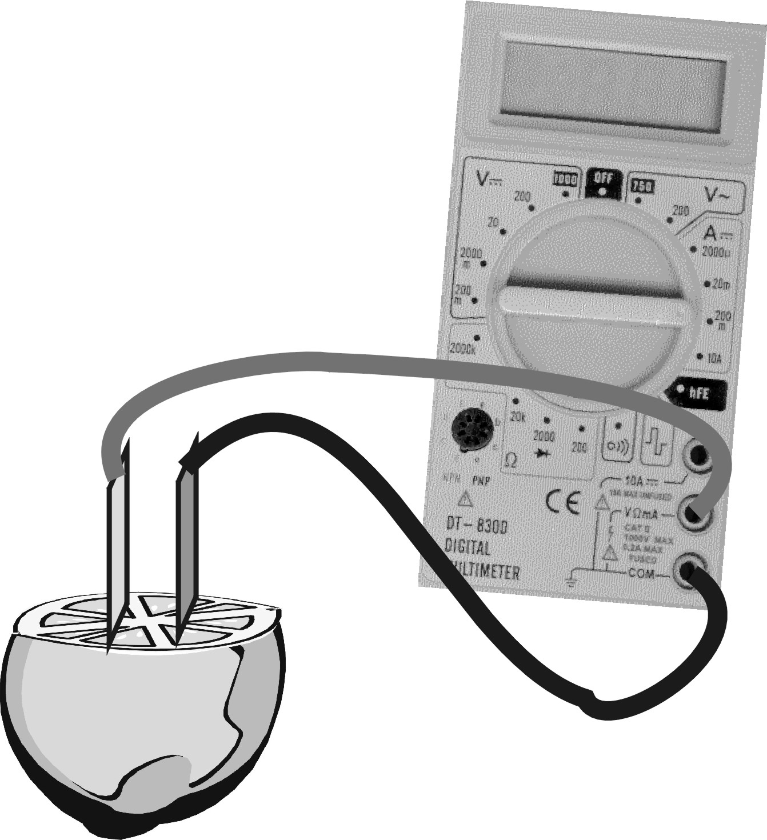
- Connect up a Voltmeter to your cell as shown in the diagram. Can your measure a voltage between the Copper and the Zinc Strips?
- What is different between the two strips if you can read a voltage between them.
- Now connect up the voltmeter to give you a positive reading. Which strip is showing the Positive potential.
- Connect up an LED (small red bulb) to your lemon battery with the longer lead connected to the positive terminal. Does the LED light up.
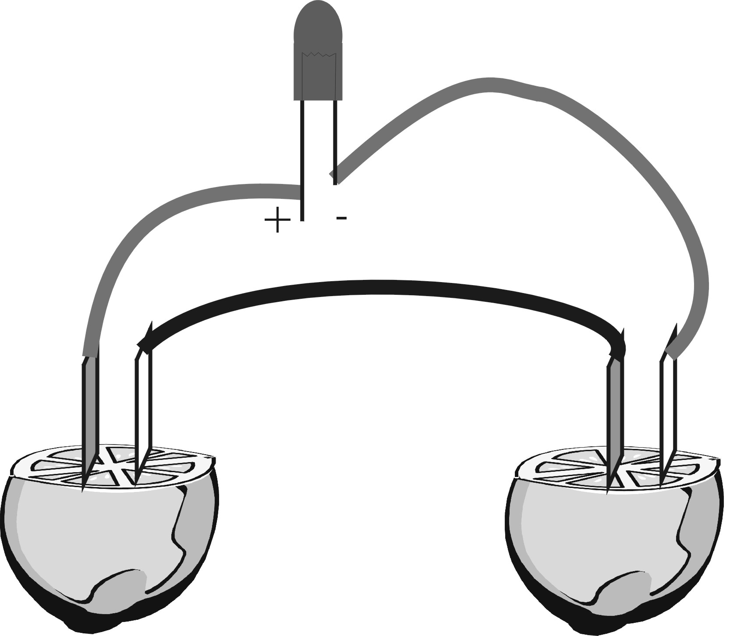
  - Enough batteries to light up an LED?

Make more lemon or potato batteries & connect them together. You need to get enough current to make the LED light up.

- Make a second lemon battery with the other half of the lemon. Use one copper and one magnesium strip this time.
- Measure the voltage between the two strips, Is it higher or lower than the Copper, Zinc lemon battery?
- Connect your two batteries in series, as shown in the diagram. Make sure you connect the Positive of the Copper-zinc battery to the negative of the copper-magnesium battery. Measure the voltage across both batteries.
- Now connect up the LED again and see if it will light up.
- Make a similar battery using the potato. See what voltage you can measure.
- Connect it up in series with the two lemon batteries. Does it glow brighter?

1.3 Electricity from different batteries
Make a table like the one shown to summarise how much electricity you can get out of different batteries.

Fruit or Vegetable | Metal strips use | Voltmeter Reading | Positive Terminal
Lemon | Zinc-copper

- What potential difference did you need to get the LED to light up?
- What combination of cells did you use to do this?

The reaction between the two different metal strips in a solution causes electrons to be pushed through the wires.
All batteries use this principle to convert chemical energy into electricity

Activity 2

THE ELECTROCHEMICAL CELL

In this activity you will be investigating why the electrochemical cell works. You will be doing a controlled experiment using known substances and exploring the chemical reaction that is happening.

You will need
- A piece of corrugated cardboard
- Cotton wool
1 CuSO₄ powder
2 ZnSO₄ Powder
2 Water
- Beaker or jar (250ml)
1 Copper strip
- Zinc Strip
4 Leads
1 Voltmeter (Multimeter)
1 100Ω resistor
2.1 Making the Electrochemical Cell

Use the procedure below to make a different king of electrochemical cell.

- Cut a piece of thick cardboard to fit into the glass beaker to divide it into two.
- Place a thin roll of cotton wool around the edge of the cardboard and slide it into the beaker.
- Make up a solution of CuSO₄ and ZnSO₄ in separate containers, with a concentration of about two heaped teaspoons per 150ml of water.
- 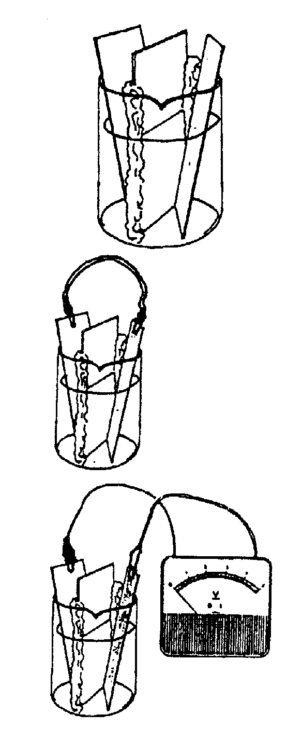Pour the two solutions, at the same time, into the two compartments formed by the cardboard so that they don’t mix together too much.
- Label each side so that you know which is which.
- Place the copper plate in the compartment with the copper sulphate solution, and the zinc plate in the zinc sulphate solution.

You now have a simple Cu-Zn electrochemical cell .

2.2 Investigating how it works.

Do the tasks below to test the cell and note down your findings

- Note down what do you see happening in the beaker?
- Connect the zinc electrode to the copper electrode using a connecting wire and note down what you see happening in the beakers.
- Disconnect the wire again? Is the connection wire doing anything?

- Connect the two electrodes to a voltmeter; measure the voltage across the two electrodes.
- What does it mean if the meter needle tries to move to the left? What should you do to get a reading?
- Remove the voltmeter. Connect the two electrodes to an ammeter and a 100Ω resistor. Measure and note down the current in the circuit.
- Measure and note down the voltage across the resistor in the circuit.
- After a few minutes, some substance begins to form on the copper electrode. Note down what do you think this substance is?
- After some minutes the blue copper of the copper sulphate solution begins to fade (disappear). What is happening? ( Remember, copper ions give the copper solution its blue colour)
- Complete the chemical equation shown for the chemical reaction-taking place at the copper electrode.
Cu²⁺ + 2e⁻ $→$ ?
- Where do these electrons in 10 above go?
- Complete the chemical equation shown for the chemical reaction-taking place at the Zn electrode.
Zn - 2e⁻ $→$ ?

- What is happening to the mass of the Zinc electrode and the mass of the Copper electrode because of the flow of electricity?
- Can this cell go on giving energy forever? If not, why will it stop?
The Zn electrode gives up two of its electrons to become Zn²⁻. These electrons flow to the Cu electrode where they react with a Cu²⁺ ion to make pure copper.
2.3 More about the Cu-Zn electrochemical cell

The electric current is flowing through the wire in a direction from the zinc electrode to the copper electrode. After some time the copper plate is covered with a deposit. This deposit is copper. Also, the blue colour of the copper sulphate solution begins to disappear. This means that copper ions are leaving the solution. Where do the copper ions go?

The copper ions are deposited as copper atoms on the copper plate:

Cu²⁺ + 2e⁻ $→$ Cu

Each copper ion takes up two electrons and turns into a copper atom. We say that copper ions are reduced to copper atoms. This is known as reduction and it takes place at the cathode. We talk of this as the reduction half-reaction.

At the zinc electrode there is no deposit formed; in fact the opposite is happening. At the zinc electrode, zinc atoms leave the zinc plate and go into solution as zinc ions:

Zn $→$ Zn²⁺ + 2e⁻

Each zinc atom gives away two electrons and turns into a zinc ion. We say that zinc atoms are oxidised to zinc ions. This is known as oxidation and takes place at the anode. We talk of the oxidation half-reaction.

The two half-reactions can be put together to give us the net cell-reaction:

Reduction Cu²⁺ + 2e⁻ $→$ Cu
Oxidation Zn - 2e $→$ Zn²⁺

or combined Zn + Cu²⁺ $→$ Cu + Zn²⁺


The movement of electrons through the connecting wire is from the zinc anode to the copper cathode. This kind of cell, which converts chemical energy into electrical energy, is known as a voltaic or a galvanic cell.

Chemical reactions can also be used to coat or plate a metal with another metal. cemical reactio can also be used

In this activity we were using a chemical reaction to generate electricity.

Activity 3

Electrolysis and Electro-Plating

In this lesson we are going to investigate how chemical reactions and electricity can be used to coat a metal with a thin layer of another metal. You have already seen this happen in activity 2 where the copper was deposited onto the copper electrode. This process is widely used in the jewellery industry where for example a silver necklace will be plated with gold. Chrome plating is also used to be very common for making metal pipes, bathroom taps & car bumpers look shiny.

3.1 Copper coating a Carbon rod

You will need

1 Jar or beaker
2 Carbon Rods
1 25g Copper(II)Chloride
1 150ml Water
1 Teaspoon
1 6V battery
2 Leads

Use the procedure below to put a thin layer of copper onto a carbon rod. Then see if it will work with a rusty nail.

- Add three teaspoons of copper(II)chloride to about 150 ml of water in a 250ml jar..
- Stir the solution until all of the copper(II) chloride dissolves.
- Put two carbon rods into the solution for one minute.

Things to note at this stage.
- Look at the rods and the solution. Note down if you can see any changes to the rods or in the solution.
- Complete the equation for copper(II) chloride dissolving in water (i.e. dissociating into copper ions and chloride ions)

CuCl₂ $→$

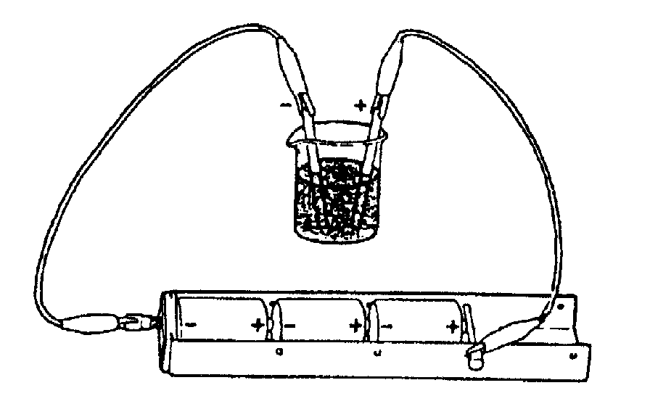
- Connect a 6V battery to the two carbon rods and look closely at what is taking place in the solution.
- After a few minutes disconnect the battery and take out the two carbon rods. Note down what you see.
3.2 Electrolysis & What you observed

Answer the questions below by observing what is happening in the jar with the solutions of copper and chloride ions.

- Look at the electrode connected to the negative terminal of the battery. Some substance is appearing at this electrode. Note down what do you think this substance is?
- Why do you think this substance is formed at the negative electrode?
- Have a look at the electrode connected to the positive terminal of the battery. Can you see anything? Can you smell anything? What do you think this substance is?
- Why do you think this substance is formed at the positive electrode?
- Draw a diagram like the one opposite and use a pencil to show:
- The direction in which the Cu²⁺ ions move in the solution.
- The direction in which the Cl⁻ ions move in the solution.
- The direction in which the electrons move in the wire.
- In this electrochemical cell, there is a flow of electrons/protons/ions in the wire and a flow of electrons/protons/ions through the solution (choose the correct word)
- The electrode connected to the positive terminal of the battery is called the anode/cathode
- Complete the half reaction equation below to show what happens at the anode.
2Cl⁻ $→$ ? + 2e⁻
- The electrode connected to the negative terminal of the battery is called the cathode. Complete the half reaction equation to show what happens at the cathode:
Cu²⁺ + 2e⁻ $→$ ?


3.3 Copper Bracelet

Take a piece of steel wire and coil it into a simple bracelet or ring. Leave a 10mm of straight wire on the end so that you can connect it to the battery.

Put the bracelet into the solution of copper(II)Chloride and connect up the battery. Make sure it is connected so that copper is deposited on your bracelet. (A chlorine coated bracelet doesn’t look very good).

In electrolysis, the electric current causes a chemical reaction. Electrical energy is converted into chemical energy.

In the copper-zinc cell, it is a chemical reaction that causes the bulb to light up; here chemical energy is being converted into electrical energy.

Activity 4

How batteries work

When you buy a cell for a torch or radio, you will want something that is cheap, small, reliable and easy to use. In this activity you will be looking at how the batteries (called cells in science) work.

The drawing below shows a typical cell (or battery as we call it).
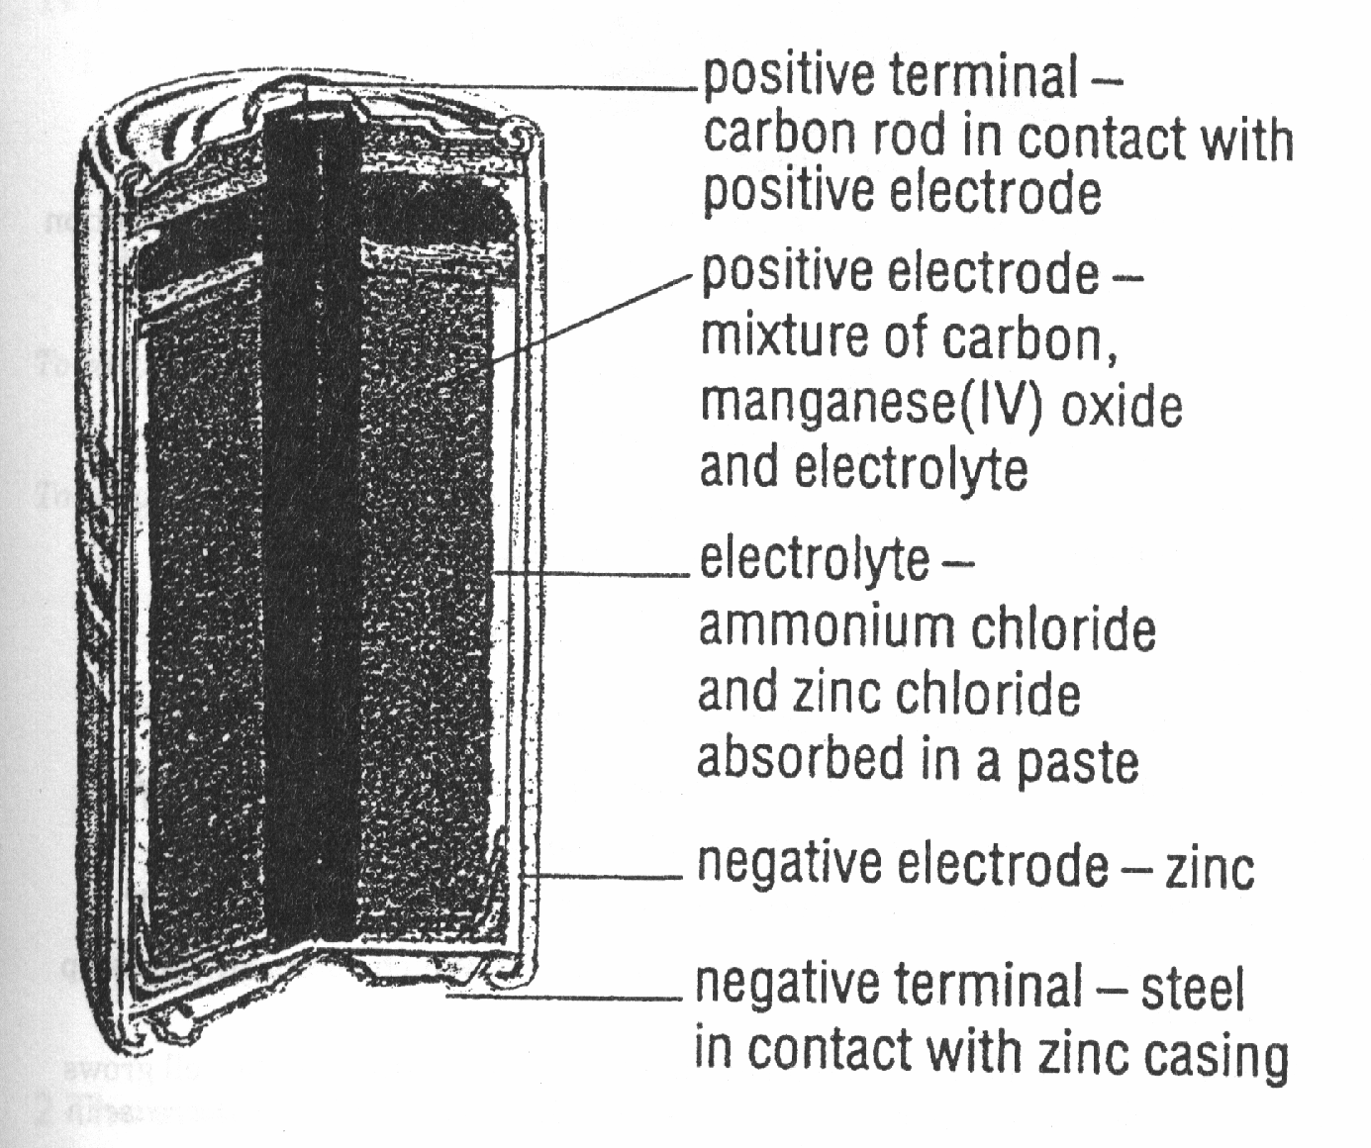
The negative electrode is zinc and is also the casing of the cell. The negative electrode loses electrons to form zinc ions:

Zn $→$ Zn²⁺ + 2e⁻

When the cell is in use (eg. When a radio is on) the electrons flow around the external circuit to the positive electrode. The positive electrode is made of manganese(IV)oxide and carbon. The reaction at this electrode is very complicated but it can be simplified as:

Mn⁴⁺ + e⁻ $→$ Mn³⁺

A solution of ammonium chloride and zinc chloride (called the electrolyte) allows ions to form and helps to conduct the electricity.

Many electrical appliances such as watches and cameras use a button cell like the one below. Once again zinc (in powdered form) is used for the negative electrode.

Mercury(II)oxide is the positive electrode. The electrolyte is a concentrated solution of zinc oxide and potassium hydroxide. The electrolyte is alkaline. The overall reaction is:

Zn + HgO $→$ ZnO + Hg

The voltage produced in this button is 1.35V.

Other oxides are also used in cells instead of mercury oxide. For example, silver oxide. These cells gives a higher voltage (1.6V) but cost more money.

4.1 Questions about cells

- Write down the oxidation half reaction for typical 1.5V cell.
- Write down the formulae for the chemicals that make up the electrolyte.
- Write down the combined reaction for the typical cell.
- Which chemical is found in both the typical cell and the button cell?
- Imagine you have a watch which uses a button cell. Which chemical makes up the anode?
- Why do you think a cell using silver oxide is more expensive than one using mercury oxide?
- The button cell can keep a watch running for a few months. As the cell grows old, which electrode (positive or negative) would you expect to see decreasing in mass? Explain your answer.

Activity 5
Solutions, Conductivity and Ionisation

In this activity you will be investigating what happens when you make different solutions from different substances. You will be looking at how well solutions of different substances conduct electricity. This is very important for the electrochemical cell and for electro-plating because if the solution does not conduct electricity, then there can be no transfer of electrons.

5.1 What substances conduct electricity?.

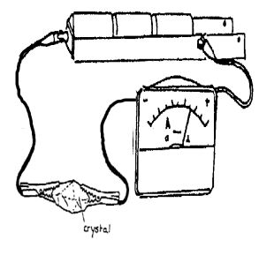
Use the procedure below to determine what substances can conduct electricity.

- Test each of the solid crystal substances in the table below by connecting them to a battery and seeing if you can get a reading on an ammeter.
- Make a table like the one below and place a tick (√) if a substance conducts an electric current and a cross (X) where the substance does not conduct an electric current.

Solids
Sugar | CuSO₄ | Naphthalene | NaCl

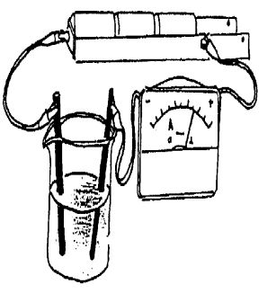
- Test each of the liquid substances in the table below by connecting a battery to two carbon rods and placing them into the liquids. Then see if you can get a reading on an ammeter.

Liquids
Water | Alcohol (Ethanol) | Paraffin
- Make up solutions of the substances in the table below by dissolving 2 or 3 teaspoonfuls of the substance into 150ml of water
- Test each of the solutions using the same carbon rod set-up you used for the liquids above. See if you can get a reading on an ammeter and then complete a table like the one below.

Solutions
Sugar in water | CuSO₄ in water | Naphthalene in ethanol | NaCl in water
.
- Have a close look at the results of this experiment and note down the answers to the following questions.
- Which substances conduct ◘ an electric current?
- Suggest why some substances conduct an electric current.
- Suggest why some substances do not conduct an electric current

5.2 Why some substances conduct electricity.

- Solids like metals conduct an electric current because they have free moving electrons.

- If a solid does not conduct an electric current it is either:
- An ionic solid, which is made up of positive and negative ions held tightly together in a crystal lattice (eg. NaCl and CuSO₄ ); or
- A covalent solid which is made up of neutral molecules (like sugar and naphthalene).

- Liquids which are made up of neutral molecules (for example distilled water, ethanol and paraffin) do not conduct an electric current.

- Solutions in which a covalent solid has been dissolved (for example, sugar in water, naphthalene in ethanol) do not conduct an electric current.

- Solutions of ionic solids are good conductors of an electric current. This is because when an ionic solid dissolves in water, the lattice breaks up allowing the ions (both positive and negative) to move freely. These freely moving ions carry the electric current.

For example ,when NaCl dissolves in water, the NaCl breaks up to release Na⁺ and Cl⁻ ions . We say that the NaCl has dissociated in water.

- 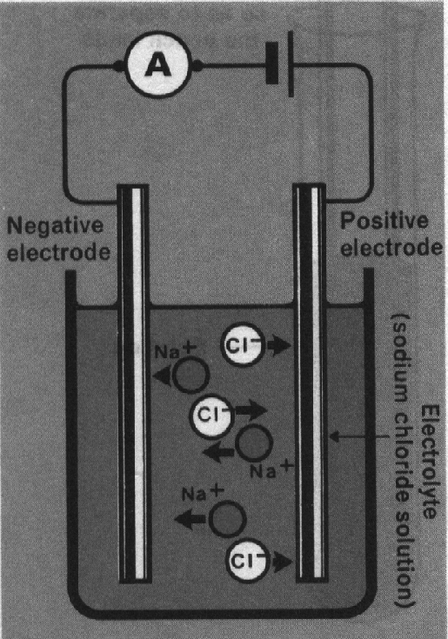A solution containing the ions is called an electrolyte. The carbon rod connected to the negative pole of the cell is called the negative electrode and the rod connected to the positive pole is called the positive electrode.

- The positive electrode repels the positive sodium ions (cations) and attracts the negative chlorine ions (anions). The opposite process takes place at the negative electrode. Chloride ions thus migrates towards the positive electrode and sodium ions migrate towards the negative electrode.

- This movement of charge causes a flow of electricity. The electrolyte, together with the two electrodes, is known as an electrolytic cell.

  - Some questions about conductivity.

- You are given two white powders, which are soluble in water. One of these powders is an ionic compound and the other is a covalent compound. Describe how you would find out which white powder is ionic and which powder is covalent.
- Would you expect dilute sulphuric acid to conduct an electric current? Explain your answer.
- Write down the ions that are released when copper sulphate dissolves in water.
- Complete the equations below to show what happens when the two ionic solid compounds dissociate in water:
(NH₄)₂SO₄ $→$

ZnSO₄ $→$

Task List Assessment

Chemical Reactions and Electricity
Task | Score | Weight | Points
Made and tested electrochemical cells that can light up an LED, using lemons and potatoes  Activity 1.3 | 1 2 3 4 | 1
Made and investigated a Cu-Zn electrochemical cell and answered questions that show that you understand what was happening.  Activity 2.1 and 2.1 | 1 2 3 4 | 3
Investigate how electrical energy can be used in a chemical reaction to deposit a metal onto an electrode (Electrolysis and Electroplating)  Activity 3.1 and 3.2 | 1 2 3 4 | 2
Answered questions that show that you understand the reactions that occur at an anode and a cathode when electricity is produced from an electrochemical cell.  Activity 4.1 | 1 2 3 4 | 2
Investigated the electrical conductivity of different liquids and solutions and demonstrated an understanding of why some substances conduct electricity and some do not.  Activity 5.1, 5.2 and 5.3 | 1 2 3 4 | 2
Total Score | Max = 10 x 4=40

