Geometry | Unit 1 | Points, Lines & Angles


WHAT THIS UNIT IS ABOUT

In this unit you will be looking at the basics of geometry. Geometry is about constructing and comparing different drawings and figures. The building blocks of all drawings are points, lines and angles. If you join two points together you get a line. If two lines meet at a point there will be an angle between them and if a number of lines enclose an area of a flat surface, you get a shape.
The pyramids in Egypt show that the ancient Egyptians had a very god knowledge of Geometry.

In this unit you will explore straight lines and how they are related to points. You will make a simple Compass (without a pointer) and using it to find out about angles and how they relate to the directions North, South, East and West.

You will be turning a square shape into a Tangram, an ancient Chinese puzzle based on 7 different shapes. You will be using these shapes to explore and compare the properties (differences and similarities) of shape.

Finally you will be looking at different triangles and making sure you know what they are called and the properties that we se to define them.

In this unit you will:

- Draw an accurate target using a compass

- Identify and place points on the target closest to and furthest away from a given point.

- Identify and explain a line segment and a ray.

- Identify a fraction of a turn by rotating.
- Make a simple compass and use it to relate angles of rotation to direction.
.
- Make a set of Tangram shapes and use it to explore some properties of triangles, squares, rectangles, trapezoids and parallelograms.

- Draw different triangles from the given descriptions and show that you know their names.

Activity 1
Points and Lines

This activity is about points and lines in geometry. You will learn how points can be used to define a line and how a line through a point can go on forever in one or more directions, making it into a ray.

  - Scores for hitting the Target

Tebogo and his friends are making a target game. People will be throwing spears at a target. Their score will depend on how close the spears are to the centre of the target.

The target is made up of rings around a centre circle with a radius of 2cm. The rings are each 4cm thick.

If the least score for hitting the target is 10 points, give a score to each of the 4 rings and the centre circle that rewards the thrower for being nearer to the centre.

1.2 Scores for hitting the Target
Note
It is easier to draw the outer ring first.

Draw a target for your group using a compass. Set the compass to 1mm to represent each centimeter. Shade in the rings to represent the different scores.

Tebogo’s first throw hits the target at point P in the middle of the ring.

- How far away from the centre of the circle is this point?
- What did Tebogo score?
- How far away was he from getting the next score up (least distance from P)? Mark the point on your target.
- How was he away from getting two scores up (least distance)? Mark this point on your target.
- How far was he away from hitting the centre circle? Mark the point.
- What can you say about all the points you have marked above?
- How far is it to the point furthest from P that would have given Tebogo the same score?
- Mark the point that is furthest away from P that still hits the target.
- If you join all the points you have marked, what have you got?

1.3 Line Segments and Rays.

- The line from O through P that carries on forever is said to be the ray OP, written OP.
- The part of ray OP that starts from O and terminates at P is said to be line segment OP, written OP.
- The line that passes through P and O, and goes on forever in both directions is written PQ. It is also called ray PQ.
- If you imagine a huge target with tiny gaps between each ring, the line from O through P would be made up of all the points that give Tebogo the closest next score

Look at the following pictures and write down whether the line in the drawing is a ray or a line segment. Use the appropriate notation to represent the line and give reasons for your answers.

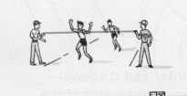
1 The line represented by two people holding a finishing line.
A
B

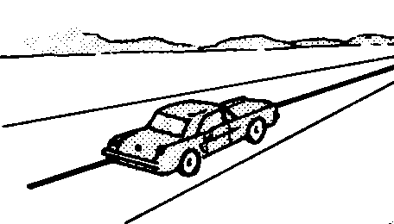

A
B
2 The white line representing the middle of a straight road.

Activity 2
Angles and rotating

  - Turning around

Let one of your group face the front. Ask them to turn until he or she faces the front again. How much of a complete turn has your group member rotated?
Repeat this exercise by asking your group member to turn :
- To face the wall behind?
Always face the front to start
- To face the window on the right hand side?
- To face the corner at the front on the right?
- To face the back right hand corner?

  - Turning on your Target

Use the diagram to answer the following questions:
- Which two rays make PQ?
- Imagine you are at the centre of the circles and facing in the direction of OP.
- What fraction of one revolution are you going to ‘rotate’ in order to face OR,
- OQ?
- OS?

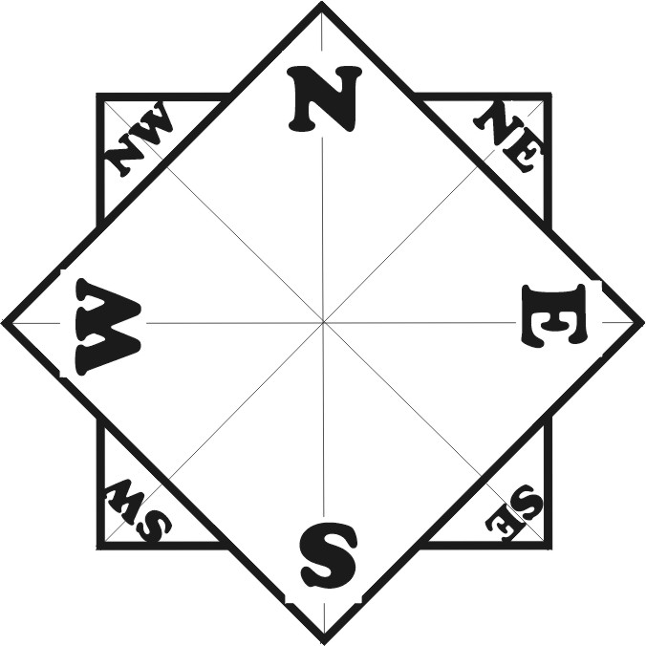
  - Making a Compass

We measure the directions North, South, East and West, as parts of a circle or angles. Instead of facing the front to start, we face North to start. We say that all directions are measured from the North Pole, or from the direction North.

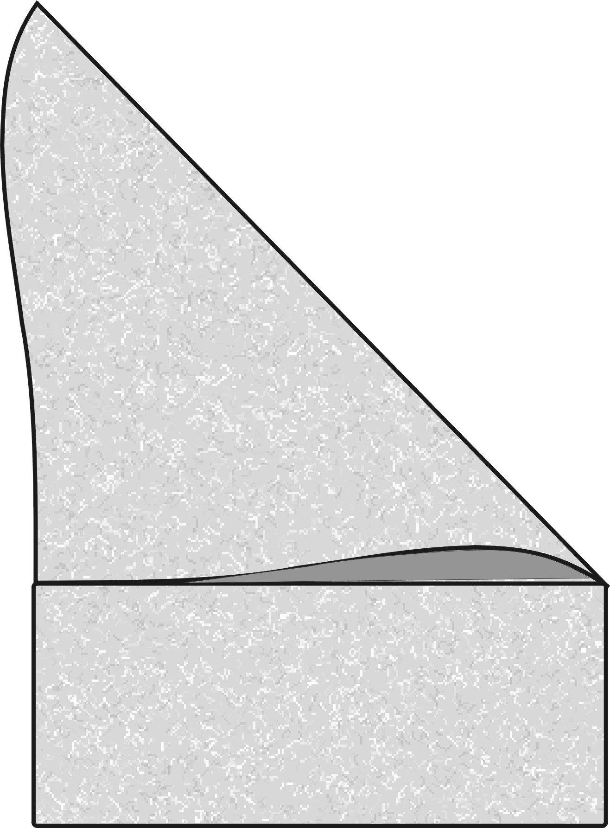
Use the Procedure below to make a simple compass or Direction Indicator.
Cut off
- Take two pieces of A4 paper and make two squares with sides of 210mm. You can do this by folding the top edge to line up with the left-hand edge, then cutting off the unfolded piece at the bottom.
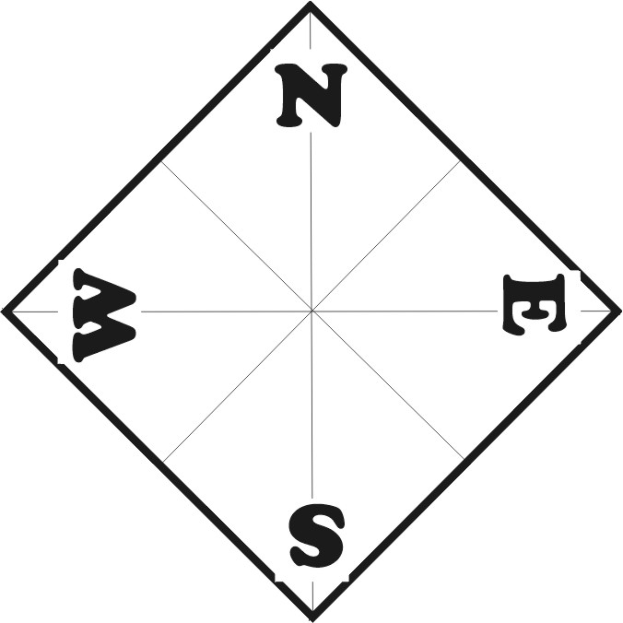
- Draw in the diagonal lines from corner to corner of each square.
- Fold the square into four and then draw in the dividing lines through the centre.
- Turn the first square so that one corner points towards the top. Mark in N for North in the corner.
- Now mark the other corners E for East, S for South and W for West making sure they are in the right order.
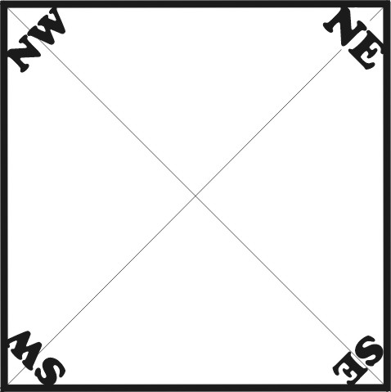
- Do the same on the second square, but mark the corners NE (for North East), SE for South East, SW for SW and NW for North West.
- Glue the second square behind the first so that the corners of the square point in the right directions.

2.4 Angles and Direction

Answer the questions below about how we measure direction and angles.
Some History
The Babylonians decided that they would call one complete turn 360°. (Written 360 degrees)
Half a turn became 180⁰ and a quarter turn 90⁰, etc.

- If you are standing in the middle of your compass and facing north and you turn through a quarter turn clockwise. What direction are you facing? How many degrees have you turned?
- If you face NW how many degrees have turned from North?
- Face west and make a 90⁰ turn clockwise, What direction are you facing?
- Face south and make three quarter turn anti-clockwise, What direction are you facing and how many degrees have you turned?
- What is the angle in degrees between East and South East?
- If you fold the corner of a square in half, what angle have you produced?

Activity 3
Shapes and the Tangram

3.1 How to make a Tangram puzzle

A tangram is a square divided into 7 different shapes.
- A small square
- Two large triangles that can fit into each other.
- Two large triangles that can fit into each other.
- A medium sized triangle.
- A parallelogram.

Use the procedure below to make your own set of Tangram Shapes.

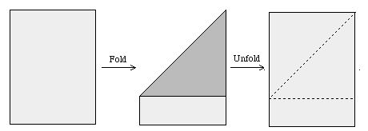
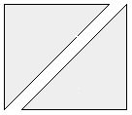
- Make a square from a piece of A4 paper. If you do not have scissors to cut the paper, you can always make the fold line a little wet and then tear carefully along the line.
Cut off

A

Cut the square into two triangles.

B
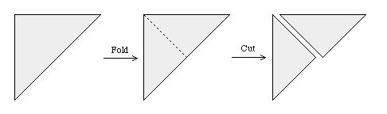

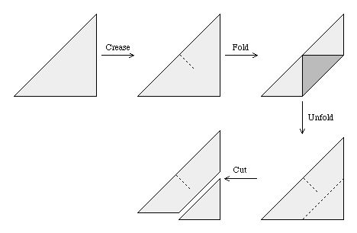
Take one triangle and fold it in half. Then unfold it and cut it into two. Mark these triangles 1 and 2. These are your first pieces

A

1

2

Crease the other triangle to find middle. Then fold the opposite corner onto the middle mark. Then cut off the folded triangle. This is your third piece.

B

3

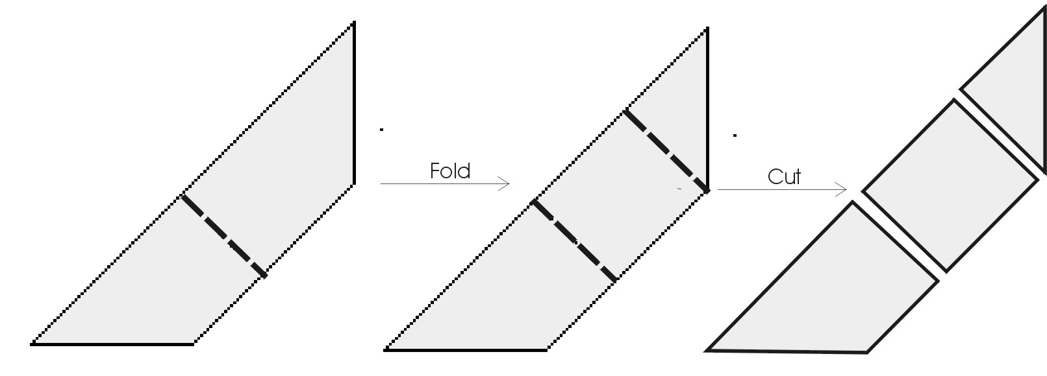
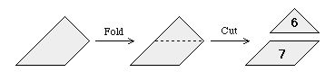
Fold the trapezoid shape in half and then fold the one triangular end into the centre again. Cut off both pieces and mark them 4 and 5.
4
Cut
5
Fold

Fold the remaining piece into two as shown and cut into pieces 6 and 7.

3.2 Using your Tangram shapes

In groups do the following activities using your Tangram shapes. Then discuss and answer the questions
- Identify as many quadrilateral shapes as you can. How do you know these shapes are quadrilaterals?
- Identify as many squares as you can. How do you know these shapes are squares? Were any of these squares listed in your answer above? Explain.
- Identify as many triangles as you can. How do you know these shapes are triangles? What can you say about the angles of these triangles?
- Identify as many parallelograms as you can. What makes these shapes parallelograms.
- How many squares can you make from the triangles of your Tangram?
- What is a congruent triangle?
- How many different shapes can you make from any two congruent triangles from your tangram? Name them.
- What can you say about the area of a square and a parallelogram made from two congruent triangles?
- Now see if you can use all your pieces to put together the original square.
- See how many different shapes you can put together using different tangram pieces. Name all the shapes you make. Make a table like the one below and write in how many of each shape you made.

Triangle | Quadrilateral | Rectangle | Square | Trapezoid | Parallelogram

Activity 4
More about Triangles
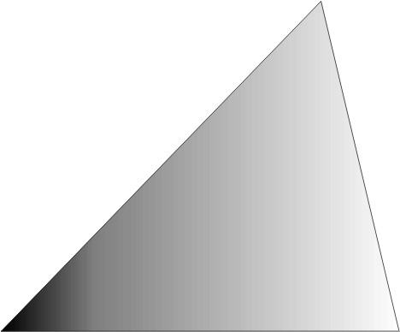
A triangle is a shape made up of three line segments or three sides. A triangle has three points, one at each corner. At each point there is an angle. To compare triangles we always compare the length of the sides and the size of each of the angles.

4.1 Drawing different triangles

Draw the triangles described below. Then draw up a table like the one below the name of the triangle next to the drawing of that triangle.

Name, description & properties of a triangle | Picture of that triangle
An Acute angled Triangle is a triangle with all its interior angles less that 90⁰ | 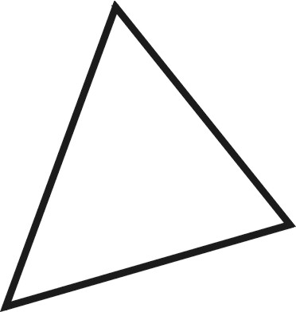
An obtuse angled triangle is a triangle with one angle greater than 90⁰ | 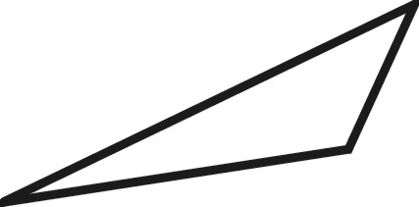
A Right angled triangle has one angle equal to 90⁰
An isosceles triangle has two of sides equal and two of its angles equal.
An equilateral triangle has all three of its sides equal and also all three of its angles equal.
Two triangles are congruent if all of their sides and all of their angles are equal.
Two triangles are similar if all of their angles are equal but their sides are not equal.

Task List Assessment
Task | Score  Comment | Weighting | Total Points
Correctly draws an accurate target using a compass.  Activity 1 Task 1.2. | 1 2 3 4 | 2
Correctly identified and placed points on the target closest to and furthest from a given point P.  Activity 1 Task 1.2. | 1 2 3 4 | 2
Correctly identified a line segment and a ray.  Activity 1 Task 1.3 | 1 2 3 4 | 1
Identifying fractions of a complete turn by rotating.  Activity 2 Task 2.1. | 1 2 3 4 | 3
Correctly make a simple compass and use it to relate angles of rotation to direction.  Activity 2 Task 2.4. | 1 2 3 4 | 4
Correctly make a set of Tangram shapes and use it to explore some properties of triangles, squares, rectangles, trapezoids and parallelograms.  Activity 3 Task 3.1. | 1 2 3 4 | 4
Correctly draws different triangles from the given descriptions and show that you know their names.  Activity 3 Task 3.2. | 1 2 3 4 | 4
Total Score | Max = 4 x 20 | 20

How to score 4 points = Perfectly correct, clearly explained and presented
3 points = Mostly correct, mostly understood and understandably presented.
2 points = Partially understood, some aspects correctly explained.
1 point = Completed with a little understanding.

Multiply score by weighting to get final score for that Outcome

