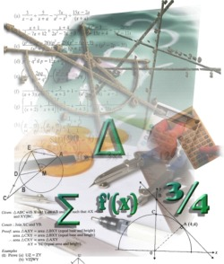
Analysis of school maths resources

School:

SECTION A
Resource name | What it is used for | How ICT can support its use
SECTION B
Targeted learning outcomes or assessment standards | Resources that could be used for the outcome | How ICT can support teaching and learning for this outcome

