The growth of Cellular Telephony

Cellular telephony is the fastest industry in the world. In fact, growth is so rapid that major processor developers are intending to include their processors in cellular handsets:
Intel® products for cellular and handheld designs include Intel® PCA application and cellular processors, Intel® Flash memory, wireless baseband chipsets, plus varied development resources and software. The Intel® Personal Internet Client Architecture (Intel® PCA) and product-enhancing wireless technologies are stimulating the future evolution of mobile devices.

An indication of the growth of cellular telephony is the establishment of base stations. The following graph shows the predicted growth of base station installation for major countries around the world.

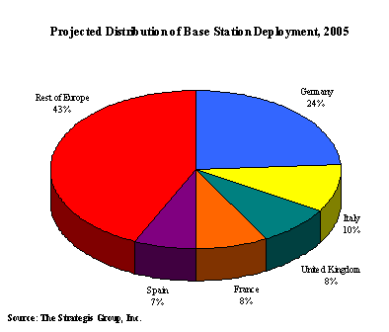
Figure 1: This graph was obtained from the website http://www.cellular.co.za/stats/stats-main.htm

The growth of cellular telephony: [Online]http://www.cellular.co.za/stats/stats-main.htm
[Online] http://www.intel.com/products/wireless/index.htm

